HGXL Airflow Sleeve Removal

Unit E2
Fairoaks Airport
Chobham
Woking
Surrey
GU24 8HU

Tel: 01276 859443
VAT registered: 833886490
Hayden Krause
Date: 29/11/2017

- Open the HGXL Door and remove both sensors from the side wall. The connectors have a sheath. Pull on the knurled section of the connectors as shown.

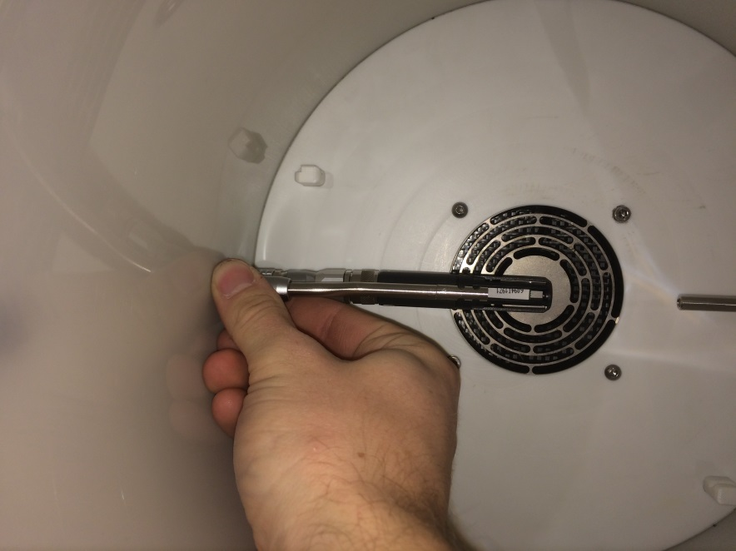

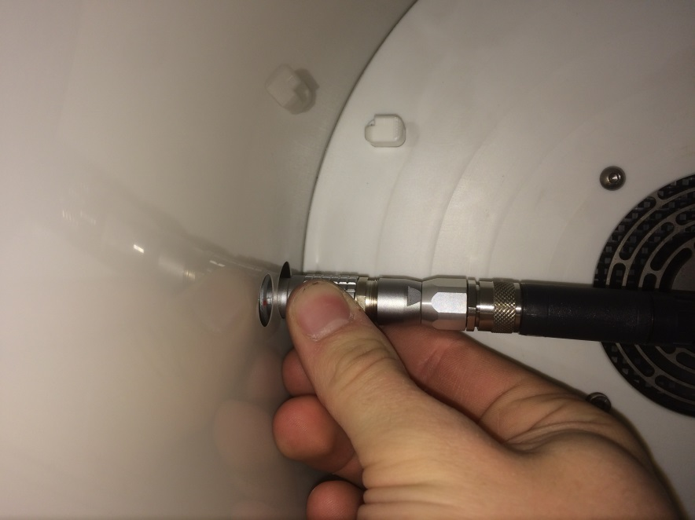

- Remove the metal tube

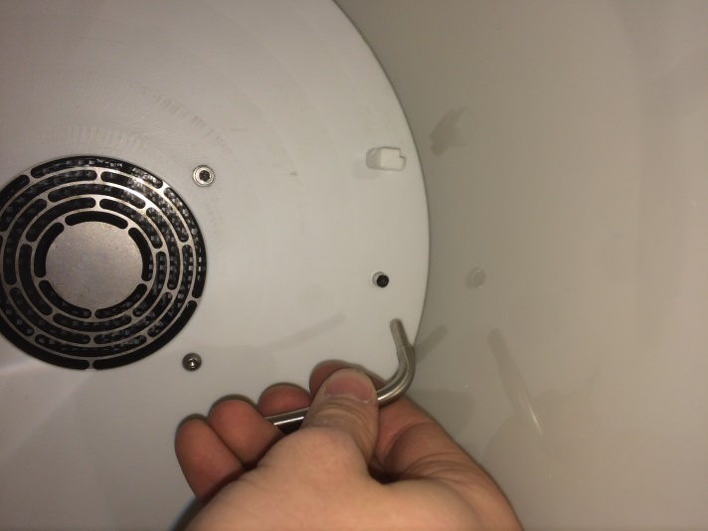

- Remove the two button heat screws using 2.5mm hex key (bottom right and top left).

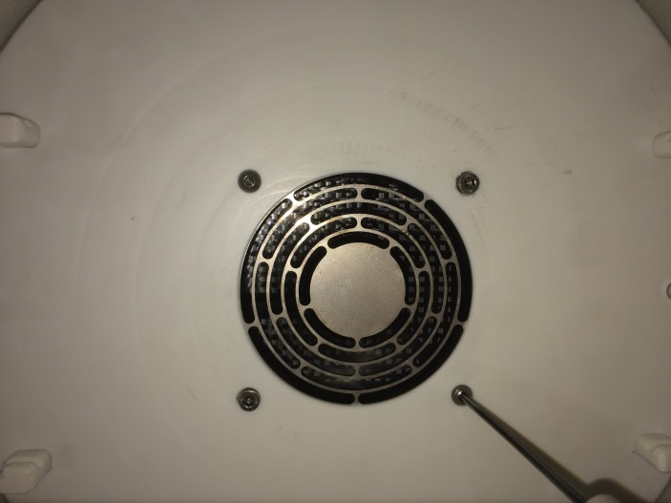

- Carefully remove airflow sleeve

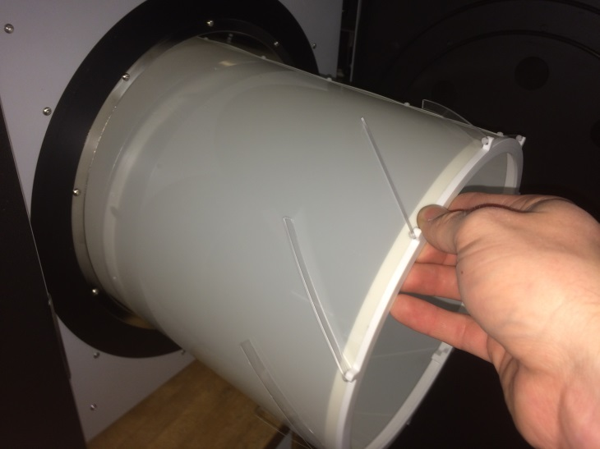

- Access to the cross head screws for removal and re-seating

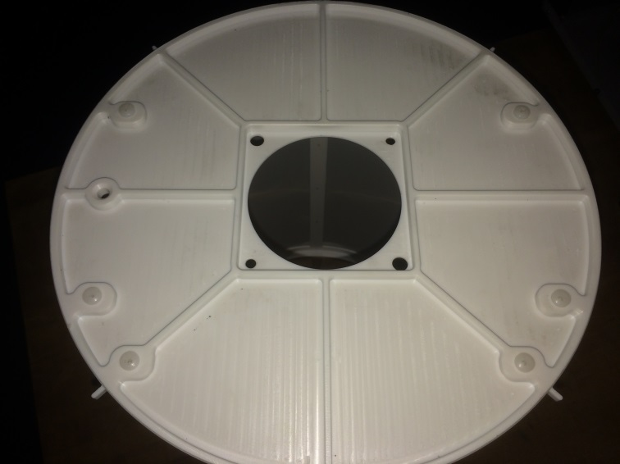

NOTE: Be extra careful when placing the airflow sleeve back into position. The fin features are delicate.
Fins

NOTE: When re-positioning sensors the red dot on the connectors should be facing towards the product door.

