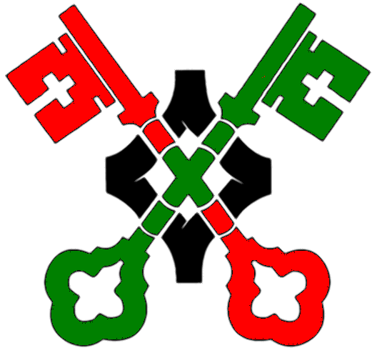 Sample Lesson Plan for Early Years
Title | Perfect People
Stimulus | Playdough people and letter from Planet Leader
Stimulus details | Letter from the Planet Leader  Dear People,  I am giving you a very important job. I am going on holiday and need you to carry on my work. You must create some people for my new planet but they must be the very best people in every way.  Please let me know all about the people you make for me. I have given you some people making material. Please create carefully. We cannot risk any mistakes.  Thank you  Leader of Planet Plato
Year Group | Nursery/Reception
Skill Focus | First thoughts. Clarifying ideas
Thinking Focus | What is a person?
Preparation | Allow time for children to explore books and stories about a variety of people.
Presentation | This activity is best done in smaller groups of 5 or 6 children at a time working around a table. Prepare enough play dough for each child to form a model person. You may wish to provide different colours. Read the stimulus letter to them and ask them if they can make the perfect person. Join in this activity yourself to model.
Conversation and Thinking time | While the children create their” people” ask them what they are doing to make their person. What does it need to look like? What does their person like to do? What colour they have chosen to make their person.
First Words | As the models progress ask the children questions such as “Would it matter if your person had no arms? Eyes? Heart? Legs?” Does your person have to look like mine? How is your person different from mine.  Allow them to express their ideas about what makes a perfectly functioning person.
Building | Introduce the idea that the person you have made might not be accepted by the leader because it is badly behaved. Can they suggest some things that it does wrong?  Ask the children if they can help you fix your person so that it is perfect again?
Last Words | Do the children think that there can ever be a perfect person or is it ok to make mistakes or look different?
Review | Were all the children able to participate and contribute their ideas and suggestions?  Were children able to discuss whether physical difference makes a person incomplete or not?  Were they able to develop thinking to think about behaviour?

