
Post-Incident Report
156 North 9th Street
3rd Alarm Box #428 - 4.11.2012
03:45 hours - D platoon
4 Story Occupied Multiple-Dwelling
Burned Occupant & Firefighter MAYDAY
Account from Deputy Chief Tom Kemery – D Platoon
I responded to the box at 9th and Elm Streets for the fire reported at 156 North 9th Street. The alarm assignment was as follows: Engines -1, 3, 5 & 9, Tower 1, Ladder 1, Rescue 1, Cars 3 & 7, along with Medic 1.
I drove east on Franklin and North on Ninth. Dispatch reported individuals are in the building, and are refusing to leave. Callers also reported watching fire drop down in front of their windows. In my mind this indicated the possibility of entrapment, or at least having to deploy limited resources to a life hazard problem. The dispatch center also reported that the police were indicating a working 3rd floor fire.
Arriving in the one hundred block of North 9th St.. I parked on the east side of the street in front of St. Paul’s Church. I found the incident to involve a 4 story corner property, first floor mercantile with an unknown number of apartments on the three floors above. There was smoke visible and what I thought was initially fire showing from two east side top floor windows. This turned out to be one 4th floor window on the east side, however, during my size up, I saw two windows from the north side of the building with fire showing. I met up with the incident commander, (Car 3 Mogel), in the intersection and he reported he was going offensive with a 2 ½ line up the interior stairwell with a gated wye for two 1 ¾ lines, as there was no sprinkler system or standpipe. The building was used as an apartment building, (had been on at least one EMS call in the property in the past) but the storefront was vacant for as long as long as I can remember.
I went in the east side stairwell where I met some civilians standing on the portico of the property at 154 north 9th St.. These folks were residents of some of the apartments. I went upstairs as the 2 1/2 was being stretched.
This stairwell wrapped around, what was thought to be an old elevator shaft but was later learned to be a ventilation and lighting shaft.
On the third floor, I met a couple of civilians in the hall way outside the apartment (that would be directly below the burning apartment) refusing to leave the building. I spoke to them in English and Spanish that they must leave the building; I got them to leave and continued up stairs. I arrived at the base of the stairs to the fourth floor. The 2½ line extended up into the stairwell to the 4th floor about half way. I passed the 2½ gated wye and went to the fire floor, where I saw the fire apartment and the fire seemed to be contained in this apartment and likely the west exposure apartment. I was not masked up as yet. Conditions were tenable at the time, with good visibility.
I came back down to the third floor, to make room for the crew to establish the hand line, meeting firefighter Sullivan with the first bundle of 1¾ hose. While on the third floor, Command called and requested me to check the apartment below the fire ASAP for extension as smoke was increasing in this apartment. I went and checked the apartment this is the same apartment where the civilians were standing that needed encouragement to leave the building. A check of the apartment revealed that there was smoke, but no fire visible at that time.
I returned to the hall, and the crew reported they were having a hard time connecting the hand line. They lost control of the coupling and the visibility decreased significantly further hindering the situation. They kept working on it but were not having any luck. I told them to take the nozzle and flake it back down on into the hallway. Firefighter Glore arrived with the second 1 ¾ hand line and went to go up the stairs, I held him back and so as not to further compound the line situation and told him to flake his line out from here to hold onto the coupling and make the connection. Visibility was markedly worse masks were required in the stairwell and soon would be needed in the 3rd floor hallway.
Firefighter Brunner was detailed ahead of the LT Rehr on the fourth floor doing primary search of western apartments. With the water supply problem continuing unabated and the fire progression escalating, a decision was made to pull everyone from the fourth floor down to the third floor and use the tower platform master stream to knock the fire down and make it more tenable and more effective with dual 1 ¾ hand lines.
LT Rehr, Sullivan & Glore continued working on the line issue. The heat increased on the fourth floor and banked down along with visibility decreasing rapidly on the third floor all contributed to the hose line establishment issue. While preparing for master stream use, we began evacuating everyone off the 4th floor. Tones were sounded by radio to notify all firefighters to evacuate the floor. I was on the third floor taking accountability, before the master stream began flowing. At 04:04 hrs, firefighter Brunner from Tower 1 issued his mayday. He started his LUNAR report, and reported high heat. I started to go across the third floor hall to the west stair well, and command sent firefighters Lerch & Leszczynski up the west stairwell (or they were operating in close proximity to the west stairwell) that they were able to reach and retrieved firefighter Brunner in a short period of time. I was ¼ to ½ way down the hall upon hearing they had him. I did radio command to confirm Brunner was physically out of the building, which was done at 04:07 hrs. A total time of 3 minutes elapsed after the mayday declaration.
It became clear that the fire was burning for some time, and had spread from the original apartment into the apartment next door and most likely into the roof or void space above the ceiling.
LT Rehr, Sullivan & Glore were finally able to establish water, and were directed by Command and myself to stay at the top of the stairs and hit what they could. Sometime around 04:13, the tower opened up and began operating
Once the tower knocked things down, the hand lines were placed into operation on the fire floor. Car 4 (Stoudt) arrived and was tasked to lead an operation from the west stair well heading east through those apartments. We operated for approximately 45 minutes to an hour with the fire still having significant control of the void space. (There was a second and third retreat from the fourth floor to the 3rd floor to allow T1 to operate their master stream in the void space.) Companies worked for two and half additional hours or so until the fire was placed under control with overhaul. I did, in the course of operating on scene, enter completely the apartment of origin and did see the void space as well as the steel beams and the stubborn areas of overhaul along the south bearing wall. I also entered and overhauled part of the west apartment on the fourth floor as well as both of the same apartments directly below on the third floor. I remained on scene till around 1200 hours.
Chief Kemery’s Thoughts
My thoughts almost immediately that this fire was eerily similar to the YMCA fire in January 1985. The fire appeared to be a pretty routine job with some windows vented. Unknown to us was the pre-burn time before the fire department was called & arrived. Both fires involved a void space between the drop ceiling and the actual ceiling or the drop ceiling and the roof. In both cases, the situation was quite tenable in the building and hallways initially.
However, in both cases the situation rapidly deteriorated into a flash over and evacuation situation in just a few short minutes. In 1985, it cost two civilian and one volunteer fire fighter’s lives, as well as several firefighter injuries. In this case, the civilians were evacuated and all fire personnel were very cognizant of the changing fire conditions and were able to communicate and maintain accountability to insure this was not a fatal situation.
Although we had a near miss, and a firefighter injured, it would be safe to say many things prevented this from becoming something worse. Changes in PPE, full use of PPE, good communications, and Mayday and RIT training helped limit injury severity and prevent the mayday from becoming a serious injury or LODD. Although, the causes are different, Arson in 1985 versus an undetermined leaning towards accidental in 2012. Neither of the buildings were sprinkler or standpipe equipped in the affected areas at the time of their respective fires. In 1985, there was one sprinkler head that poked out into the hallway from renovation to the day care center. This single sprinkler head is credited with helping to protect us at the time.
(In 1985, I was a volunteer Lieutenant on Engine 9 and Chief Mogel was a volunteer Captain on Engine 3)
In the present, our members, although had numerous road blocks thrown at them, some taking time to overcome, but eventually overcame them and in the face of a potentially bad situation, remained calm, composed, deliberate and professional on the radio, in their actions and on video in resolving the most important roadblock thrown at the them, the mayday situation.

Account from Lt. Tom Rehr – Rescue Co. 1
The following account is from my vantage inside as circumstances unfolded-times are approximate.
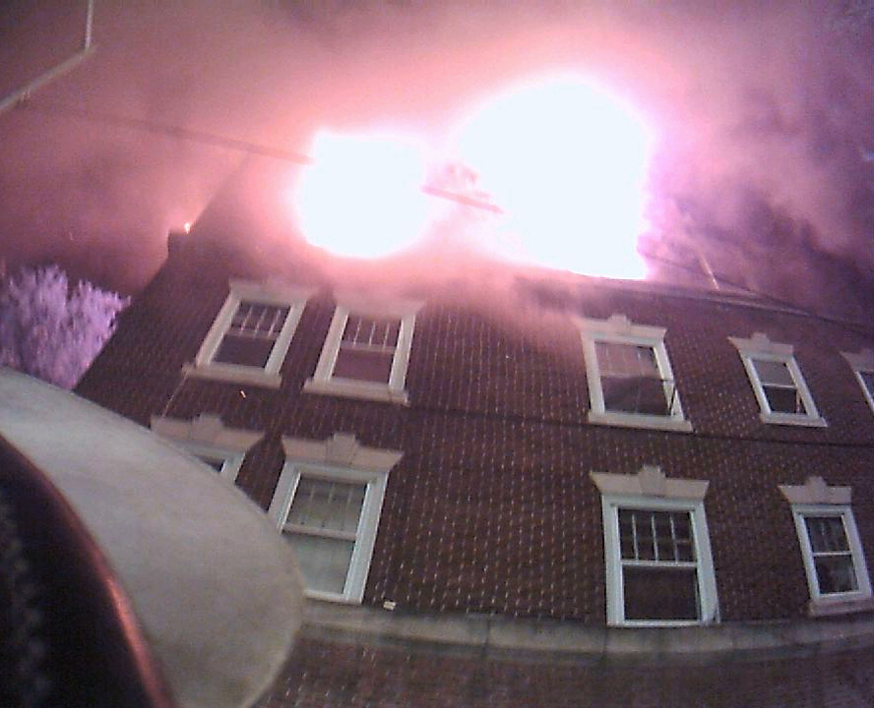
03:49 hrs: arrived on Rescue 1 with chauffer James Lerch at 156 N. 9th street. (4 story 20x100 EOR multiple dwelling of ordinary construction, consisting of apartments above vacant commercial.) Reports during response advised the building was occupied, with residents refusing to leave their apartments. A civilian burn victim that was on the sidewalk after Car-3 (Mogel)’s arrival at 03:47 was already being treated and removed by medics. Fire was showing from 4th floor corner windows on both the A and D sides. Few civilians were on the street or seen exiting the building. After finishing my size-up and having a briefing with C-3, entered the stairwell on the 9th street side along the B exposure wall with firefighter Brunner (T-1B) as a 2½ inch line was being stretched. Hallways and landings on floors 2 and 3 were clear of civilians and smoke. Arriving on the 4th floor, there was a lazy but medium smoke condition 1-2 feet off the ceiling, with smoke seeping from around the doorway & window moldings in the hallway. The fire apartment was quickly located adjacent to the stairs with the door closed and vibrating with heavy soot marks around it. C-3 transmitted the 2nd alarm at 03:53.
03:54 hrs: Firefighter Brunner and I are able to mask up in the hallway and I assigned Mike to search the remaining apartments on the 4th floor while I searched the fire and adjoining apartment and waited for the line that was being stretched. Opening the door to the apartment there was a heavy fire condition that was rolling across the ceiling and moving westward through the apartment. Unable to search due to heavy fire conditions, I closed the door and proceeded down the hall to the next door. The next door I opened was a 2nd unlocked entrance to the fire apartment; there was a heavy smoke condition down to the floor with moderate fire visible. I closed the door and proceeded to a 3rd door located at a 90-degree angle to door number 2. This door was an entrance to the adjoining apartment and was also unlocked. There was a medium smoke condition similar to that in the hallway and after a primary search of the apartment I closed the door and returned to the hallway where the 2½ inch line with a gated wye was now on the stairs just below the 4th floor landing and charged. The smoke condition in the hallway was now starting to bank down and I returned to the stairway to check on progress of the attack line and was informed that sections of 1¾ inch attack line were on there way to the fire floor. Fire was now visible under the crack of both doors to the fire apartment.
03:58 hrs: I call T-1B and advise him of a delay in getting water on the fire and for him to consider backing down to the 3rd floor. Another unit contacts T1-B, and Mike gives his location. Companies on the 4th landing advise me they are having problems getting the attack line connected to the wye. Conditions in the hallway are now becoming untenable with a heavy, sooty smoke condition (which obscured both SCBA face pieces as well as the thermal imager screen) banked down to the floor and heat rapidly rising. Fire is now visible in the eastern air shaft (adjacent to the stairwell) at the roof level. Hose crew is advised to back down to the 3rd floor to straighten the problem out with the attack line. After conferring with Car-3, Car-7 (Kemery) issues an evacuation order of personnel from the fire floor so that an exterior attack can proceed from the platform gun of T-1. Around 04:03 T-1B calls a mayday and gives his location and situation. Knowing where I assigned him, and that he hadn’t come back past me, I make my way back to the 4th floor and start westward down the hallway to search for Mike. Visibility in the hallway is now zero with extreme heat. Less than a minute later FF Brunner is located on the 4th floor west stairwell by firefighters Lerch (R1-D) and Leczynski (L3-T). Hearing this transmission I stop and return to the east stairwell and 3rd floor landing with the hose team and realize that I’ve been burned across the shoulders and neck. I radio T1-B to check in (goes unanswered). R1-D radios that they (L3-T) got T1-B and are exiting the building.

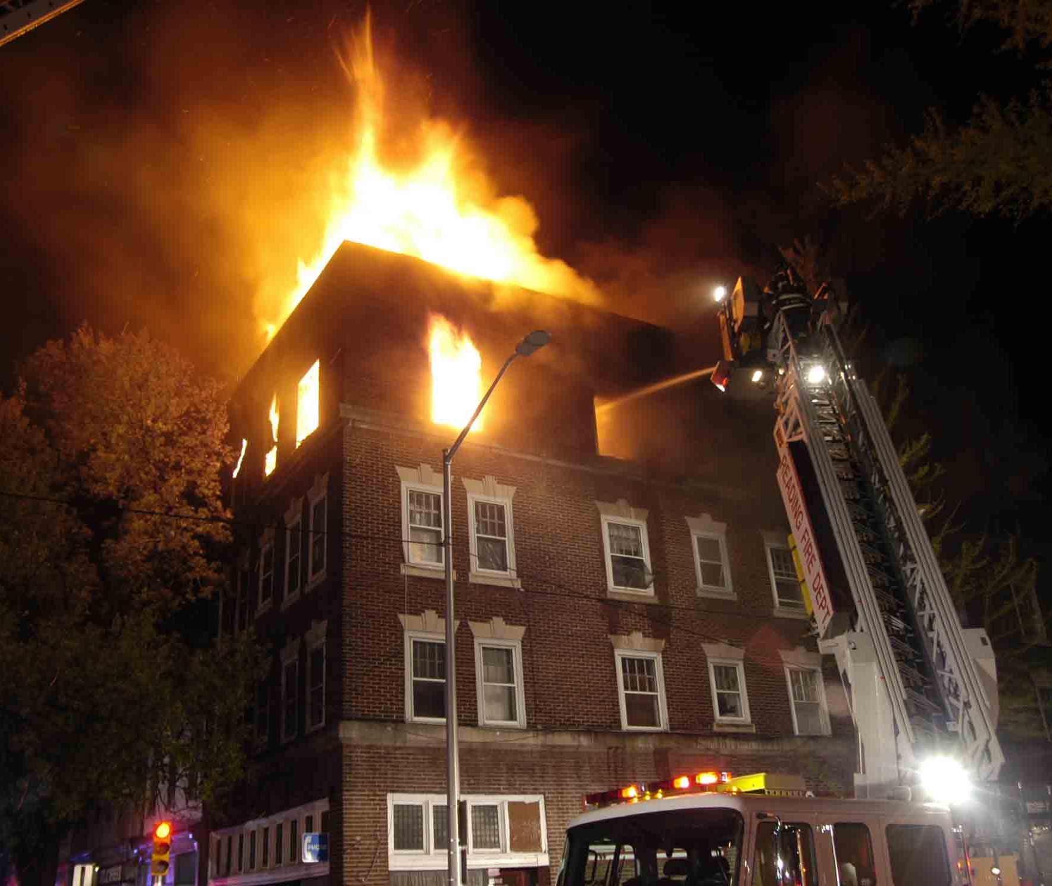
04:05 hrs: Fire is now through the roof on the A/D corner of the building and C-3 transmits a 3rd alarm and after visually confirming Brunner is accounted for and outside and all companies are off the fire floor has T-1 open their master stream and begin fire attack. While T-1 is attacking the fire, hose team now has 1¾ inch line hooked up and charged.

04:09 hrs: T-1’s master stream is shut down and the line is now advanced to the fire apartment. Conditions in the hallway have improved with the heat significantly abated and the smoke condition starting to lift but fire was still visible at the roof level through the eastern shaft. The attack line is positioned at the 1st doorway of the original fire apartment but is unable to advance due to roof collapse/burn through with exposed “I” beam at the A/D corner of the apartment. Line is redeployed to the 2nd doorway of the fire apartment and operates as other members begin pulling ceilings in the hallway. At this time I return to the adjacent apartment to check on the fires progress. There is still heavy smoke with some fire visible at the ceiling level moving westward. While in this apartment I witnessed 3 separate walls of the living room ignite, similar to a vapor ignition, encompassing the entire surface of the wall then self-extinguish in a few seconds with no increase in heat. Small fires were starting on the floor level from burning material that had fallen and the line was redeployed from the fire apartment to extinguish them.

04:15 hrs: Car-8 (Lessar) arrived on the fire floor and with my SCBA nearly expended, I briefed him on what the conditions were and what members were operating where. After being relieved, I exited the building and was transported to RHMC with 1st degree thermal burns to my shoulders and neck.
Lt. Rehr’s Thoughts
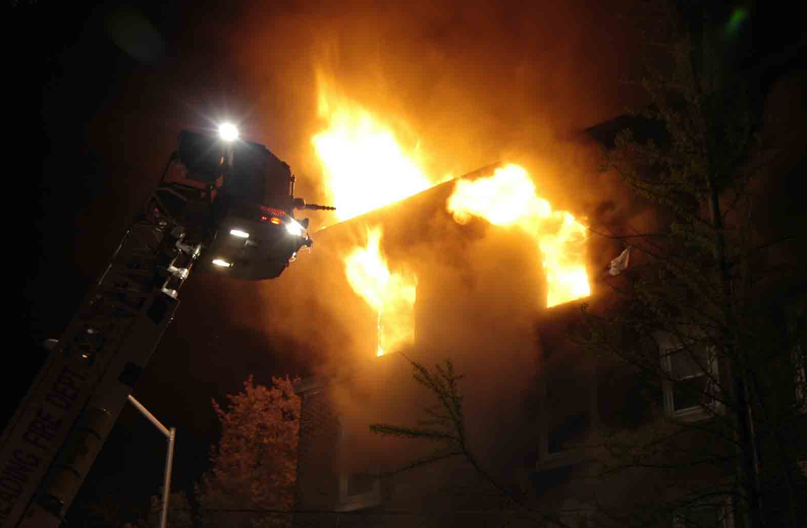
This was an “uncommon” fire (4th floor of an OMD) that started going bad due to delays that could have possibly been averted by adequate manpower. I do not condone sending a firefighter alone to search half of a large apartment building fire floor (the building was approximately 20x100). However, due to our current staffing levels and given Brunner’s experience, I was able to assign him such a task comfortably knowing he would get the job done. I would like to commend him for remaining calm and doing what he was taught essentially saving himself, and to all of the members who operated at this fire. Last, but not least I would like to commend the officers of the D platoon for keeping track of their people, monitoring the radio and communicating changing conditions in a fire that should have been “routine” (if there is such a thing!).
Account From Firefighter Michael Brunner – Tower 1
We responded to Box #428 at 03:45 hrs for a reported fire on the fourth floor. Tower 1 arrived on scene with E-1, R-1 and Car 3 to find fire showing from 3 windows - 1 on the 9th St side (A) and 2 on the Walnut St side (D) at the A/D Corner. The fire building was a 4-story occupied multiple dwelling of ordinary construction. I did a 180-degree survey of the building prior to entering. I saw that there was a door at the West end of the building on the D side. I also saw no smoke or occupants at any windows. There were only a few people outside the building, one of whom was burned. Lt. Rehr and I moved through the front door on the A side of the building and headed up to the fire floor. The alarms were sounding, but no residents were evacuating. All floors below were clear of smoke.
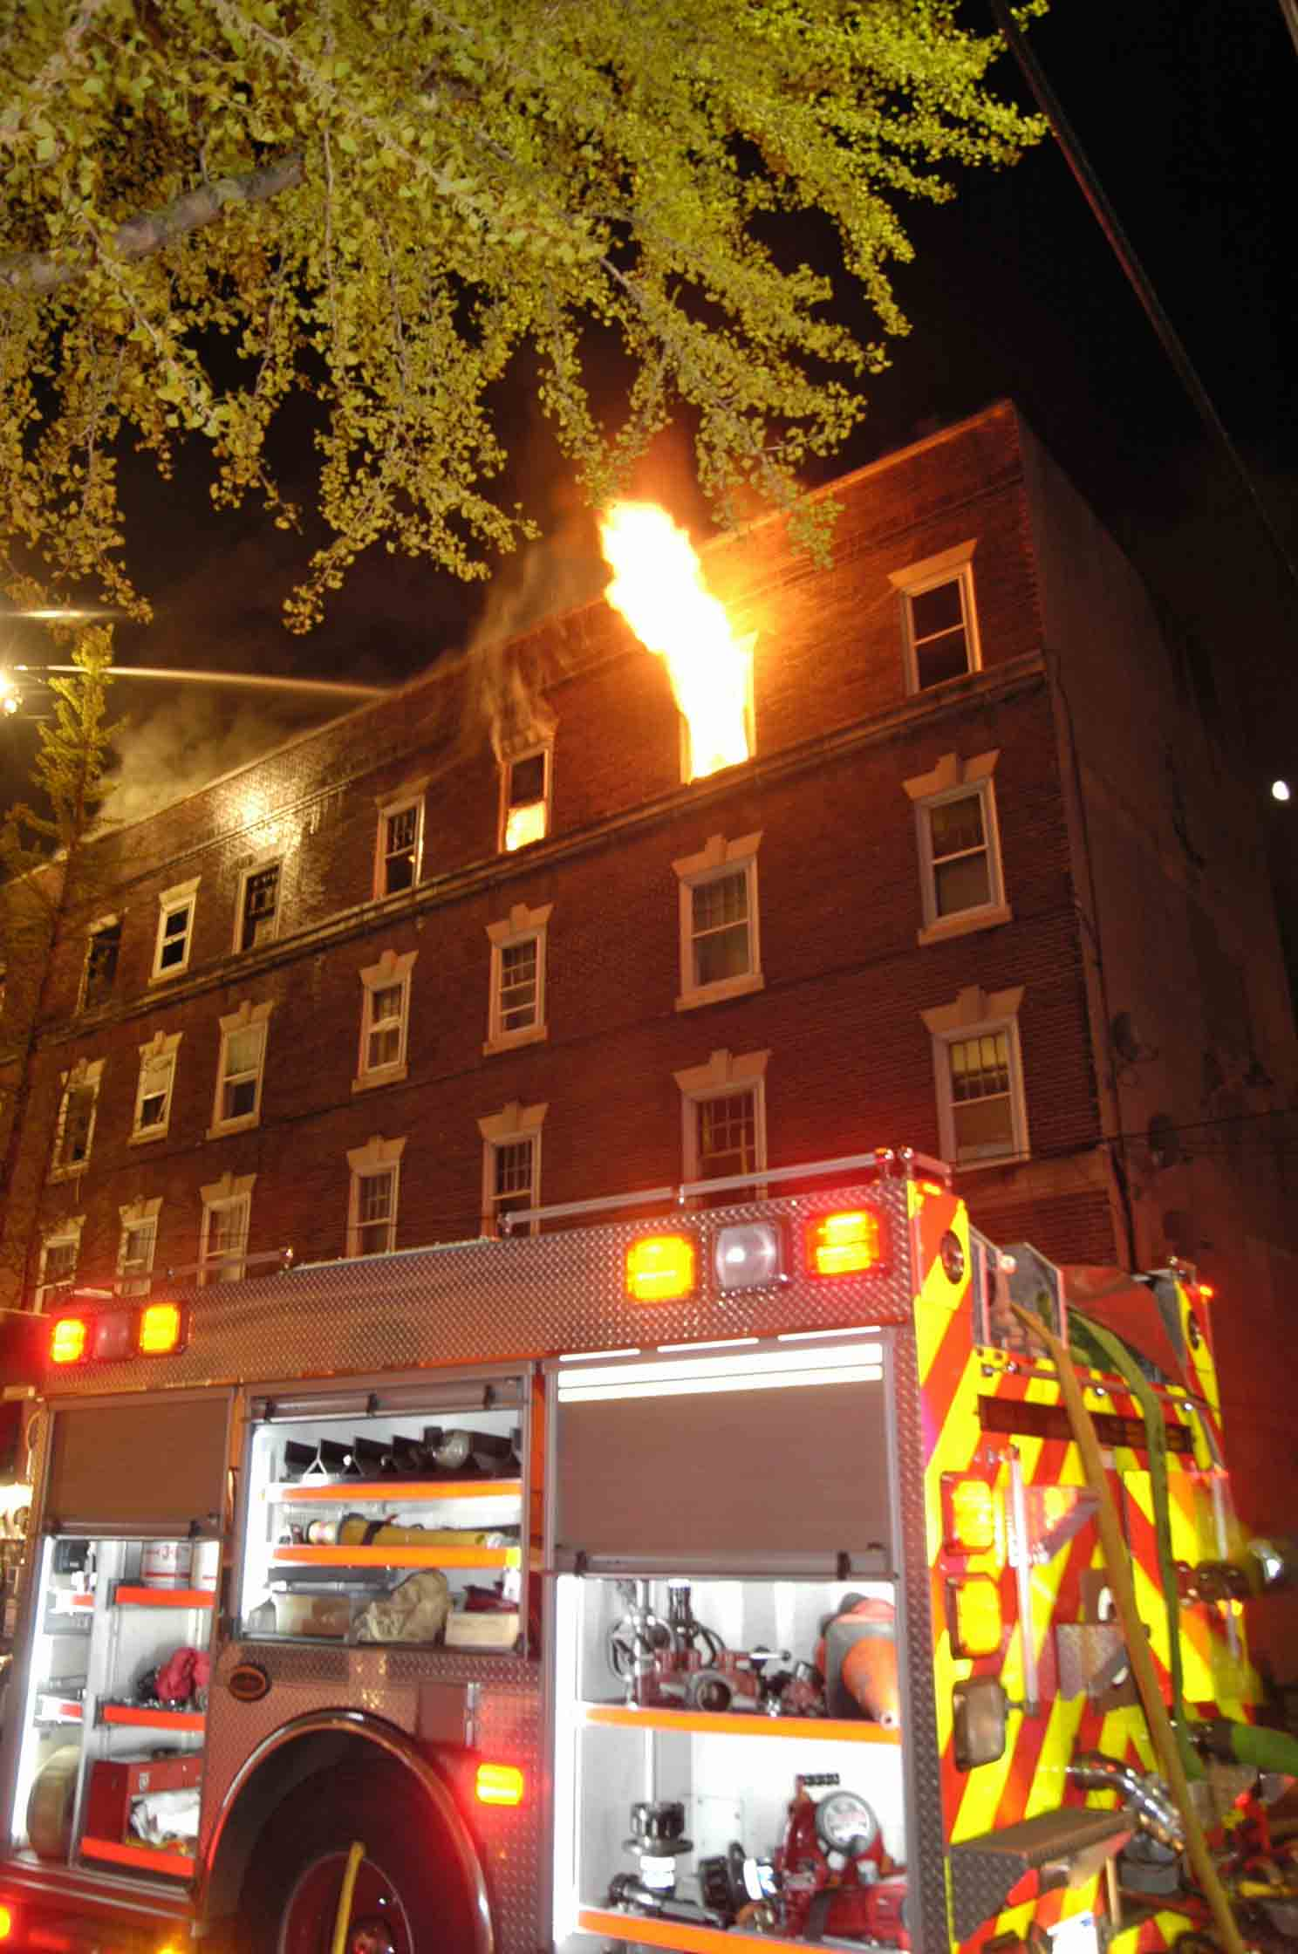
Upon arrival on the fire floor we had good visibility, with smoke a foot or so off the ceiling. The apartment door was closed and holding at this time. As we masked-up, Lt Rehr sent me to start a search of the fire floor. The hallway had numerous doors, all being along the right or D side. Conditions deteriorated quickly. The smoke banked down hard and fast. Halfway down the hall, I was forced to crawl from a standing position. Visibility was down to zero. I noticed as I crawled that the hall turned to the right with the corner rounded off. (I noted this bend) It was at this time that I found an apartment door. I opened the door and did a quick scan of the apartment with the TIC. Visibility at this time was still zero and I was barely able to make out the screen of the camera. I saw no victims, but was able to make out where a window was located. Heat wasn’t an issue at this time, but the smoke condition was so thick I could not clear my mask. I started a left hand search. I left my ax by the door to the apt and carried my halligan bar and TIC inside. I came to the only window in this room. I took the window, sash and all. I hung my head out of the window to get an idea of my location within the building, and again tried cleaning my mask off. I saw E-3 below and noted that I was at the last apt near the stairwell. I continued my left hand search and made my way into the next room. Visibility became so poor; I could no longer see the camera screen.

The whole time I was hearing radio reports of all the trouble the crews were having in getting water on the fire. I made the decision to start working my way out due to the water issues as well as the amount of air I had left. At this time, command was considering evacuating the floor and hitting the fire with a blitz attack. I began doing a right hand search to retrace my steps in an attempt to exit the apartment.
I believe I may have missed the apartment door and found myself in a small closet or alcove. The heat level was increasing then and I knew it was imperative that I find the door in order to escape the rapidly deteriorating conditions. I turned around to double-back while looking for the door. If I didn’t find the door this time, I was going to head back to the window and call a MAYDAY. I also started looking for an anchor point to set my escape rope to go out the window. The next thing I knew, I fell down the stairs of the rear stairwell headfirst. My mask was completely black, and I could see hints of light from the stairwell. I thought I felt a door right before I fell. Lt Rehr called me to check on my location and status. I advised him I was in the stairwell between the 3rd and 4th floors. Protecting the stairwell was my next concern so I went back up the stairs to try to locate this door that I felt and close it, but never found it. My ¼ service alarm bell wasn’t ringing yet, but I knew it had to be close. I became disoriented again in the hallway due to turns and alcoves. When I began to feel as though my neck was burning, I called a MAYDAY at 04:04.
I wanted to give myself enough time for the RIT Team to find me. Firefighters Lerch and Leszczynski were making evacuations on the 3rd floor, and knew exactly where the stairwell was. This knowledge enabled them to find me in less than a minute. In an attempt to get my attention, FF Lerch yelled for me while waving his flashlight, which I was unable to see. I had a box light on, but neither of us could see the light. I was able to hear his yelling, which helped me find my way to them. Immediately upon being found my ¼ service alarm bell began ringing. My mask was blackened so badly I had to rely on both Lerch and Leszczynski to physically guide me out of the building to safety. I was reported out of the building at 04:07.
Firefighter Brunners thoughts
As with any incident of this type, there were several mistakes that occurred. I will only touch on items that I myself was involved in. Due to our low staffing, I was detailed to search the fire floor alone. It seemed safe at the time, particularly with the smoke conditions we observed on the fire floor. I choose to break a window in a building without a hose line in operation. This is not something that should be done all the time, however I felt it was necessary due to conditions in the apartment. There was a double cockloft with an open hatch to the hallway right by the door of the apartment I was in. This opening allowed smoke & heat from the fire to funnel to my location. After falling down the steps, I should not have gone back up those stairs. I allowed my years of experience cloud my judgment in an attempt to re-enter the fire floor to look for and close a door. (of which I had no idea where it was) Looking back on the incident, this was the worst mistake that I made…and almost my last one.

