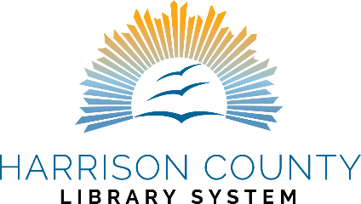

We’re so glad to have your family as patrons and to join you in starting your children on the path to reading and learning success. Kids who are who are read to and who receive active engagement from caregivers benefit from the key building blocks they need for their brain development. We have put together some useful tools to help you in creating an ideal learning environment for your child.
Library tools
Each library in the Harrison County Library System offers regular storytimes, Summer Reading programs, and other children’s programming. You can find calendars at your favorite branch and on our website www.harrison.lib.ms.us/calendar/ If you’d like the weekly events emailed to you, you can find a signup link for our email newsletter on our website as well.
Each branch has a large variety of children’s books and audio materials. Our Hoopla app offers digital books and audio for children that can be downloaded from anywhere. The free streaming service Kanopy provides extensive children’s materials, such as PBS programming, and you can access it with your library card as well. View our website for more details. Each branch also has a Children’s Librarian on staff to help you with any questions you have about selecting items for your child.
1,000 Books Before Kindergarten
Our Library System participates in the 1,000 Books Before Kindergarten program that encourages families to read together and to track their progress. Families completing the program receive a prize. See the brochure for links to registration and logs to track reading.
Additional Tools
There are many resources online to help inspire you. Here are a few places where you can find great information on your child’s development needs.
Vroom: https://www.vroom.org/ website and app with simple tips on nurturing learning
https://talkingisteaching.org/ website with more tips and information about early learning
Reading Bear https://www.readingbear.org/ a wonderful, free tool for learning phonics building blocks

Book Ideas

Ages Birth to Toddler
Keep in mind that just spending time with your child and reading is the most important part of reading together, so don’t worry about picking the “right” books. However, sometimes it’s hard to choose, so here are some short and fun books that you both will enjoy. Please don’t hesitate to ask our staff for help with suggestions. Hoopla also has a collection of suggested books for the 1,000 Books program.
Books by Sandra Boynton, such as The Going-to-Bed Book
The Llama Llama series by Anna Dewdney
Olivier Dunrea’s simple books, such as Gossie
Ten Little Fingers and Ten Little Toes by Mem Fox, illustrated by Helen Oxenbury
First One Hundred Words (also available in other languages)
Shades of People by Shelly Rotner and Sheila M. Kelly
Chicka Chicka Boom Boom by Bill Martin, Jr., and John Archambault, illustrated by Lois Ehlert
The Pout-Pout Fish by Deborah Diesen, illustrated by Dan Hanna

Preschool
Books by Eric Carle, such as The Very Hungry Caterpillar
Brown Bear, Brown Bear by Bill Martin, Jr., illustrated by Eric Carle
How Do Dinosaurs Series by Jane Yolen
And all the picture books you enjoyed together when your child was a baby!

Kindergarten
Books by Mo Willems
Pete the Cat Books by James Dean
Biscuit Books by Alyssa Satin Capucilli
Clifford Books by Norman Bridwell
Books by Ezra Jack Keats, such as The Snowy Day

