Math 105: Music & Mathematics
November 22, 2016
Test #3B

For each question, show your work and/or explain your answer as appropriate (unless the instructions for that question indicate otherwise). You will not receive full credit for an answer with insufficient supporting work or explanation, even if it is correct. Also, keep in mind that partial credit (for an incorrect answer) can be given only if your supporting work or explanation is shown.
If you need more space for work or explanation than is provided, please use the back of the page rather than a separate sheet of paper.

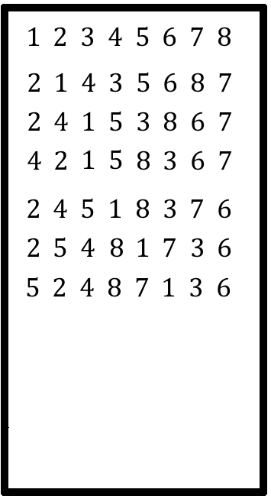
1. A change-ringing group produces changes of eight bells by repeating a sequence of three permutations. The first several changes that they generate using their system are shown to the right.

a) What are the three permutations that are being used to generate these changes? Write your answers using cycle notation.

b) Continue the list shown in the diagram by filling in the next three changes that will be obtained if the same pattern is continued.

c) What permutation would rearrange the list in the first row, 1 2 3 4 5 6 7 8, into the list in the fourth row, 4 2 1 5 8 3 6 7, all in one step? Write your answer using cycle notation.

d) If this same repeating pattern is continued long enough, how many different changes will be generated before repetition occurs? Explain your answer. (Note: do not try to answer this question by actually listing all of the changes; that would take way too long. Find another way to count them!)

2. For each of the following, all tones are to be selected from the set {C, D, D#, E, F, G, G#, A}. (There are eight notes in this set). Show your work; make it clear how you are getting your answers. Remember that a melody is an ordered selection of notes.

a) How many ways are there to write a four note melody if no repetition of notes is allowed?

b) How many ways are there to write a three note melody if there are no restrictions on repeating notes?

c) How many ways are there to write a four note melody if repetition is allowed, with the restriction that you can’t use the same note twice in a row? (For example, if the first note of the melody is an A, then the second note can be anything except an A.)

3. In the game of “blackjack,” a “hand” consists of two cards that are selected from a standard deck of 52 cards. The order of selection is not considered, and no card can be selected twice. (Reminder: in a standard deck, there are 13 cards of each suit, and 4 cards of each rank.)
a. How many different ways are there to select a blackjack hand from a standard deck?

b. How many different ways are there to select a blackjack hand in such a way that both cards are of the same rank? (Reminder: in a standard deck, there are 13 ranks, and 4 cards of each rank)

c. How many different ways are there to select a blackjack hand in such a way that both cards are of the same suit? (Reminder: in a standard deck, there are 4 suits, and 13 cards of each suit)

4. Find the number of different rearrangements of each of the following words:
a. SALISBURY

b. ARKANSAS

5. For this problem, all notes are to be selected from the set {F, G, G#, A, A#, B, C, C#, D#, E}. (There are ten notes in this set.) Show your work; make it clear how you are getting your answers. Remember that a chord is an unordered selection of notes.

a) How many ways are there to select a four note chord?

b) How many ways are there to select a four note chord that includes the F as one of its notes?

c) How many ways are there to select a four note chord that includes exactly two “sharp” notes (G#, A#, C#, or D#) and exactly two “natural” notes (F, G, A, B, C, or E).

6. For this problem, start by writing out the first ten rows of Pascal’s triangle in the space provided. (Remember that the first row consists of two 1’s.) Then, answer the questions that appear below.
a. Write out the first ten rows of Pascal’s triangle (the first two rows are provided for you):
1 1
1 2 1

b. Circle the number in the above triangle that corresponds to $C\left(8, 4\right).$ Briefly explain your choice.

c. What is the value of the 4th number in the 20th row of Pascal’s triangle? Briefly explain how you came up with your answer. (Note: please do not try to write out the first 20 rows of Pascal’s triangle! You don’t have time for that, and it shouldn’t be necessary.)

