Calculation of kinematics of lever zagruzhatelja ENG

General problem statement.
- To transmit force boot springs through the rocker arm zagruzhatelja lever ENG.
- Transfer function must be linear.
- The mechanism should not have stepped change efforts on ENG.
- When translating ENG through the Center efforts should increase smoothly and without mechanical knocking.
- ENG should have tactile tangible fixation point central position.

The last two items clearly contradict each other. So, in this issue we'll have to look for a compromise between accuracy and smoothness Centre fixing stragivanija ENG from central position.

Schematic design
To further build on something specific vozmom classic version in a dual-axis suspension RUS cardan. Since the calculation for zagruzhateli roll axis and pitch is different, for the construction of the kinematic scheme shall consider only ENG movement around one of the axes.
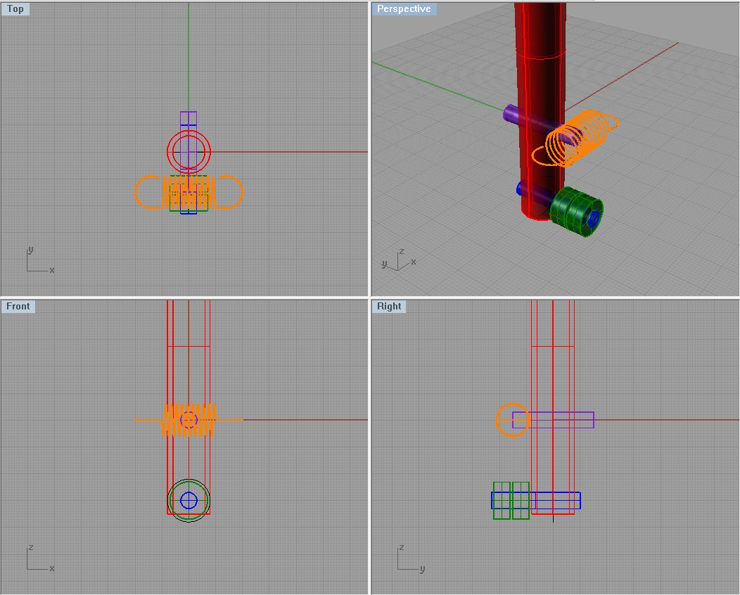
Now you need to create a kinematic diagram that corresponds to our project.
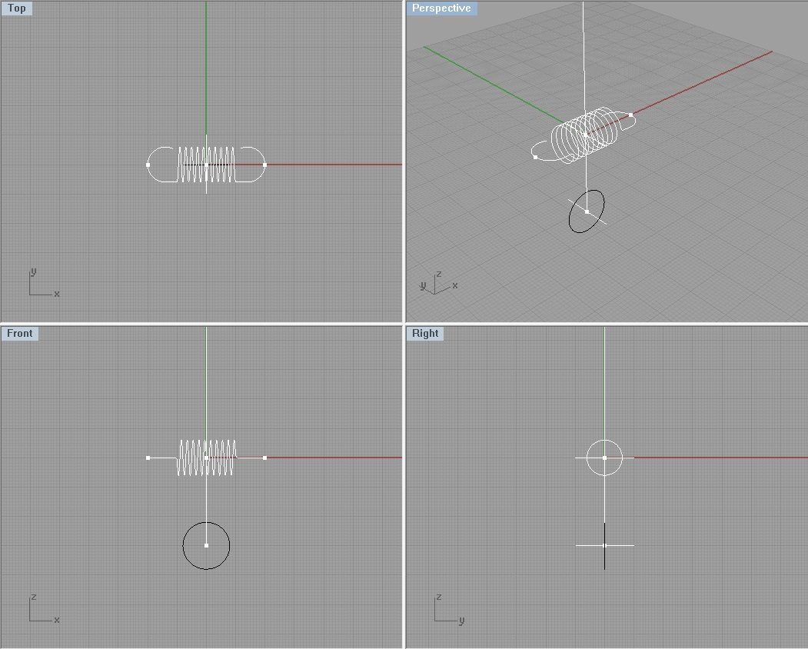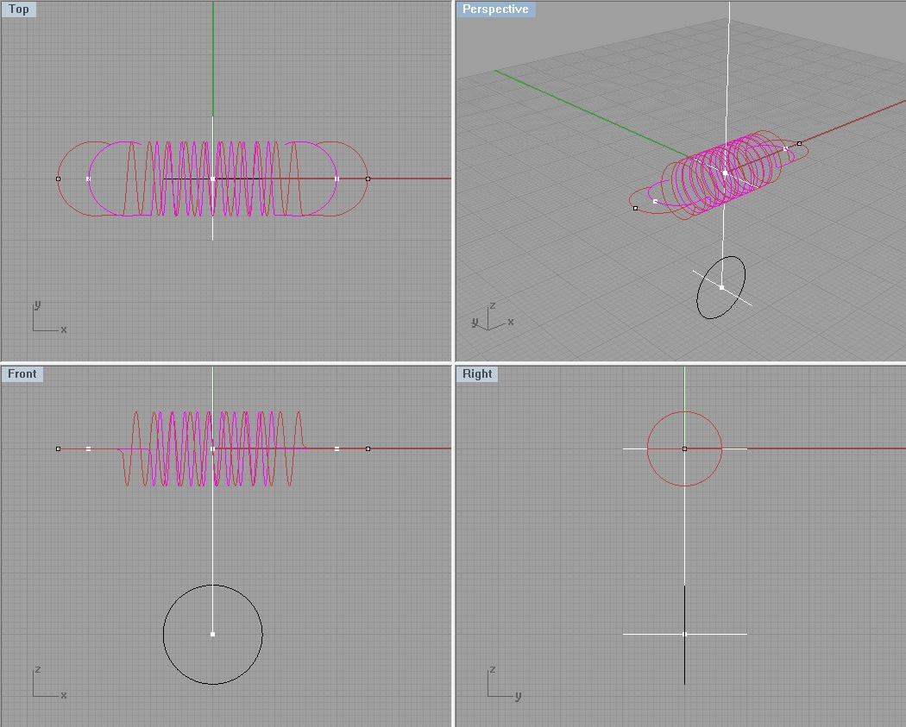
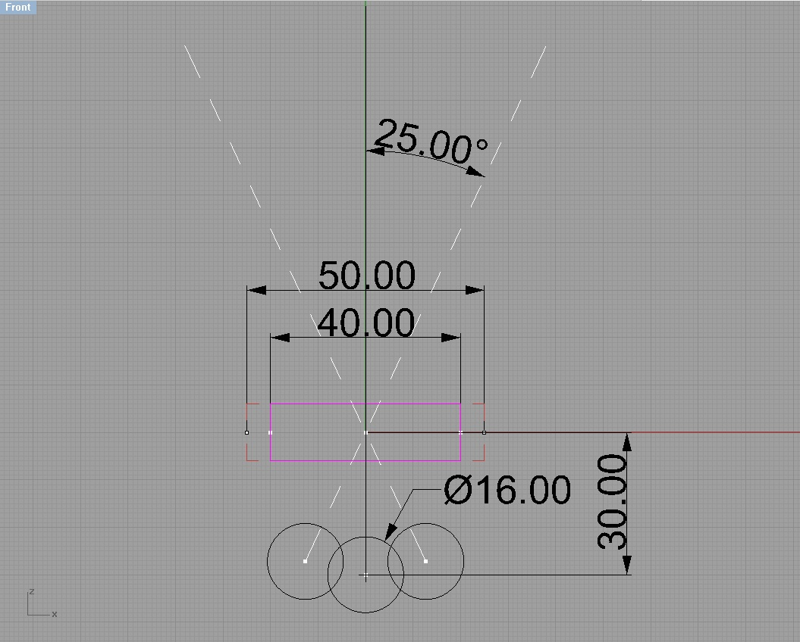
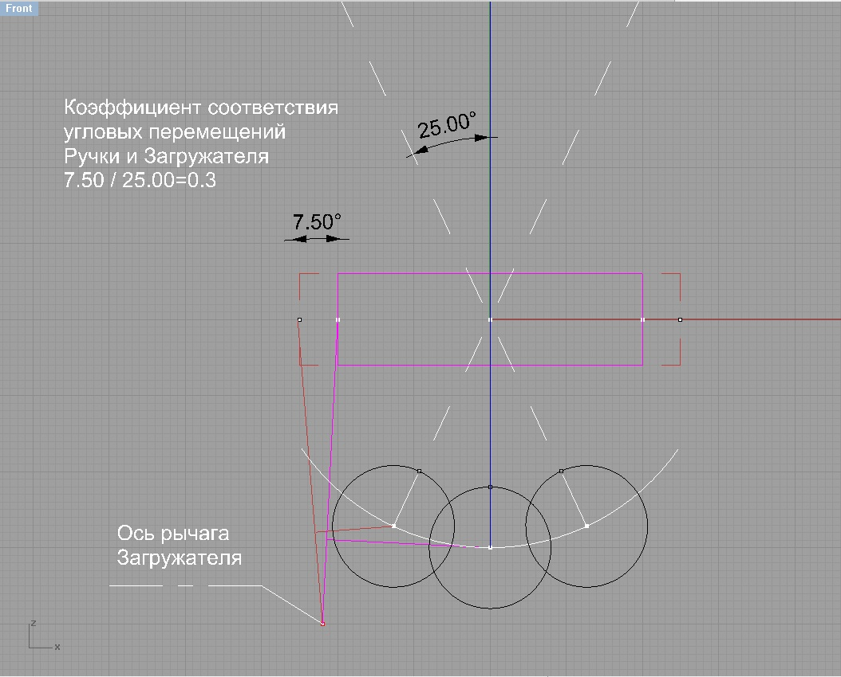
It seems that this is what you need.
At this stage, the most difficult thing was to choose the position of the swing arm axis zagruzhateli. In the practical design of this will depend on the particular design of the suspension and the space available. By trial layout has been verified that the method for calculating the node does not depend on the design and can be considered universal.
What do we want to achieve in reality?
To keep things simple and not to get bogged down in the wilds teormeh so to speak:
We want to turn the corner zagruzhateli was proportional to the angle of deflection RUS.
Will find the proportionality factor.
Half of the course we RUS is 25º, and move the lever zagruzhateli determined allowable tension spring - 7,5º.
7,5º \ 25º = 0,3º
That is, for every degree of deviation RUS lever zagruzhateli will turn to 0,3º.
Put that we neglect the change vynuzhenno zagruzhateli shoulder length rejecting RUS. Fortunately, the nature of the dependence of the transfer effort in the shoulder linear change as linear. Note, however, that while moving the lever forward ENG, RUS retraction force will continue to grow faster than the force of the spring tension. And when driving from the lever RUS - retraction force will lag behind. In other words, if you look at the diagram, push RUS counterclockwise will be harder than against.
What can help us to compensate for this effect?
The presence of the second lever zagruzhateli symmetrical about a vertical axis. For sufficiently accurate geometry, compensation will be incomplete.
But, since the mechanism is expected to be symmetric continue the search for a method of calculation of the lever.
strange word "involute" emerges from the depths of his memory.
Google in our hands ...

involute circle
Circle involute curve is called a planar - moving trace any point A circle with its deployment in one direction and a simultaneous straightening (fig.161).
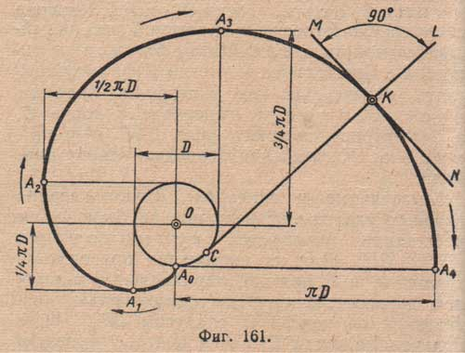
Step involute A0A4 equal circumferential length, that is. E. ΠD. CL line passing through any point K involute tangent to the deployed circumference, called the normal involute. Direct the MN, through the point perpendicular to the normal, tangent to the involute.
1. Education involute of a circle. On (fig.162) Shows a device whereby one can easily understand the formation of the involute of a circle.
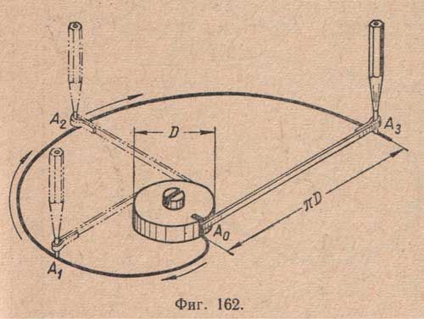
Around the fixed disk diameter D Screw one turn webbing end of which is fixed on the side edge of the disk and at the other end of the loop is made. If, pulling the braid inserted into the loop pencil its unwinding, the pencil will trace the curve - involute circumferential pitch which is equal to nD circumference of the disc. In any position at such a deployment tape it will concern-ing to the circumference of the disc.

Construction of involute of a circle.
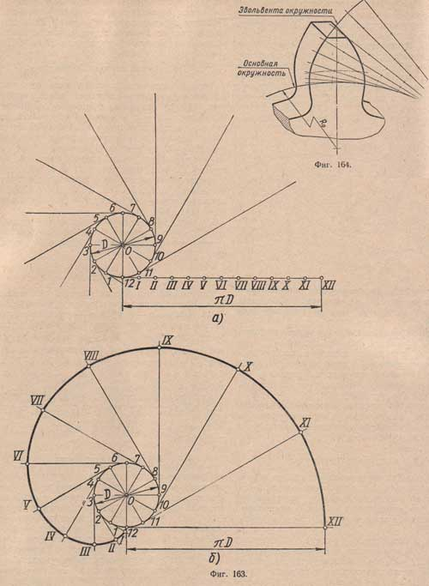
This deployable circle diameter D (fig.163 and) Is divided by an arbitrary number of equal parts (for sufficiently smooth curve is recommended to divide the circumference of not less than 12 parts). From each point of division is performed tangent directed in the same direction, for example in the opposite clockwise direction (or vice versa) .On the first lay tangent point of tangency 1/12 of nD, the second - 2/12; 3/12 at the third, and so on. g., therefore the twelfth tangent must defer 12/12 nD, r. f. nD. Having found on the curve of the tangent endpoints prepared involute circle (fig.163 b).
How did it all stick to our problem?

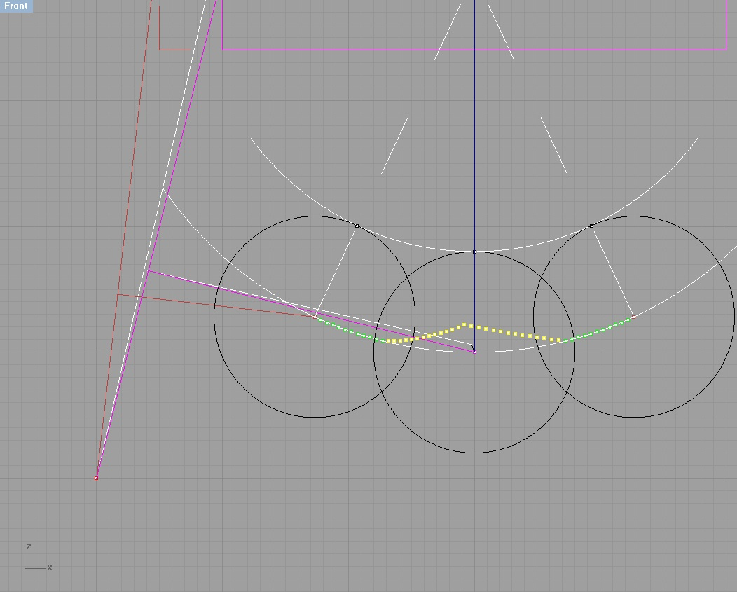

Divide the trajectory of displacement of the center axis of the bearing (pusher) EN 1º increments in both directions from the center. We obtain a family of points (50 pieces) lying on a single arc.
And that should do at this time the lever zagruzhateli?
He, too, turned to 0,3º per degree rotation RUS.
Then we take a neutral point of the axis of the pusher and turn it on 0,3º relatively zagruzhateli axis. Let's call it "Point 0".
Now select the point 0 and two adjacent points 1 and 1 '. Again we turn to 0,3º.
Adding to this group a couple of nearest neighbors 2 and 2 '... and so 25 times.
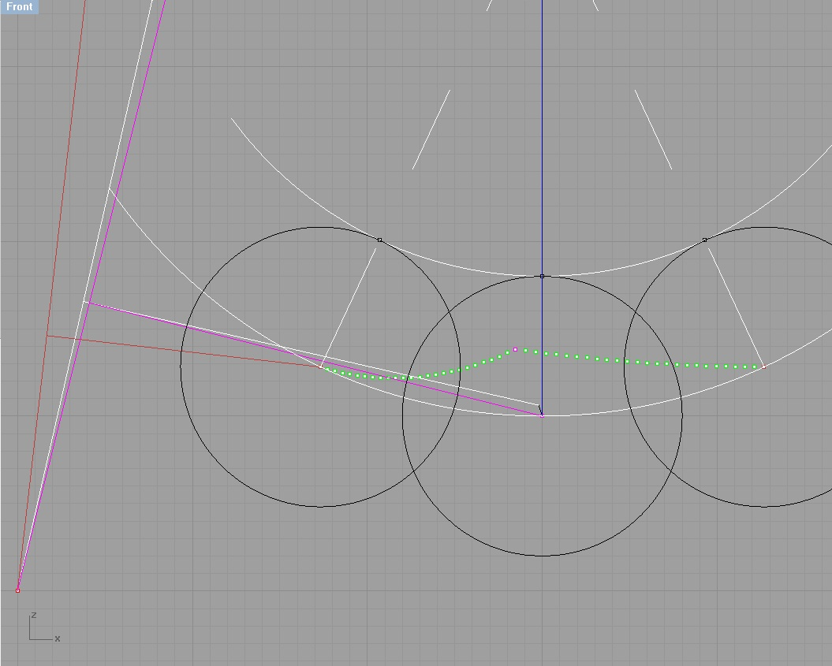
Here is zelonenka group, it turns out, is the desired involute.
And what is it? So far - niochem. But it begins to loom ghost solutions.
It turns out that we are looking for the surface shape of the lever obeganiya zagruzhateli.
Oh, damn, how skazanul, I was frightened. In short, this is the place by which to ride the roller tappet RUS.
First you need to restore our position in involute RUS neutral.
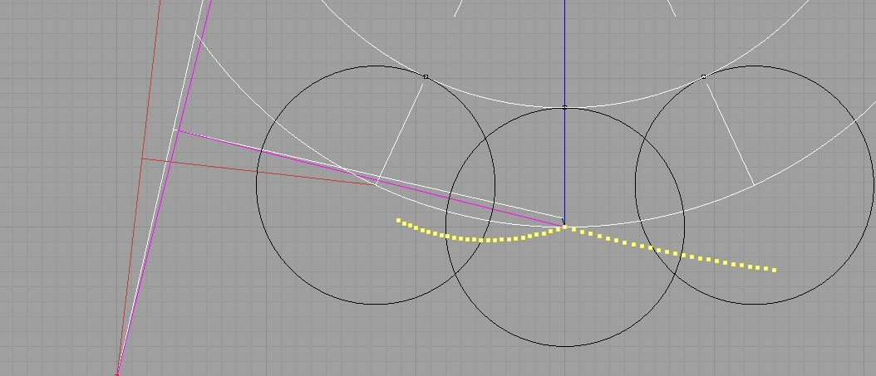
Now, this "friendly family" became yellow dots.
And here it is - the moment of truth.
The radius of the roller tappet draw 50 circles with centers at the points of the involute.
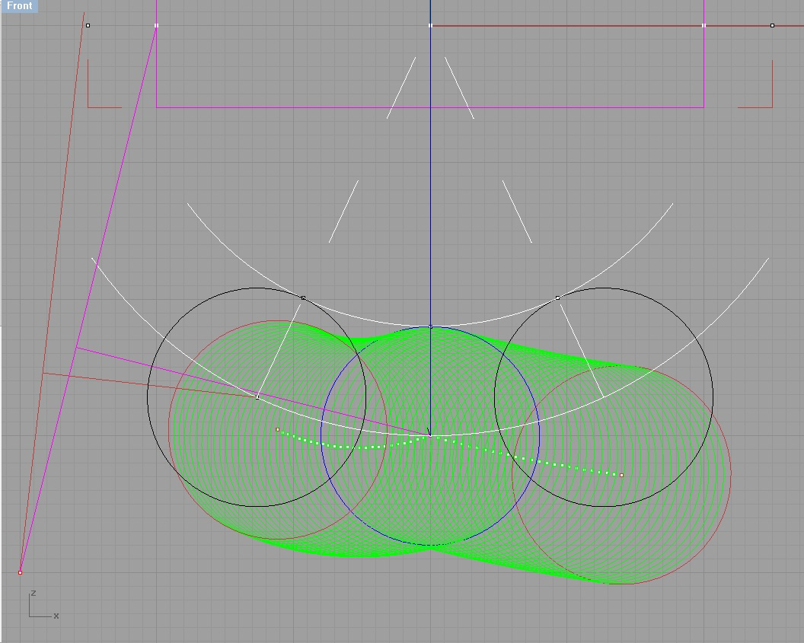
It remains to draw the envelope on the top of our circles and get a perfect surface profile obeganiya lever zagruzhateli. Excess - erase.
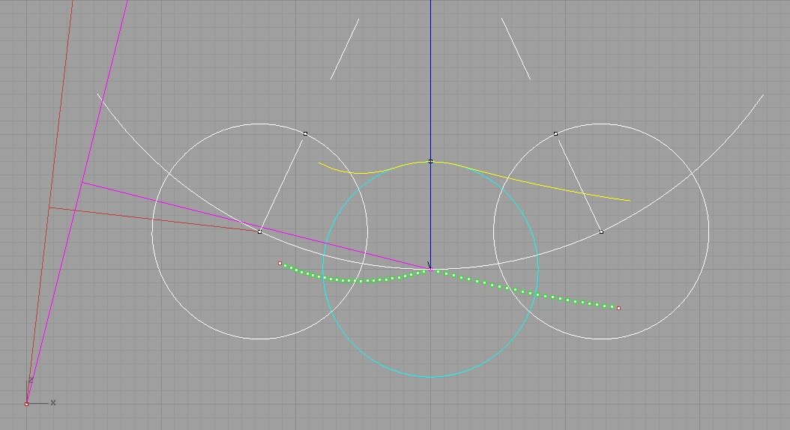

Let us now try to imagine all this as something material.
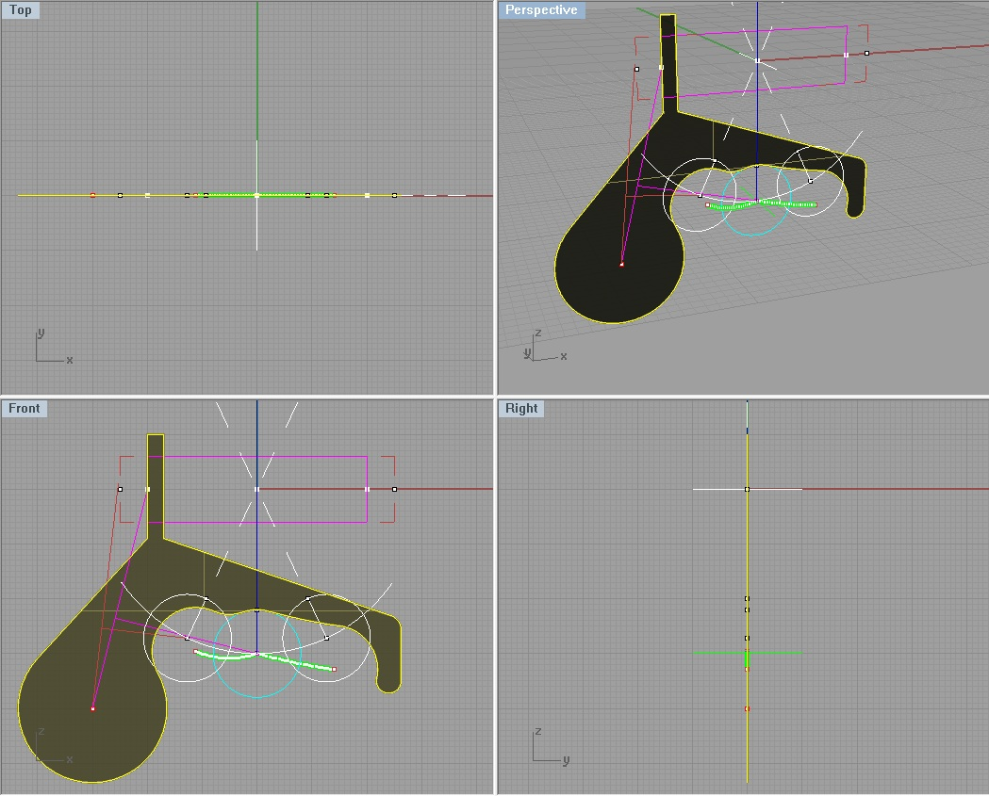

Why would simplify
Not without errors, but the logical point reached.
However, it is difficult to imagine a maniac toolmaker ready to similar methods to mark up the workpiece.
Let's try to simplify a little form to a condition suitable for the construction.
Peering - note that within our angular movements, the left branch of the envelope is very similar to an arc of a circle, and the right - and do tends to become straight.
Let's try to build it. If we can identify at least three characteristic points on the left branch zagruzhateli, we will be able to find the center and build them suitable circular arc radius.
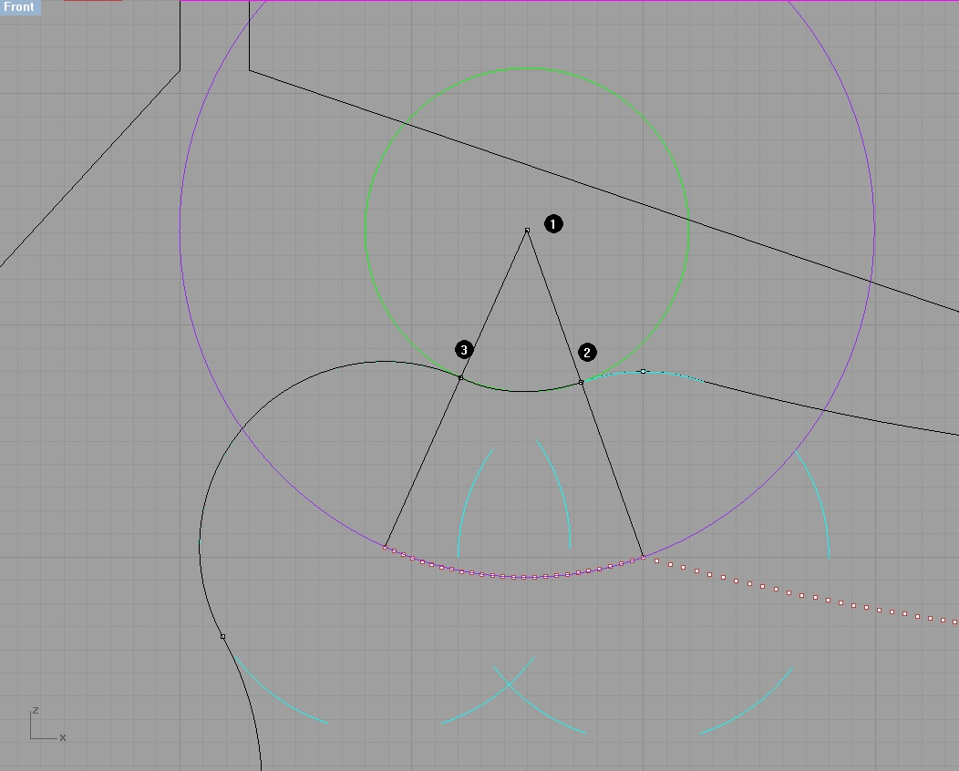

Hallelujah involute. We have a whole 50 points ...
The result was a purple circle.
It's not like daisies in dzhoytestere draw ... find ease separation point number 2 and number 3 at the intersection of the radii of purple with pale blue siluetikami denoting the clip pusher.
Now prikraivaem green circle, or rather build an arc between points 2 and 3.
The path is clear. We can repeat the process in the right branch of ...
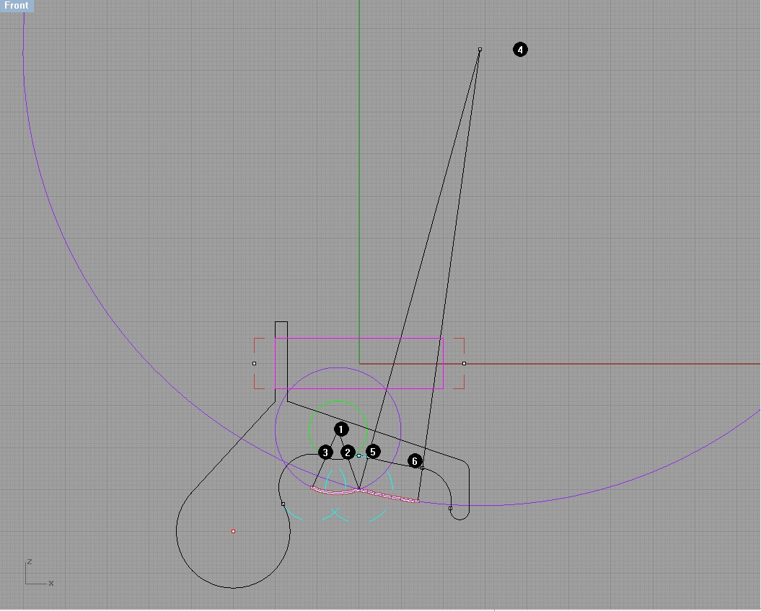

Ltd! That's radius. It is already drawing lofting a to.Da branch and so this is like a straight line.
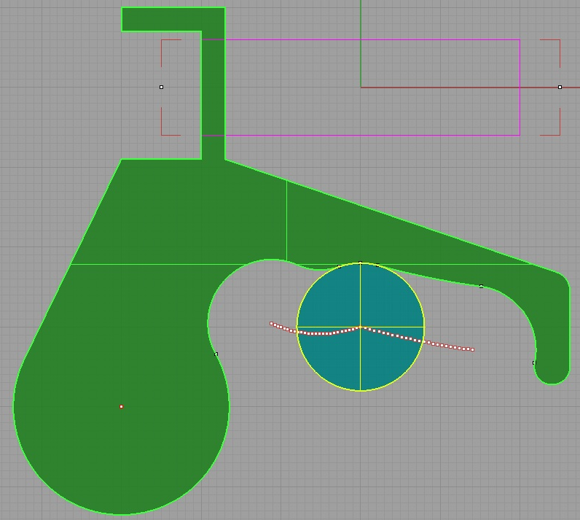
It's funny, but if you choose the gear ratio and leverage RUS zagruzhateli, this line becomes perfectly straight. Or, if you prefer, an arc of a circle of infinite radius. And this is our theme and food for thought.

slow motion
We painted, built, simplified ... and tears.
Itself originated the term "separation point." What is it for?
And this is the ideal center. And a loud knock.
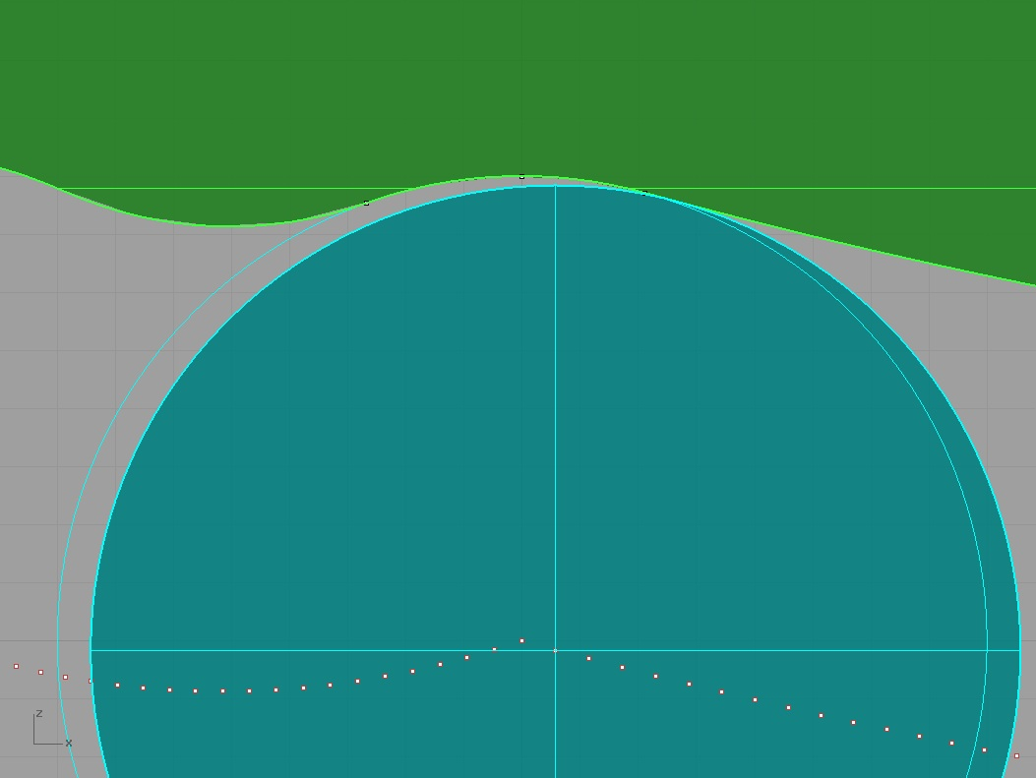

This is the place "under the microscope".
Golubenky pusher closer to neutral.
Stayed degree.
Yikes!
Rate the contact surface of the roller and zagruzhateli to neutral, and at the time of collapse. Well, how about a wall udarchiki out.
And if you come from the other side?
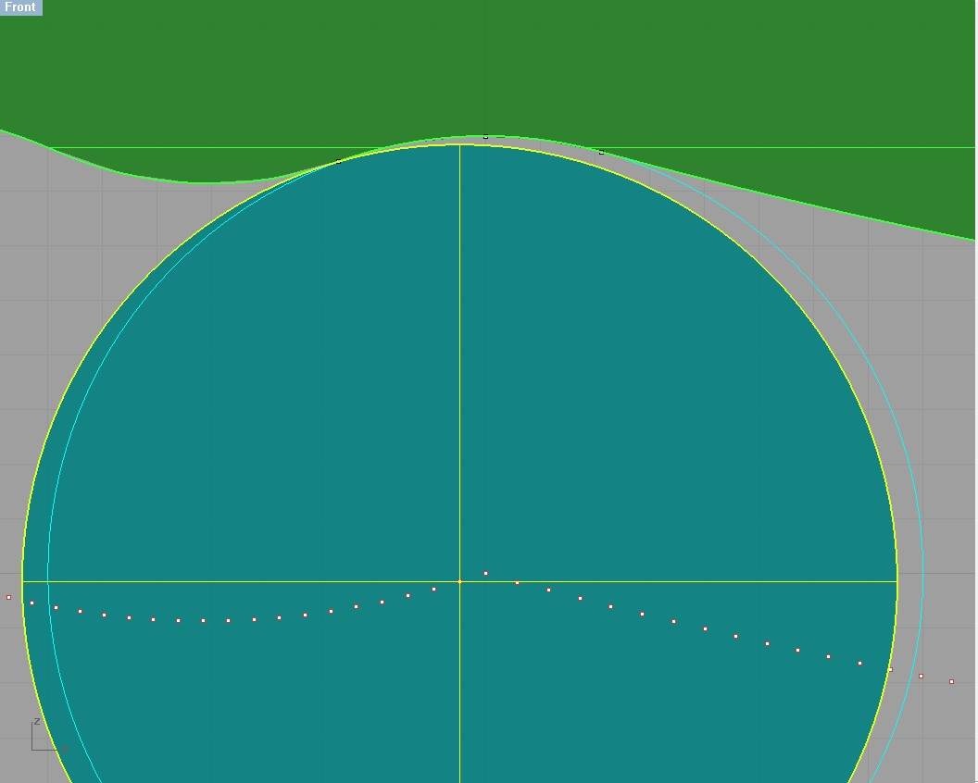

Softer as it is, but also to eat.
What we can?
Can we deliberately distort our ideal surface to contact area in a neutral diminished? Can.
To do this, increase the radius of the arc zagruzhateli in neutral.
Clicking, of course, disappear, but it will disappear and the exact center!
Obviously, the larger the radius of the arc, click the quieter and softer center.
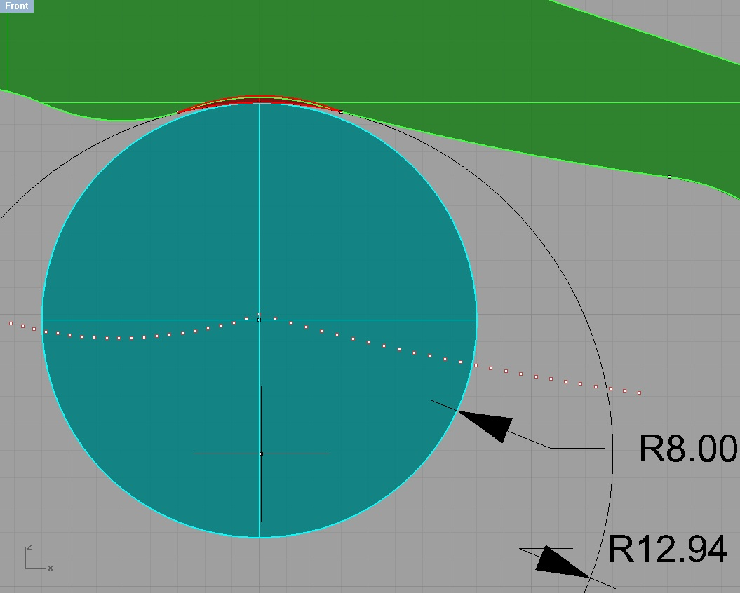

We see that in the contact zone between the blue and the red section of the drum surface anymore. But the central point of the involute shifted below. So, the center of efforts became less. "Pencil in a glass." And only when deviations EN more than 1 degree, a jump appears the center of efforts.
These things "no ice", but there are fans of such decisions. It seems to them so shoot easier.

even easier
Let us return to the remark that the plunger travel to zagruzhateli heavier than move away. To align the efforts still need a second zagruzhateli.
But then why bother to push the plunger into the lever?
What if you remove the load from the left branch zagruzhateli.
Come out something like this.
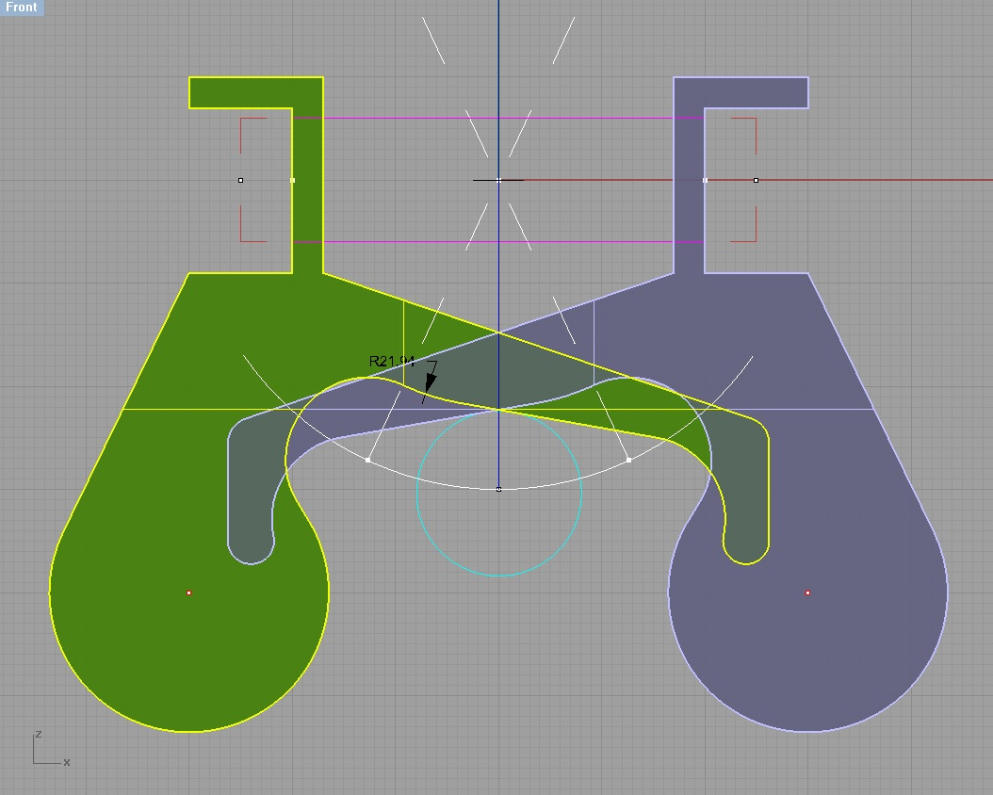

Funny, but we got a shock-free center, with a soft lock.
However, there was almost imperceptible uneven forces on the handle.
And who said that the actual aircraft, these efforts are too uniform?
Idealists do not agree with me and practice - check.
There will be questions - I will try to answer.
Milic.

