2020 23Mission Trip: Charleston, West Virginia
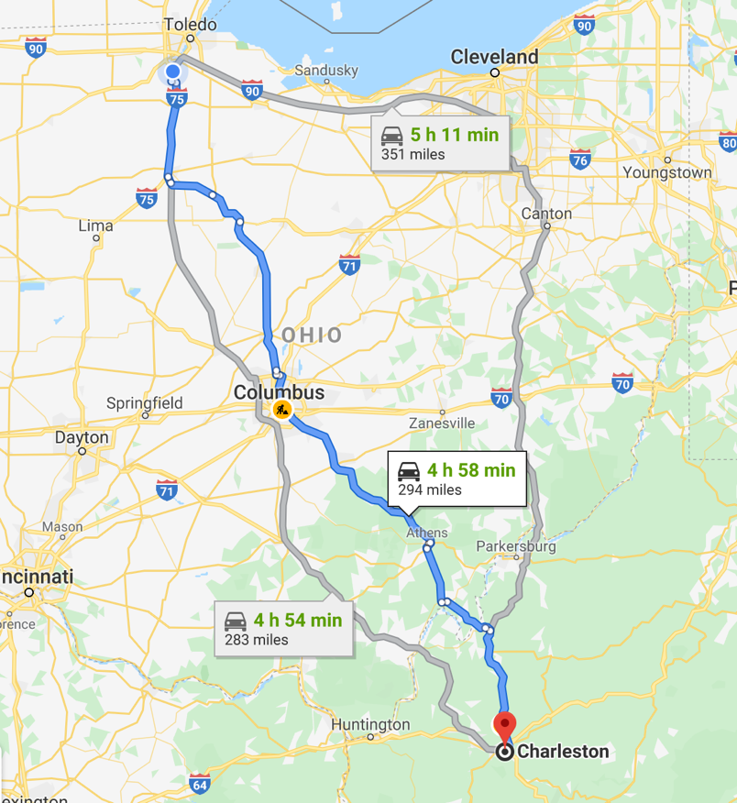
June 27 – July 3.

Location Address:
This is the current organization that we are working with:

WEST VIRGINIA CONFERENCE
PO Box 2313, Charleston, WV 25328
Phone: (304) 344-8331

- Money:
  - Cost of Trip: $350.
  - Payments:
    - Full Payment is due by May 4
    - After May 4, it is only refundable if we can replace the student.
  - Mission Partners:
    - Each student is expected to find 5 mission partners who will support our trip financially and through prayers.
      - The amount does not matter but ANYTHING you raise will be deducted from your registration IF it is turned in before May 4.
      - This is a very important part of our preparation. In regular missions, missionaries have to rely on the providence of the Lord and the support of their communities. It might seem uncomfortable for us to ask but we believe that it is a VITAL part of the process of being a missionary. When people give to us, in response, we bring our experience back to them.
        - When you receive a mission partner, you need to get their address because we will be writing to them on our trip and sending letters from North Carolina.
      - We will have sample letters you can write/email. Phone call scripts. Etc..
    - Fundraisers/Scholarship: For every hour of a fundraiser that you help with, you can get $10 off the trip: Fundraisers:
        - January 18: Trivia Night 1
        - February 16/23/March 1: BIG Board
        - March 21: Euchre Night
        - May 10: Mother's Day Bake Sale
        - June 6: Trivia Night 2
        - July 18: Euchre Night 2
- IF you have 5 mission partners and still need financial aid for the trip, we are able to help and will never turn people away. Simple speak to Paul about your student’s situation

  - Trip cost includes
    - Meals for duration of trip
    - Work supplies and tools
    - Transportation
    - T-shirts and programming throughout the trip
    - Free Day Activity: TBD

- Mission Meetings.
These are meetings in which we will get to know each other, build community, and learn about where we are going.
  - January 26: Parent Info Meeting @ 6:30
  - Monday, April 6 – Students & Team 7p, Location TBD
  - Monday, May 4 – Mission Partner Letter Writing
  - Monday, June 8 – Students & Team 7p, Location TBD
  - Sending Mass: Sunday, June 21 @ 5:30p

- Transportation:
  - Meet at 1pm at St. John 23 on Saturday, June 27
  - Arrive back midday at St. John 23 on Friday, July 3
  - Transportation:
    - Rental vehicles: 15 passenger vans and Pickup Trucks driven by St. John 23 Staff and Core Team

- Packing List
  - General Rules:
    - Wear clothes that are comfortable to move around in, good walking shoes, you could be on your feet for hours
    - As a faith community, we need to rise to the occasion and show off our fashion while being MODEST. Here is a great rule: cool T-shirts & Shorts
      - No tight leggings, tank tops, spaghetti straps, short shorts, shirts that show midriff, etc.
  - Specific List:
    - Clothes to work in Monday – Thursday (4 days)
    - Clothes to sleep in Saturday – Friday(6 nights)
    - Clothes for Travel (2 days)
    - Possible Swim Trip: Girl swim suits need to cover midriff, not show cleavage. We will have extra t-shirts if we think that you need it.
    - Shoes: Comfortable shoes that you can be on your feet for several hours, flip flops for swimming and showers
      - The place we are staying is heavily wooded so socks and shoes at all times are recommended
    - Hats/Sunglasses, Sunscreen
    - Water bottles(bring your own, write name on them)
    - Hygiene stuff: …deodorant is a MUST…. Boys.
      - Towels and shower supplies
      - Tooth-brushing equipment
    - Lay off the make-up ladies
    - Bedding for sleeping on. NO need to bring cots or air mattresses. We will have beds to sleep on.

  - What NOT to bring:
    - Bad attitudes
    - Electronics
    - Social Media Addictions

  - ELECTRONIC RULES
    - NO Electronics…pretty simply rule. Nothing allowed except cans and string.

