**Sponsor Trees**

**$5 per Tree**



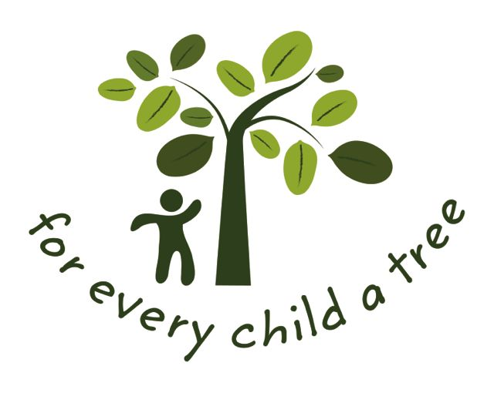

For Every Child A Tree Sponsorship Form

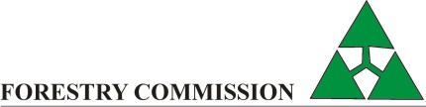

I/We                                              

Will sponsor:

                Number of Trees

**$**                Total Amount Sponsored

Name & Surname:                                     Type of Organisation (please tick)

Organisation:                                      Private individual

Position:                                      Local or National Government

Position:                                      Private Sector Company

Email:                                      Children & youth

Address:                                      School

Civil Society and NGOs

Town/ City:                                      Farmers

Country:                                      Community Groups

Telephone No:                                      Other (please specify)

                         

Payments to be made in cash, bank deposit or EFT:

Account Name: **Environment Africa** Ref: **For Every Child A Tree (and your name)**

Bank: **Barclays Bank** Branch No. **2157**

Account No: **1026538**

**Our Goodwill Ambassador is Wayne Black**

For further information, please contact **Environment Africa**

76 Queen Elizabeth Road, Greendale, Harare

[info@environmentafrica.org](mailto:info@environmentafrica.org). [www.environmentafrica.org](http://www.environmentafrica.org)

