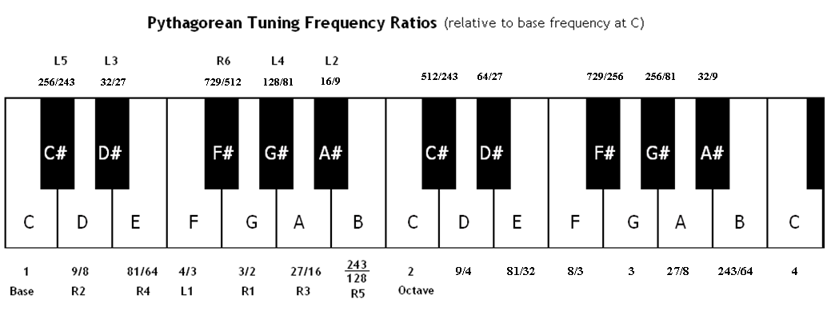

Note: We’ve added an extra octave to make it easier to compute frequency ratios for intervals whose higher and lower tones are above and below a “C”, respectively (e.g. the perfect fifth A-E).

Pythagorean tuning preserves every perfect fifth except the F#-C# perfect fifth – note that we are referring to the C# above F# in this case. More generally, the interval formed by the tones “L5” and “R6” is a “broken” fifth, since its frequency ratio is very close, but not equal, to 3/2.
For example, if we were to start from a base frequency of C: 500 Hz, we would obtain the approximate frequencies shown below:

F#: $\frac{729}{512}×440 Hz≈711.914 Hz$, and C#: $\frac{512}{243}×500 Hz≈1053.498 Hz$

The frequency ratio of this interval, then, is about $\frac{1053.498}{711.914}≈1.480$, which is noticeably less than the desired ratio of 1.5. This “broken” fifth, which always occurs for the L5-R6 interval under Pythagorean tuning, is often called the “wolf fifth” or “wolf interval.”

Note that the exact “wolf interval” frequency ratio can be found without selecting a specific base frequency at all:
$$\frac{512}{243}÷\frac{729}{512}=\frac{512}{243}×\frac{512}{729}=\frac{262144}{177147}, or\frac{2^{18}}{3^{11}}, which is approximately 1.480$$

