Math 105: Music & Mathematics
September 26, 2016
Test #1A

For each question, show your work and/or explain your answer. Always write something to justify your answer, unless specifically instructed otherwise; you will not receive full credit for an answer with no supporting work or explanation, even if it is correct. Also, keep in mind that partial credit (for an incorrect answer) can be given only if your supporting work or explanation is shown.

If you need more space for your work on a problem, please use the back of the page on which the problem appears rather than a separate sheet of paper.

1. Consider a just intonation tuning system with base note D:280 Hz.

a) Find the correct frequency for the next higher G (between 280 Hz and 560 Hz):

b) What note is a major sixth above D: 280? Give the note’s name (A, B, C, etc.) and its frequency in Hz.

c) Find the name (A, B, C, etc.) of the note that would be tuned to a frequency of 1400 Hz.
(Hint: remember that notes an octave apart from each other have the same name.)

2. a) Find the frequency ratio of an interval whose width is 840 cents. Write your answer as a decimal rounded to the nearest thousandth (three decimal places).

b) Find the width, in cents, of an interval whose frequency ratio is 1.6. Round your answer to the nearest whole number of cents.

3. Correctly name (A, A#, B, C, etc.) each of the notes on the section of a piano keyboard shown below. Start from the leftmost white key, and label all the keys (both black and white) from left to right until you reach the rightmost white key. No work or justification is necessary for this problem; just write the answers.

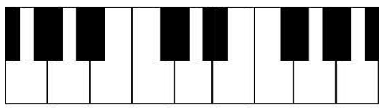

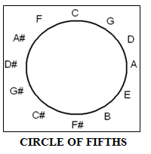
4. Consider a Pythagorean tuning system with base note C:360 Hz.

a) Using the notation from class, what note would be “R3” in this tuning system? Give the name of the note (A, B, C, etc.), and find its frequency in Hz (a number between 360 and 720).

b) Find the frequency of the note A# in this tuning system. (Your answer should be between 360 Hz and 720 Hz.)

5. Suppose a keyboard is tuned according to 12-tone equal temperament, with an A tuned to a frequency of 432 Hz.
- What is the frequency of the E above A:432 (that is, the E between A:432 and A:864)? (Round your answer to the nearest hundredth.)

- What is the frequency of the E below A:432 (that is, the E between A:216 and A:432)? (Round your answer to the nearest hundredth.)

6. Use the method of “continued fractions” to find a rational approximation for the irrational number $2^{2.25}$. (Note: that’s 2 raised to the 2.25 power; you should get approximately 4.7568 on your calculator for this.)

Use a list of four whole numbers to find your answer. When you’re done, check your result to make sure your fraction is a good approximation for $2^{2.25}$.

7. In the space beneath each of the following statements, circle the name(s) of each of the tuning system(s) we studied – Pythagorean, just intonation, and/or equal temperament – for which that statement is true. Note that some of the statements are true for more than one tuning system. (No work of justification is necessary for these; just circle the correct answer(s) for each.)

a) Pianos are usually tuned according to this tuning system.

Pythagorean tuning just intonation equal temperament

b) All semitones have the same frequency ratio.
Pythagorean tuning just intonation equal temperament

c) The interval consisting of the base note and the note seven semitones above the base note has a frequency ratio of exactly 3/2.

Pythagorean tuning just intonation equal temperament

d) Frequencies of notes are determined by repeatedly raising or lowering the base note’s frequency by perfect fifths, adjusting for octaves as necessary.

Pythagorean tuning just intonation equal temperament

e) Whenever possible, major thirds are given a frequency ratio of exactly 5/4.

Pythagorean tuning just intonation equal temperament

f) Twelve-tone intervals, or octaves, all have the frequency ratio 2/1.

Pythagorean tuning just intonation equal temperament

