Math 105 – Music & Mathematics
Collected Homework Assignment #2 – Just Intonation; Semitones
Due Date: Wednesday, September 14

Please show all necessary work, and write your answers on a separate sheet of paper. As stated in the class policies, I will not grade your assignment if it is not reasonably neat, legible and organized.

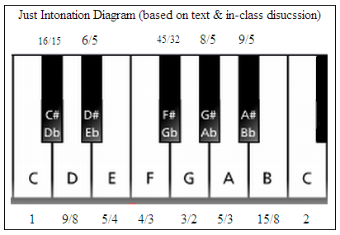
1. Using the version of just intonation based on p. 27 of the text (with the frequency ratios for the “black keys” from the “Intro to Just Intonation” handout, also shown below):
If C is tuned to 720 Hz, assign a frequency to each of the tones of the 12-tone scale, using C = 720 Hz (base frequency) and C’ = 1440 Hz (octave). For each, find an exact answer (as a fraction or mixed number), and a decimal answer, rounded (where necessary) to the nearest hundredth.

Hints (to get you started):
C: 720 Hz
$C\#:\frac{16}{15}×\frac{720}{1} Hz=768 Hz$

$D: \frac{9}{8}×720 Hz=810 Hz$

$D\#:\frac{6}{5}×720 Hz=864 Hz$ , etc…

2. A “semitone” is a name for the interval formed by two consecutive keys on a keyboard – e.g., C–C#, C#–D, D-D#, etc. Find the frequency ratio of each semitone of the 12-tone scale based on the frequencies you worked out for problem #1. You should get twelve answers, one for each semitone, and they should all be pretty close together (within a few hundredths of each other). You may use a calculator for this part; please round each answer to the nearest thousandth (three decimal places). (Note that you don’t aren’t being asked for fractional values for these, just decimals!) Then, write a sentence or two to describe your observations about these results (e.g., are they consistent? If not, how much do they vary? Do you see any sort of pattern?)

Examples (to get you started):
C-C# frequency ratio: $768÷720≈1.067$
C#-D frequency ratio: $810÷768≈1.055$
D-D# frequency ratio: $864÷810≈1.067$
Etc…

3. Find the frequency ratio of each “major third” (4 semitone interval) in the 12-tone scale based on your answers for problem #1. That is, find the frequency ratio of each of the following intervals: C-E, C#-F, D-F#, D#-G, E-G#, F-A, F#-A#, G-B, and G#-C.

You may use a calculator for this; please round each answer to the nearest thousandth (three decimal places). Then, write a sentence or two to describe your observations about these results (e.g., are they consistent? If not, how much do they vary? Do you see any sort of pattern?).

