Math 105 – Music & Mathematics -Tuning Systems – Supplemental Practice Exercises

Throughout these exercises, “just intonation” refers to the version of just intonation developed in class (see the diagram in homework assignment #2).

1. Without looking at the textbook, your notes, or any other reference, correctly identify each of the keys on the keyboard below.

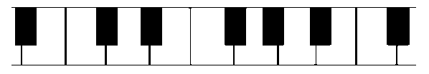

2. Suppose we set out to devise a just intonation system based on “A” rather than “C”. That is, the base frequency will be identified with one of the “A” tones on a keyboard, and other tones’ frequencies will be found accordingly. Under this system, what should be the frequency, in Hz, of each of the following tones? (Where necessary, round answers to the nearest hundredth.)

Note: “A:220” represents an “A” which is tuned to the base frequency of 220 Hz.

- The E above A:220
(Sample solution: Since the E is seven semitones above A:220, the A-E interval should be a perfect fifth under just intonation, with a frequency ratio of 3/2. Therefore, the frequency of the E above A:220 should be $220×\frac{3}{2}=330 Hz.$
- The D above A:220
- The F above A:220
- The F below A:220
- The G above A:220
- The A three octaves below A:220.

3. Find the frequency of each of the tones from #2 if we use Pythagorean tuning, rather than just intonation, to devise a tuning system based on A:220. (This means the frequency of each tone is found by raising or lowering by perfect fifths starting from A:220.) Hint: you may wish to use the “Circle of Fifths” diagram, which is attached at the end of this document, to help you figure out how many times to raise/lower by fifths.

4. Suppose we tune a C to a base frequency of 648 Hz. Consider the 12-tone scale from C:648 up to the C one octave higher (C:1296). Tune the 12-tone scale in each of the following ways. When necessary, round answers to the nearest hundredth of a Hertz.

- Find the correct frequency for each tone in the scale using Pythagorean tuning.
- Find the correct frequency for each tone in the scale using Just Intonation.
- Find the correct frequency for each tone in the scale using equal temperament.

5. For the following, use just intonation frequency ratios. (See the diagram in #12 below if you need help remembering some of these.)
Suppose, from a starting pitch of 360 Hz, the pitch is raised by an octave, then lowered by a perfect fifth, then lowered by a major sixth, then raised by a perfect fourth, then lowered by an octave, and finally raised by a minor third.

- At what frequency do we end up? What are the other frequencies we hit on the way there?
- What is the frequency ratio of the interval between the ending pitch and the starting pitch (360 Hz)?
- How could we have found the answer to part (b) more quickly (without necessarily finding all of the answers to (a))?

6. Redo #5 (all parts), but use equal temperament rather than just intonation frequency ratios.

7. Convert each of the following frequency ratios into “cents.” Round each answer to the nearest whole number.

a) 7/6 b) 12/7 c) 11/6 d) 7/5 e) 14/5 f) 3/1

8. Convert each of the following to frequency ratios; round your answers to the nearest hundredth.

a) 351 cents b) 580 cents c) 885 cents d) 949 cents e) 1404 cents f) 1586 cents

(8.5. –optional- for each answer to #8, find a simple fraction whose value is equal, or at least very close, to that decimal)
Find answers to #9 and #10 without the use of a calculator. (If you have difficulty with these, read the “Exponents and Logarithms Review” handout.)

9. Simplify each of the following, using properties of exponents. You should be able to write each answer as a whole number.

a) $3^{7}×3^{-5}$ b) ${\left(5^{1/4}\right)}^{8}$ c) $9^{3/2}$ d) $8^{2/3}$ e) $\frac{\left({12}^{20}×{12}^{30}\right)}{{12}^{49}}$

10. Simplify each of the following, using properties of logarithms. You should be able to write each answer as a whole number or a fraction.

a) $\log_{10}{(100)}$ b) $\log_{2}{(32)}$ c) $\log_{4}{(32)}$ d) $\log_{3}\left(9^{1000}\right)$
(Hint: for part (c), rewrite 32 as $2^{5}$. If you can figure out $\log_{4}{(2)},$ then $\log_{4}{(32)}$ follows…)

11. Consider the following diagram that represents our version of just intonation based on “C”:
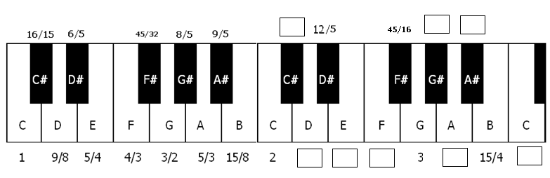
a) Fill in the missing frequency ratios for the next higher octave of notes. In each case, write your answer as a fraction reduced to lowest terms.

b) Find a few examples of “broken” perfect fifths – that is, notes that are seven semitones apart but which do not have an exact 3/2 frequency ratio. How many can you find?
(For example: The interval D-A is a seven semitone interval, but the ratio of their frequencies is
$$\frac{5}{3}÷\frac{9}{8}=\frac{5}{3}×\frac{8}{9}=\frac{40}{27}≈1.48,$$
which is not equal to 3/2. Therefore, the perfect fifth D-A is “broken” under this intonation.)

c) Find a few examples of “broken” major thirds. (Hint: this is related to question #3 in the second collected homework assignment.) How many can you find?

For the next problem, recall that “12-TET” is an abbreviation for “12-Tone Equal Temperament.” This is a generalization of that idea.

12. Suppose a musician decides to construct a keyboard that divides the octave into 17 tones, rather than the usual 12, using equal temperament. (In other words, consider “17-TET.”)
Note – just for the purposes of this practice problem, we’ll temporarily refer to the interval between two consecutive tones of the 17-tone scale as a “semitone.”

a) What would be the frequency interval of each “semitone” (rather than the usual , or )?

b) Find the frequency of each tone in an octave (as a multiple of the base frequency). Give an exact answer for each, as well as a decimal rounded to the nearest thousandth (three places).

Comment (before working on (c) and (d) below): Recall that under 12-TET, an interval of seven semitones is a close approximation of a perfect fifth, since its frequency ratio, $2^{7/{12}}≈1.498$, is very close to 1.5.

c) Under a 17-TET tuning system, an interval of how many “semitones” comes the closest to approximating a perfect fifth? (Hint: because we’re currently in 17-TET rather than 12-TET, the answer will not be seven “semitones.”)

d) How many 17-TET “semitones” would most closely approximate a perfect fourth? …a major third? …a major sixth?

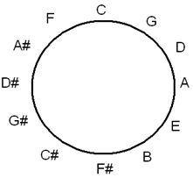
Diagram: “Circle of Fifths”

This diagram is helpful in raising/lowering by perfect fifths.

In the diagram to the right, starting from any given tone of the twelve-tone scale, count clockwise to raise by fifths, or counterclockwise to lower by fifths.

If you’re unfamiliar with this “circle of fifths,” you should verify for yourself that the above arrangement of tones corresponds to what you see on the keyboard when you count seven semitones to the right (or left) to raise (or lower) a given tone by a fifth.

For example (as seen in the practice exercises): If we use Pythagorean tuning with A as our “base,” then how do we tune an F?

Answer: Starting from A, we must count four places in the counterclockwise direction to reach F.
So, using the Pythagorean tuning method, starting from an A, we’d lower by fifths four times (raising by octaves when necessary) to tune an F. (In other words, if we base a Pythagorean tuning system on A, then F would correspond to “L4”, using the notation introduced in class for raising/lowering by fifths.)

Another example: Starting from C, how many times must we raise or lower by perfect fifths to reach B?

Answer: Starting from C, we can count five places in the clockwise direction to reach B. Therefore, starting from C, we must raise by fifths five times to reach a B.

