NOTE: THIS DESIGN DOCUMENT REPRESENTS THIS LEVEL’S INITIAL PLANNING PHASE AND WAS WRITTEN IN ONE WEEK
THIS DOCUMENT IS NOT ENTIRELY REPRESENTATIVE OF THE FINAL LEVEL
REFER TO http://www.mdirenzo.com/titan-vr---unreal-tournament-iii.html FOR UP TO DATE INFORMATION
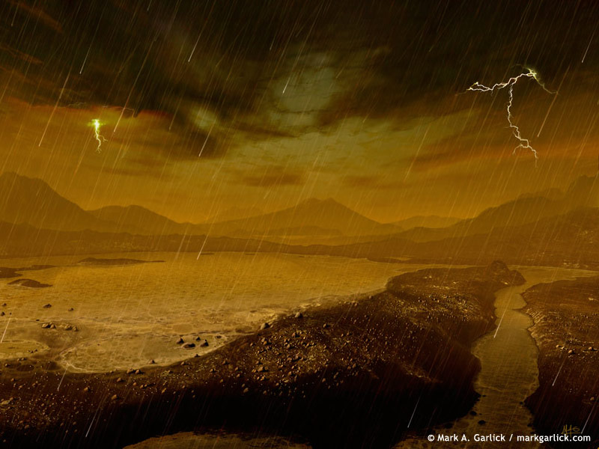

MP Level Design Document: Titan VR
  - Titan VR
  - Version 1.0
Designer: | Mike DiRenzo
Document Date: | 02/10/2012
Intended Level Delivery Date: | 03/02/2012

Document Revisions Table
Version | Description | Requestor | Date
1.0 | Initial Document | Professor McCoy | 02/10/2012
2.0 | Portfolio Revisions | N/A | 12/12/2012

Table of Contents
Table of Figures 7
Quick Summary 9
Gameplay Overview 9
General Game Flow 9
Major Elements 11
Objective Summary 12
Environmental Hazards 12
Technical Overview 12
Mission Location 12
Gametype(s) 12
Items/Powerups 12
Mission Difficulty 19
Mission Metrics 19
Level Details 20
Level Atmosphere/Mood 20
Major Characters/Vehicles 20
Story 21
Major Areas/Visual Themes 22
Area 1: Titan Mining Station 22
Level Objectives 35
Challenge Highlights 36
Water Cooler Moments 36
Area 2: Titan Sniper Alcove 37
Level Objectives 45
Challenge Highlights 45
Water Cooler Moments 46
Area 3: Liandri Deep Space Training Station 47
Area 3: Liandri Deep Space Training Station 53
Level Objectives 53
Challenge Highlights 54
Area 3: Liandri Deep Space Training Station 54
Area 3: Liandri Deep Space Training Station 54
Water Cooler Moments 54
Actors 55
User Interface 56
Gameplay Details 57
Gameplay Mechanics 57
Level Overview Map and Key 57
Area Walkthroughs/Detailed Map Descriptions 59
Area 1: First Floor 59
Gameplay 59
Dialog 60
Visual References 60
Area 2: Second Floor 63
Gameplay 63
Dialog 64
Visual References 64
Area 3: Third Floor 68
Gameplay 68
Visual References 69
Area 4: Fourth Floor 72
Gameplay 72
Visual References 73
References 76

Table of Figures

1. Game Flow Overview Map 10
2. Map Key 11
3. Enforcer 13
4. Impact Hammer 13
5. Link Gun 14
6. Shock Rifle 14
7. Flak Cannon 15
8. Rocket Launcher 15
9. Sniper Rifle 16
10. Enforcer Clip 16
11. Link Gun Ammo 16
12. Shock Core 16
13. Flak Shells 16
14. Rocket Pack 17
15. Sniper Shells 17
16. Health Vial 17
17. Health Pack 17
18. Big Keg 'O Health 17
19. Thigh Pads 17
20. Armor Vest 18
21. Damage Amp! 18
22. Major Areas/Visual Themes Map 22
23. Example of thick atmosphere, harsh weather, and methane lakes 23
24. Another artist’s rendering of Titan’s red, rocky surface featuring the Huygens probe. 24
25. Example of the barren, red terrain of Titan and an active volcano 25
26. Artistic rendition of a mining operation on Titan 26
27. Architectural example 27
28. Architecture within large rock formations 27
29. Low visibility, short line of sight, haze 28
30. Warm earthy textures for Titan’s terrain 29
31. Low light and obstructed vision of cold, metallic surfaces of industrial Titan mining equipment 30
32. Example of possible Liandri tournament combatants 31
33. Example of possible Liandri tournament combatants 32
34. Example of possible Liandri tournament combatants 33
35. Example of possible Liandri tournament combatants 34
36. Example of possible Liandri tournament combatants 35
37. Red cave formations 37
38. Additional cave formations 38
39. Large rock formations 39
40. Photograph of Titan rock structures 40
41. Rover surface photographs of titan 41
42. Earth comparison satellite photograph 41
43. Rock surfacing 42
44. Warm earthy textures for Titan’s terrain 43
45. High contrast low lighting inside the alcove 44
46. Example of space station environment 47
47. Space station environment as seen in Unreal Tournament III 48
48. Stars and planetary backdrop as seen in Aliens 49
49. Futuristic, yet rough industrial architecture 50
50. More angular space architecture 50
51. Space vessel as seen in Star Trek 51
52. Earth-Orbiting vessel, directional light from reflecting planet 52
53. Rough, cold materials as seen in Aliens 52
54. Level Overview Map 57
55. Level Overview Key 58
56. Area 1: First Floor - Map and Key 59
57. Area 1: First Floor - Whitebox example 60
58 . Area 1: First Floor - Whitebox example 61
59. Area 1: First Floor - Whitebox example 62
60. Area 2: Second Floor - Map and Key 63
61. Area 2: Second Floor - Whitebox example 64
62. Area 2: Second Floor - Whitebox example 65
63. Area 2: Second Floor - Whitebox example 66
64. Area 2: Second Floor - Whitebox example 67
65. Area 3: Third Floor - Map and Key 68
66 Area 3: Third Floor - Whitebox example 69
67 Area 3: Third Floor - Whitebox example 70
68 Area 3: Third Floor - Whitebox example 71
69. Area 4: Fourth Floor - Map and Key 72
70. Area 4: Fourth Floor - Whitebox example 73
71. Area 4: Fourth Floor - Whitebox example 74
72. Area 4: Fourth Floor - Whitebox example 75

Quick Summary
Titan VR is an intense Unreal Tournament III re-imagining of the classic Longest Yard (DM-17) map for Quake III: Arena. This Deathmatch map is ideal for eight but supports up to 16 players. Combatants fight toe to toe, on what initially appears to be a mining facility on the harsh planetoid that is Saturn’s arguably most interesting moon, Titan. However when players choose to disrupt the simulation equipment that houses a berserk powerup, they discover their true location is a deep space simulation arena where gravity is no longer earth-like (only slightly stronger than Titan’s gravity). This new low gravity environment abruptly introduces players to an exciting new atmosphere and gravitational twist. They may suddenly find the playing field level as those in the lead have difficulty adapting. Titan VR turns foregone conclusions on their heads and offers a truly dynamic experience where players need not wait for the end of the match for a new map.

Gameplay Overview
Titan VR is a small and chaotic multiplayer Deathmatch map. The high amount of pickups gives players constant incentive to explore and acquire the most advantageous arsenal. The abundance of levels and emphasis on verticality requires players to be alert and aware in the fullest sense to survive. All three of the teleports lead to the bridge on the green level directly in front of the Armor vest. In this relatively small map, players have little opportunity to hide from encounters. Even with fewer than eight combatants, encounters are frequent and explosive. Success in Titan VR results from quick reflexes, strategically collecting pickups and a high level of map layout and awareness. Strong points of interest and conflict include the Sniper platform and the Damage Amp! powerup. Capitalizing on these assets awards players hefty, though brief advantages.

General Game Flow
Players spawn on one of the first three floors. The immediate objective is to acquire additional weapons. All player starts are relatively close to weapon pickups. As players rush to the closest weapon pickups and begin to attempt scoring kills, they may wish to compete for some of the less abundant but more substantial pickups that Titan VR offers like the Big Keg ‘O Health or Damage Amp!. Seeking out the Sniper Rifle can be a hugely advantageous strategy as well. However, there is risk involved as opposing players can periodically shoot down loose rocks above the alcove that crush and kill all who stand below. The Titan virtual reality training simulation malfunctions either halfway through the set time limit for a match or when the first person scores half the amount of kills to win the match. As a result, the map changes drastically by reducing gravity to half of the initial value, and revealing an entirely new deep space station environment. The thick haze, rain, and terrain of Titan disappear in a blinding flash as stars, nebulae and asteroid belts appear in their place.
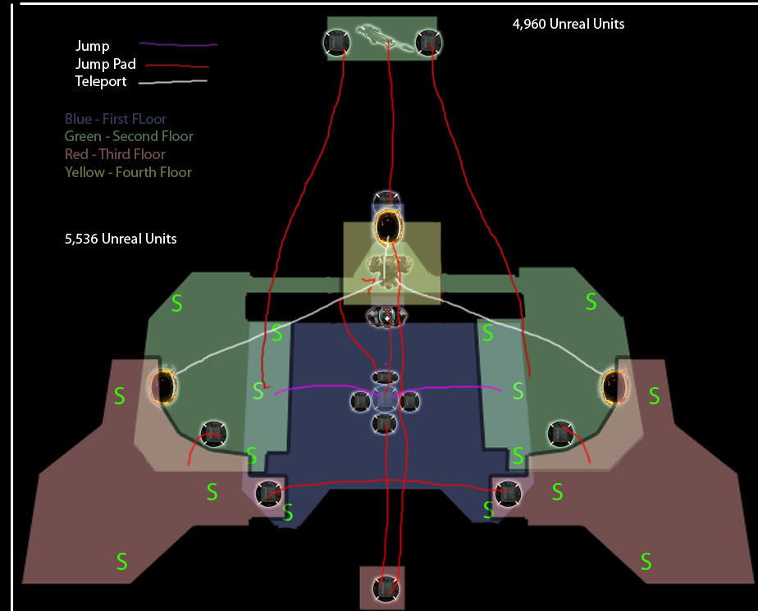
1. Game Flow Overview Map
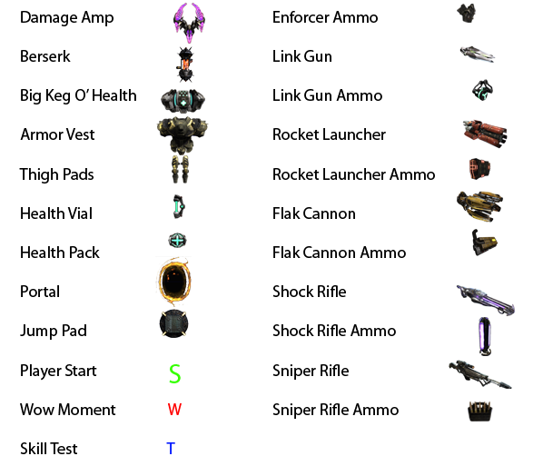
2. Map Key

Major Elements
- Hook
  - Experience the chaotic and harsh environment of Saturn’s moon, Titan
  - Halfway through matches, environments swap out from an exotic organic, normal gravity atmosphere, to a low gravity deep space station
  - Two maps in one with distinct sets of visual elements and gameplay style
- Wow moments
  - Ending the Titan simulation and entering low gravity space is a shocking visual and gameplay twist
  - Shooting loose rocks down onto players who are stubborn about leaving the Sniper Alcove
- Major visual and gameplay elements
  - Titan mining technology
  - expansive red terrain

Objective Summary
- Maximize kills
- Minimize deaths
- Avoid Damage
- Capitalize on Powerups
- Collect weapons
- Capitalize on health and armor pickups

Environmental Hazards
Titan VR hosts an array of dangerous environmental hazards. The virtual reality portion of this map surrounds players with a lake of liquid methane, which kills immediately on contact. Players also have the opportunity to take aim at loose rocks above the Sniper Rifle outpost periodically and damage cowardly snipers who refuse to leave their comfort zone. The simulation ends when one player reaches half the amount of maximum kills to end the match. This second phase of the map reduces gravity by half, introducing a new environmental challenge.

Technical Overview

Mission Location
- Theme – Wage war while experiencing the duality of an exotic world and a deep space station.
- Mood – Urgent and chaotic
- Setting – Year: 2023, location: Old Liandri Mining Corporation training facility in deep space, environment: The surface of Titan and deep space station
- Time of Day – Evening, sunset allows for more prominent directional lighting; days on Titan are roughly as long as 16 Earth days;
- Season – N/A – Titan and Space
- Weather – Violent, stormy, dust clouds, thunder methane rain, haze

Gametype(s)
- Gametype 1: Deathmatch
  - Min Players: 4
  - Ideal Players: 8
  - Max Players: 16
- Gametype 2: Team Deathmatch
  - Min Players: 4
  - Ideal Players: 8
  - Max Players: 16

Items/Powerups
All pickup items respawn after some time. There are two ammunition pickups available for each weapon.
- Weapons
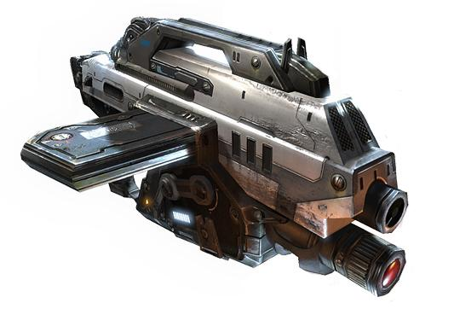
3. Enforcer
  - Enforcer (0, Players spawn with this weapon) – Enforcer is a semi-automatic single-shot handgun. Five primary fire shots kill players at 100 health with no armor. Enforcer’s secondary fire is a three-shot rapid fire burst. Two of these shots kill players at 100 health with no armor. Enforcer’s shots do not always land directly in the center of its crosshairs. All players spawn with Enforcer, but it does not exist on the map as a pickup nor does ammunition for it. A player who dies while holding Enforcer drops the weapon, allowing another player to pick it up and dual-wield Enforcers.
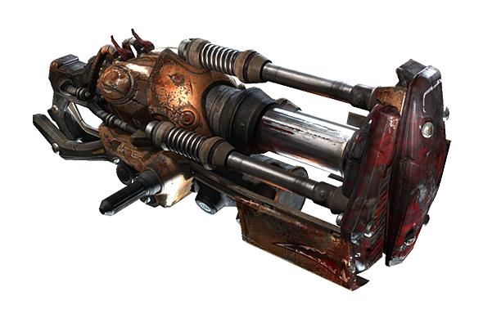
4. Impact Hammer
  - Impact Hammer (0, Players spawn with this weapon)– Impact Hammer is a close range melee weapon that all players spawn with. It uses no ammunition. Its primary fire charges for as long as the player holds down the button. Green lights appear when the hammer is at full charge. A full charge Impact Hammer strike kills players instantly. The Impact Hammer emits a noise as it charges, alerting potential victims of impending danger. Firing the impact hammer close to a facing a wall or floor knocks the user back and causes some self-damage. The Impact Hammer’s alternate fire damages vehicles and removes power-ups.
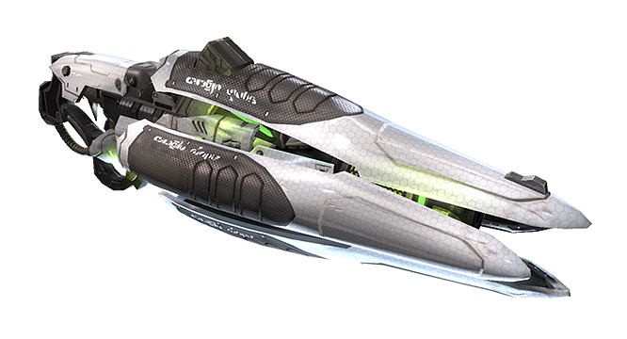
5. Link Gun
  - Link Gun (2) – The link gun is a fully automatic slow rate of fire assault rifle. Its secondary fire ignites a terminal beam that causes damage to players.
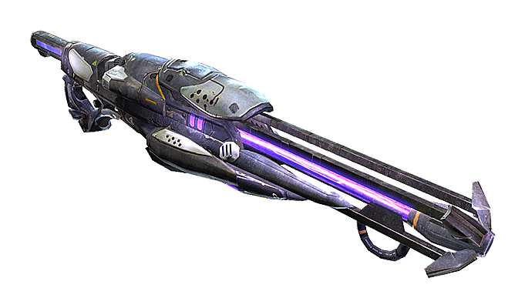
6. Shock Rifle
  - Shock Rifle (1) – The Shock Rifle is an accurate long-range semi-automatic rifle. The primary fire shoots a fast beam directly in the center of player’s crosshairs with a short cooldown in between shots. Three primary fire shots kill players with 100 health and no armor. The Shock Rifle’s secondary fire propels a slow-moving ball of energy (Shock Core) that kills players with 100 health and no armor in two hits and inflicts knockback. Players who use this secondary fire close facing a wall or floor suffer damage and knockback. Players can fire a Shock Core and detonate it with the Shock Rifle’s primary fire to case a small explosion that kills players with 100 health and no armor in one hit.
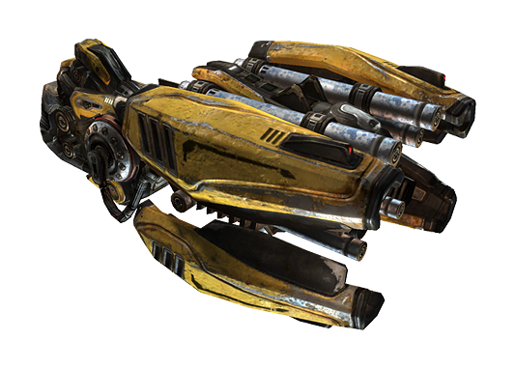
7. Flak Cannon
  - Flak Cannon (1) – The Flak Cannon is a close-range high-damage potential gun. Its primary fire spits out shards of metal that spread further with distance. Close range shots in which all of the spread connects with a player with 100 health and no armor results in a kill. The flak bounces off walls. Players who are not careful can inflict damage on themselves. The Flak Cannon’s secondary fire launches an undetonated shell in an arc that explodes on impact. A direct hit from this shell also kills players with 100 health and no armor. Players can also damage themselves with the Flak Cannon’s alternate fire by aiming at the floor beneath them or at a close wall that they are facing. The Flak Cannon is a weapon pickup in Liandri Concert Hall, which contains two ammo packs (Flak Shells).
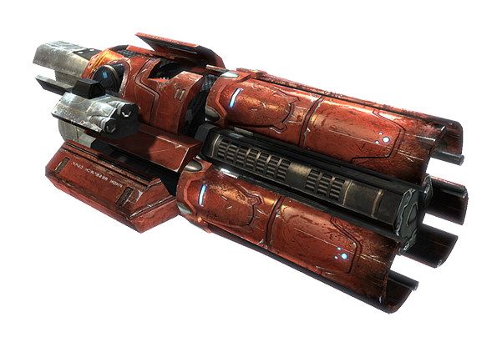
8. Rocket Launcher
  - Rocket Launcher (2) – The Rocket Launcher fires explosive rockets that can seek targets at long range. Its alternate fire allows players to fire three simultaneous rockets in a straight horizontal line, a spiral, or as grenades.
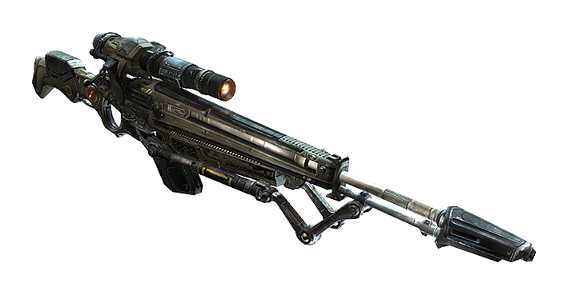
9. Sniper Rifle
  - Sniper Rifle (1) – The Sniper Rifle is a long-range rifle with a scope. A headshot with the Sniper Rifle Results in an immediate kill the victim is wearing an armor helmet or possesses a large amount of extra health and armor. Two Sniper shots anywhere else on the body kill players with 100 health and no armor. The amount of time a player holds secondary fire determines the zoom of their scope while aiming. Releasing secondary fire returns to normal view.
- Ammunition
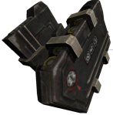
10. Enforcer Clip
  - Enforcer - 2
  - Impact Hammer – 0, Does not require ammunition
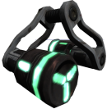
11. Link Gun Ammo
  - Link Gun – 2
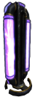
12. Shock Core
  - Shock Rifle – 2
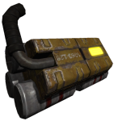
13. Flak Shells
  - Flak Cannon – 2
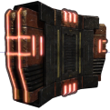
14. Rocket Pack
  - Rocket Launcher – 2
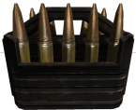
15. Sniper Shells
  - Sniper Rifle - 2

- Health – 250 Health Points + Big Keg O’ Health
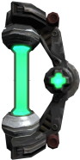
16. Health Vial
  - Health Vials (20) - Players can collect Health Vials beyond the starting health of 100 up to 200 maximum health points.
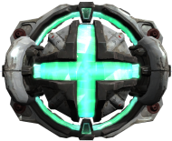
17. Health Pack
  - Health Packs (6) –Health Packs only heal players up to 100 health and not a single point beyond. Players with 100 health cannot pickup Health Packs. A player with 99 health would only receive one health point from a Health Pack.
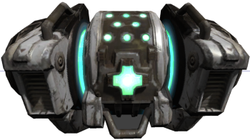
18. Big Keg 'O Health
  - Big Keg O’ Health – Heals players for 100 health up to 199 health.
- Armor – 100 Armor Points Total
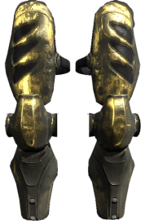
19. Thigh Pads
  - Thigh Pads (1) – One pair of Thigh Pads exists. They provide 30 points of protection and absorb 50% of damage.
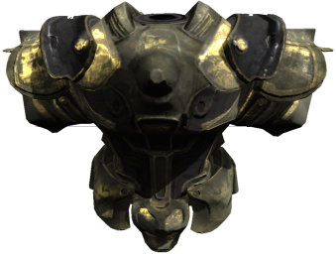
20. Armor Vest
  - Armor Vest (1) - One Armor Vest, which adds 50 points of protection and absorbs 75% of damage, exists on the seating floor, making the collectible armor points total 100.

- Powerups
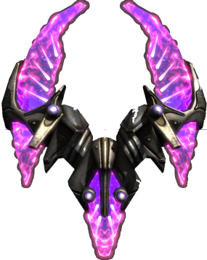
21. Damage Amp!
  - Damage Amp! (1) – Grants user double damager for all weapons. The Damage Amp does not spawn immediately at the beginning of matches. Killing a player with the Damage amp causes it to drop and any other player can claim it. The duration does not reset when this happens. The Damage Amp lasts for 27 seconds as soon as a player takes it and disappears at the end of 27 seconds regardless of who has or does not have it. The Damage Amp respawns after 82 seconds. A universal cue through text and audio occurs when the Damage Amp respawns.

Mission Difficulty
7/10 (1 is Easiest and 10 is Hardest)
Titan VR requires players to be truly aware above and below them as well as in front and behind if they hope to survive. The multiple layers and abundant Jump Pads emphasize verticality and spatial awareness. Titan VR’s high capacity for players and close player starts make quick reflexes a must for a shot at victory. The change in gravity is a curveball especially for players who are extremely comfortable with traditional Unreal Tournament III physics. Players have the opportunity to shoot down loose rocks and damage opponents who choose to stake out a position at the Sniper rifle from afar.

Mission Metrics
- Play Time – Optimal playtime for Titan VR is roughly 20 minutes or 30 kills. Titan VR is a relatively small and open map for eight or more players. Matches that last longer than 30 minutes may become a bit redundant for some. The user or server specifies the win/end conditions.
- Physical Length/Width/Height – 4,900 x 4,200 x 2,112 Unreal Units
- Player Length/Width/Height – 64 x 64 x 96 Unreal Units
- Visual Themes
  - Mining facility on harsh planet, Titan – Methane lakes, methane rain, clouded atmosphere, warm colors, catwalks, quarry; low saturation, low contrast lighting, mechanical lights, fog
  - Training arena in deep space – passing ships, asteroid belt, nebula, stars, planets, machinery, futuristic technology

Level Details

Level Atmosphere/Mood
Titan is a harsh planetoid where methane behaves as water does on earth. Titan’s thick red atmosphere blocks out all bright light as a constant storm of methane rain rages around mining platforms that stands on rocky terrain above a methane lake.
- Lighting – Warm, low saturation, low contrast lighting, coincide with Titan’s thick and violent atmosphere, this contrasts sharply with the openness of the space station; distinct style of lighting stimulates players and encourages a sense of urgency
- Materials – Custom yellow and orange tint materials for Titan’s terrain and rock meshes, worn metallic materials for the industrial meshes that represent mining equipment and structures on Titan, cold and clean futuristic materials for the deep space training arena; the duality of organic and inorganic subject matter makes the environment more dynamic and interesting for players
- Sound –Titan VR employs strong ambient noise in its exterior due to harsh weather conditions; ambient noise further immerses players into the dangerous environment they inhabit; strong winds howl into the players’ ears as a constant reminder of their peril; methane rain collides with the surface violently and thunder cracks the sky.
- Static Meshes - Titan VR employs custom terrain along with organic and rock meshes for its Titan environment. The mining equipment consists of pieces from Liandri Tech along with Human architecture sets; space station retains the layout and static meshes of the playable area.
- BSP –Titan VR uses some BSP for the playable space in order to achieve particular shapes, BSP blends with static mesh seamlessly.

Major Characters/Vehicles
- Player – Major Objectives
  - Maximize kills
  - Minimize deaths
  - Avoid Damage
  - Capitalize on Powerups
  - Collect weapons
  - Capitalize on health and armor pickups
  - Win the tournament
- Human Opponent – Major Objectives
  - Maximize kills
  - Minimize deaths
  - Avoid Damage
  - Capitalize on Powerups
  - Collect weapons
  - Capitalize on health and armor pickups
  - Win the tournament
- Bot Opponent –
  - Maximize kills
  - Minimize deaths
  - Avoid Damage
  - Capitalize on Powerups
  - Collect weapons
  - Capitalize on health and armor pickups
  - Win the tournament

Story
- Intro
  - Loading screen displays Unreal Tournament III graphic and name of loading map, no further introduction
- In-Game
  - Players compete in the Unreal Tournament that now occurs on the Liandri Mining Corporation deep space training station. The match begins with this training station’s simulation of Saturn’s moon, Titan. As players approach the win condition, the simulation ends and players continue the rest of their match in the low gravity environment of the deep space training station.
- Extro
  - Players view win screen.

Major Areas/Visual Themes
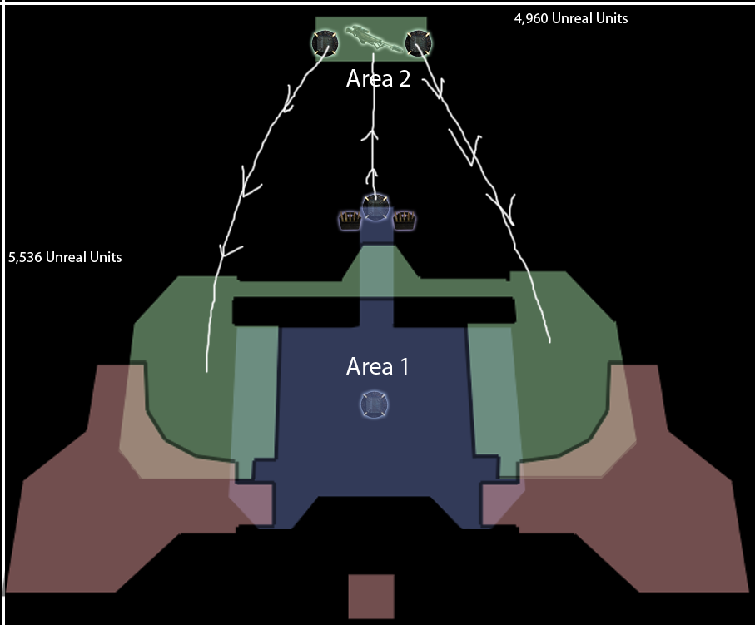
22. Major Areas/Visual Themes Map

Area 1: Titan Mining Station

Text Description
This is a small mining facility on the surface of Titan. All players spawn here. The station exists between steep terrain, above lakes of methane, and near active volcanoes outside of the playable area. A constant storm brews as thunder cracks the sky and a warm haze clouds players’ vision.

Visual References

Terrain/Vegetation
23. Example of thick atmosphere, harsh weather, and methane lakes

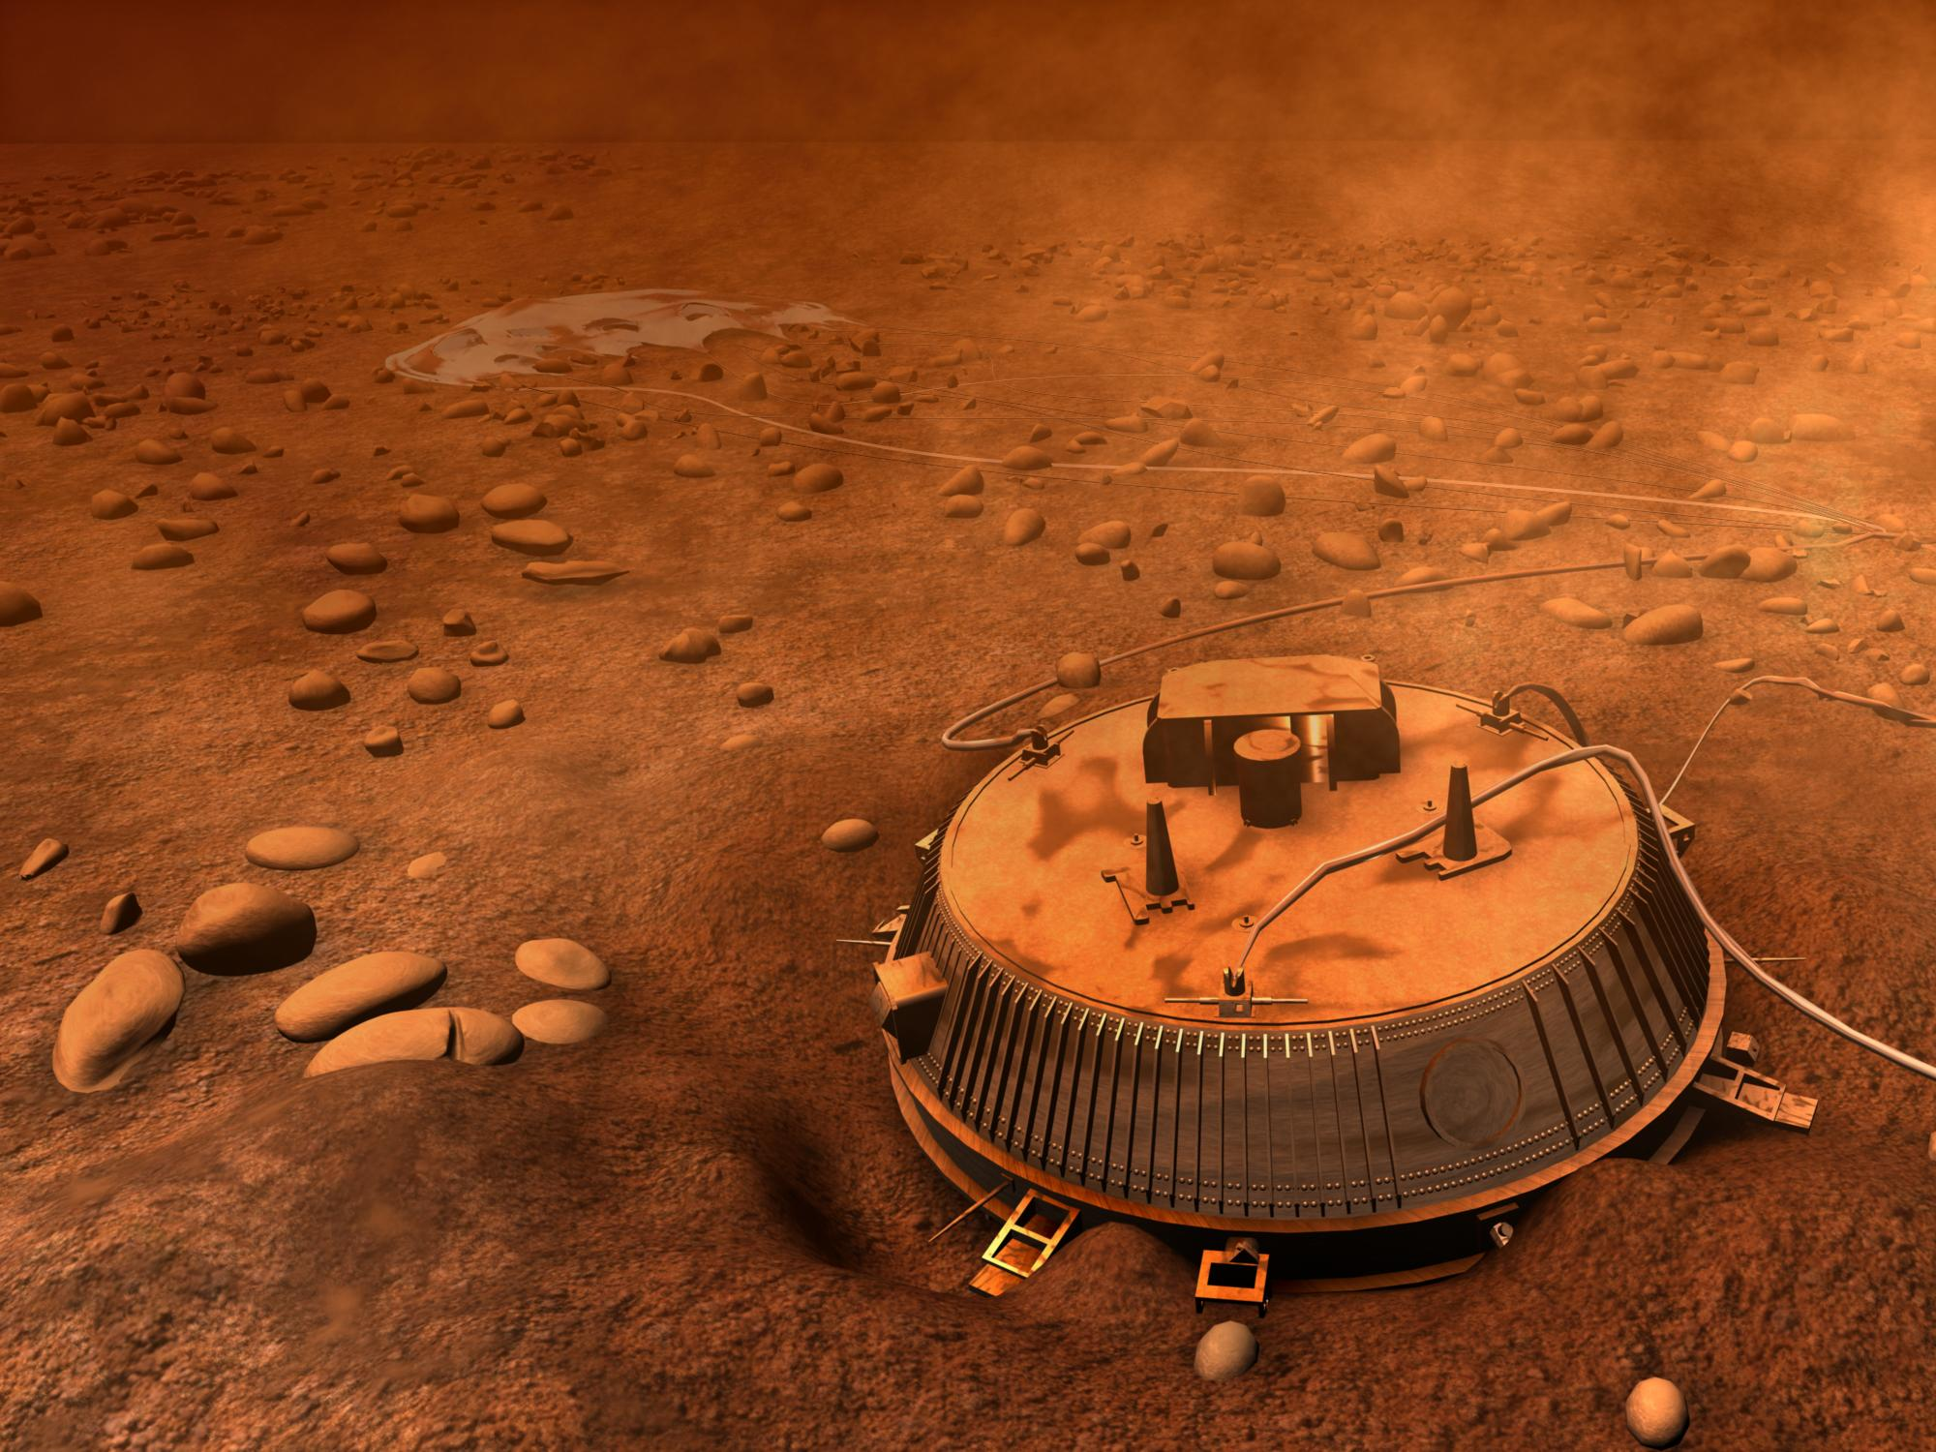
24. Another artist’s rendering of Titan’s red, rocky surface featuring the Huygens probe.
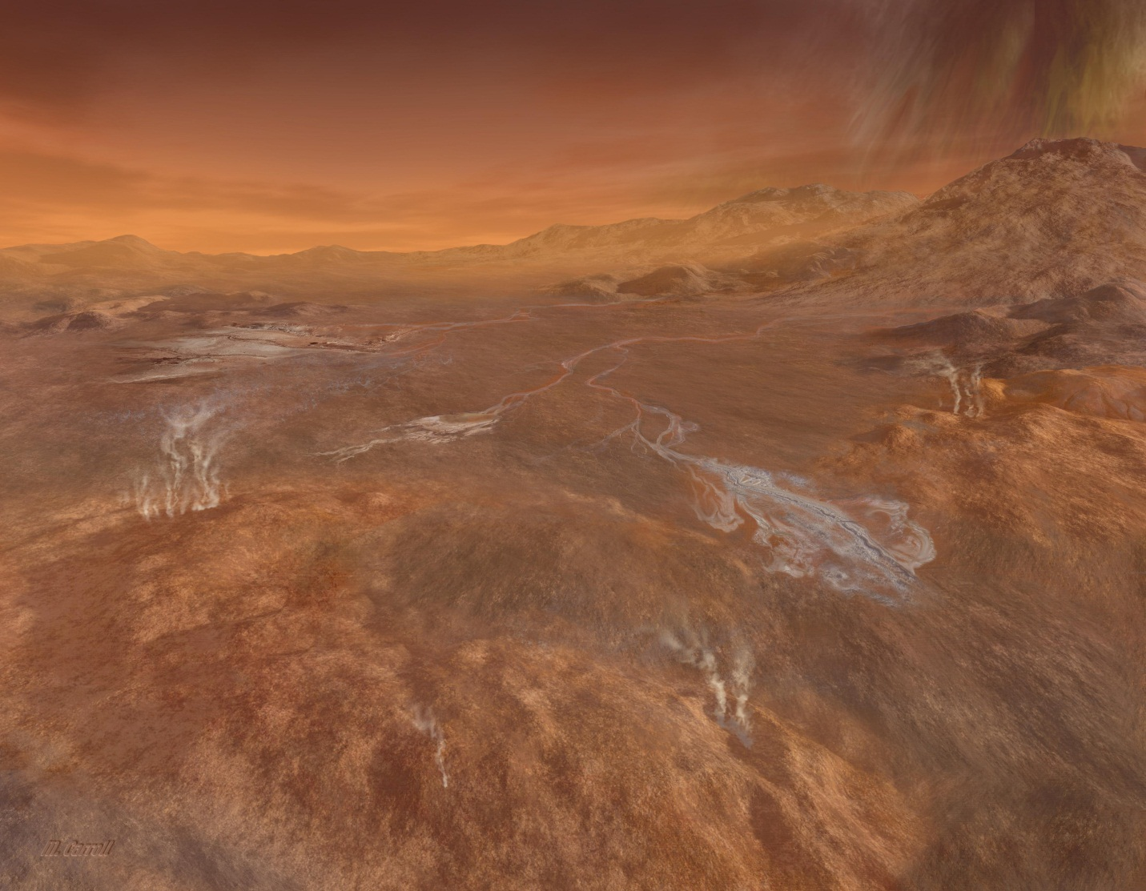
25. Example of the barren, red terrain of Titan and an active volcano

Models/Architecture
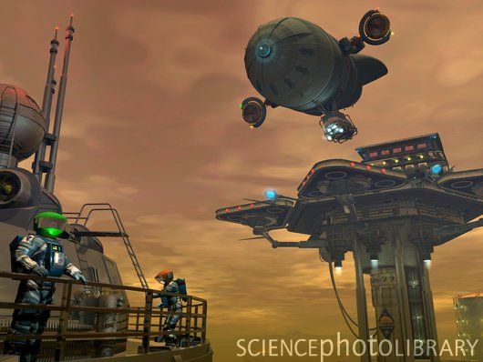
26. Artistic rendition of a mining operation on Titan
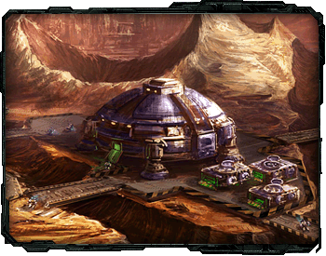
27. Architectural example
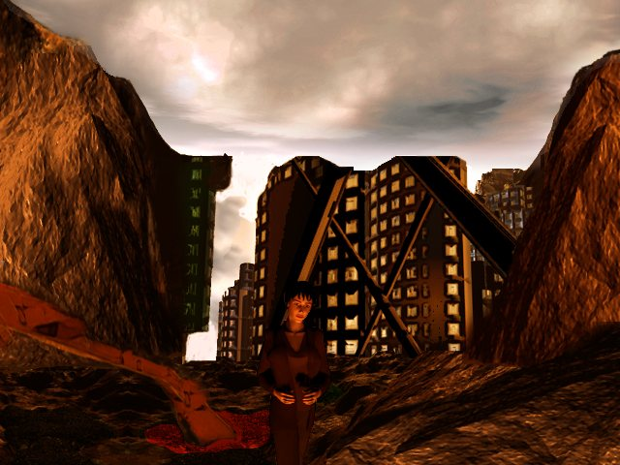
28. Architecture within large rock formations

Textures/Lighting
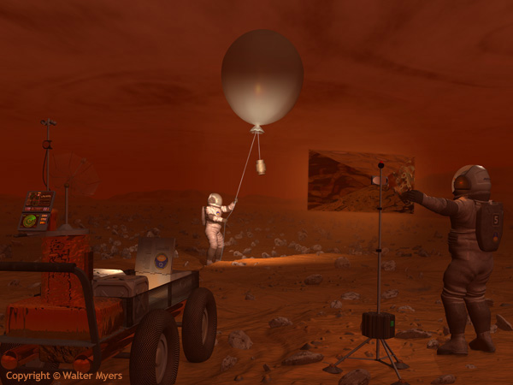
29. Low visibility, short line of sight, haze
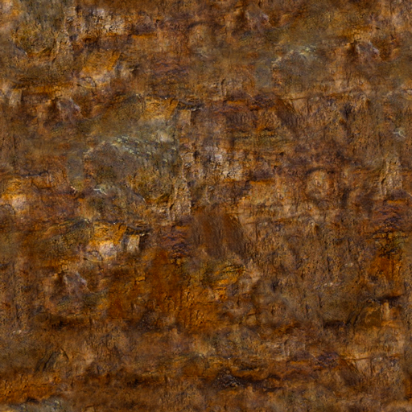
30. Warm earthy textures for Titan’s terrain
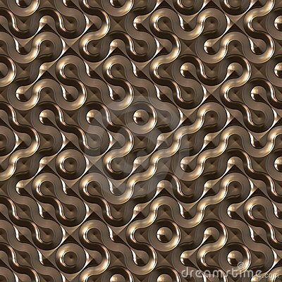
31. Low light and obstructed vision of cold, metallic surfaces of industrial Titan mining equipment

Characters/Vehicles

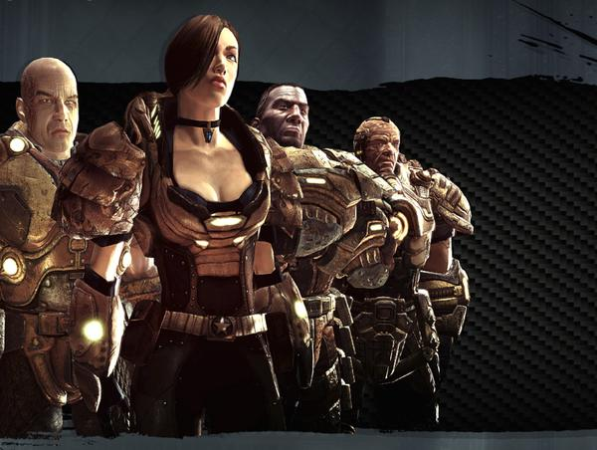
32. Example of possible Liandri tournament combatants

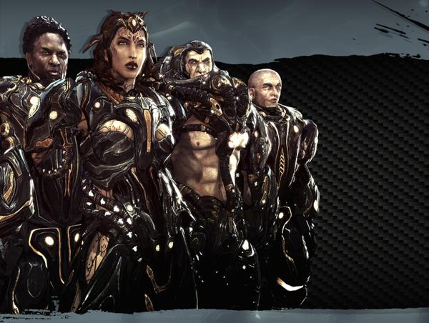
33. Example of possible Liandri tournament combatants

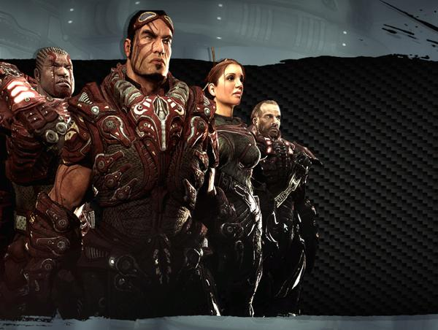
34. Example of possible Liandri tournament combatants

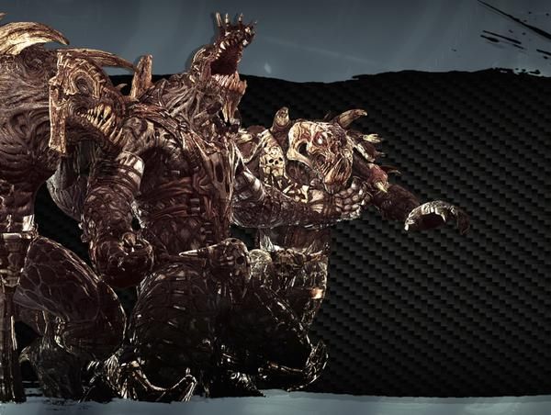
35. Example of possible Liandri tournament combatants
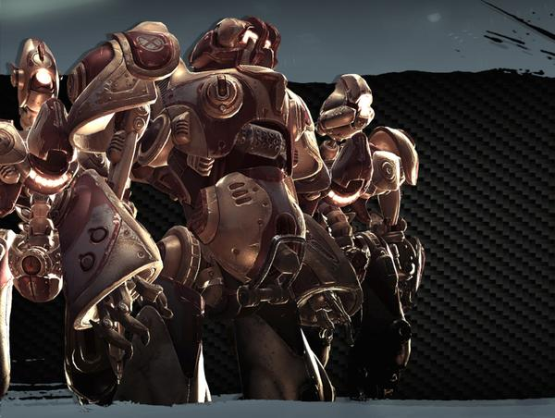
36. Example of possible Liandri tournament combatants

Area 1: Titan Mining Station

Level Objectives
- Primary
  - Maximize kills
  - Minimize deaths
  - Avoid Damage
- Secondary
  - Capitalize on Powerups
  - Collect weapons
  - Capitalize on health and armor pickups
- Bonus
  - First Blood – First to score a kill in a match
  - Killing Spree – 5 kills without dying
  - Dominating – 10 kills without dying
  - Rampage - 15 kills without dying
  - Unstoppable – 20 kills without dying
  - Godlike – 25 kills without dying
  - Massacre – 30 or more kills without dying
  - Double Kill – 2 nearly simultaneous kills
  - Multi Kill - 3 nearly simultaneous kills
  - Mega Kill - 4 nearly simultaneous kills
  - Ultra Kill - 5 nearly simultaneous kills
  - Monster Kill – 6 or more nearly simultaneous kills
  - Jack Hammer – 15 kills with the Impact Hammer
  - Gun Slinger - 15 kills with the Enforcer
  - Combo King - 15 kills with the Shock Rifle combo
  - Shaft Master - 15 kills with the Link Gun alternate fire
  - Flak Master - 15 kills with the Flak Cannon
  - Rocket Scientist - 15 kills with the Rocket Launcher
  - Head Hunter - 15 Headshots with the Sniper Rifle
- Hidden
  - N/A

Challenge Highlights
Area 1: Titan Mining Station
- Combat
  - Quick, frantic, danger comes from all dimensions because of the map’s use of verticality
- Stealth
  - Very little stealth gameplay in Unreal Tournament III; the layout of Titan VR leaves few to no viable stealth options
- Puzzles
  - Wise players make strong note of jump pad and portal destinations, players can shot loose rocks down on opponents in the Sniper Alcove from afar
- Conversation
  - N/A
- Boss Battles
  - N/A
Area 1: Titan Mining Station

Water Cooler Moments
- Volcanoes erupting throughout the match outside of the playfield
- Shooting loose rocks above the Sniper Alcove to crush Snipers from afar

Area 2: Titan Sniper Alcove

Text Description
This is a small alcove, in the side of a mountain on Titan, which players reach via jump pad from Area 1. The alcove is far from the mining facility and features a Sniper Rifle. Opponents can shoot loose rocks above the alcove down periodically. This falling rock kills those who are not careful.

Visual References

Terrain/Vegetation
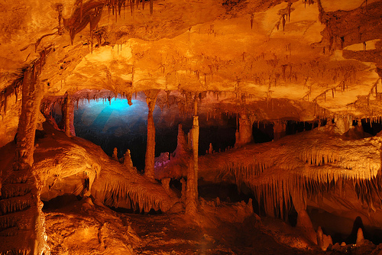
37. Red cave formations
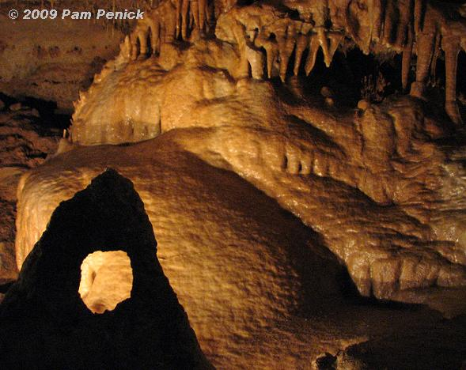
38. Additional cave formations
39. Large rock formations

Models/Architecture
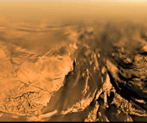
40. Photograph of Titan rock structures
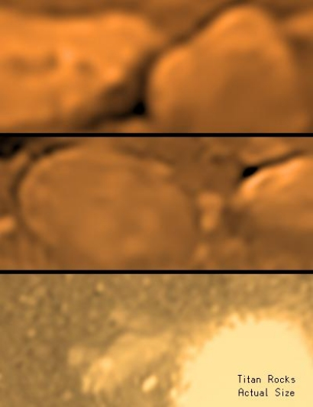
41. Rover surface photographs of titan
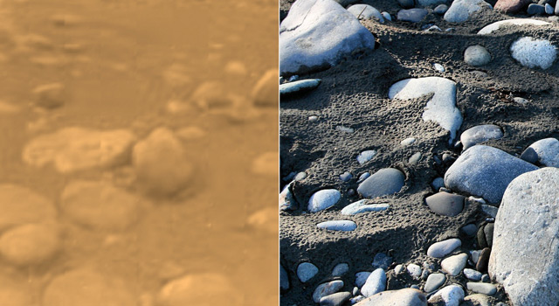
42. Earth comparison satellite photograph

Textures/Lighting
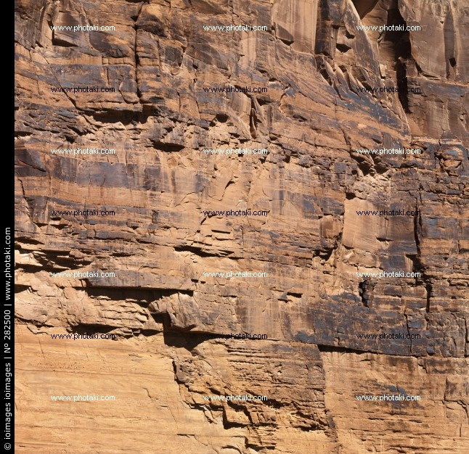
43. Rock surfacing
44. Warm earthy textures for Titan’s terrain
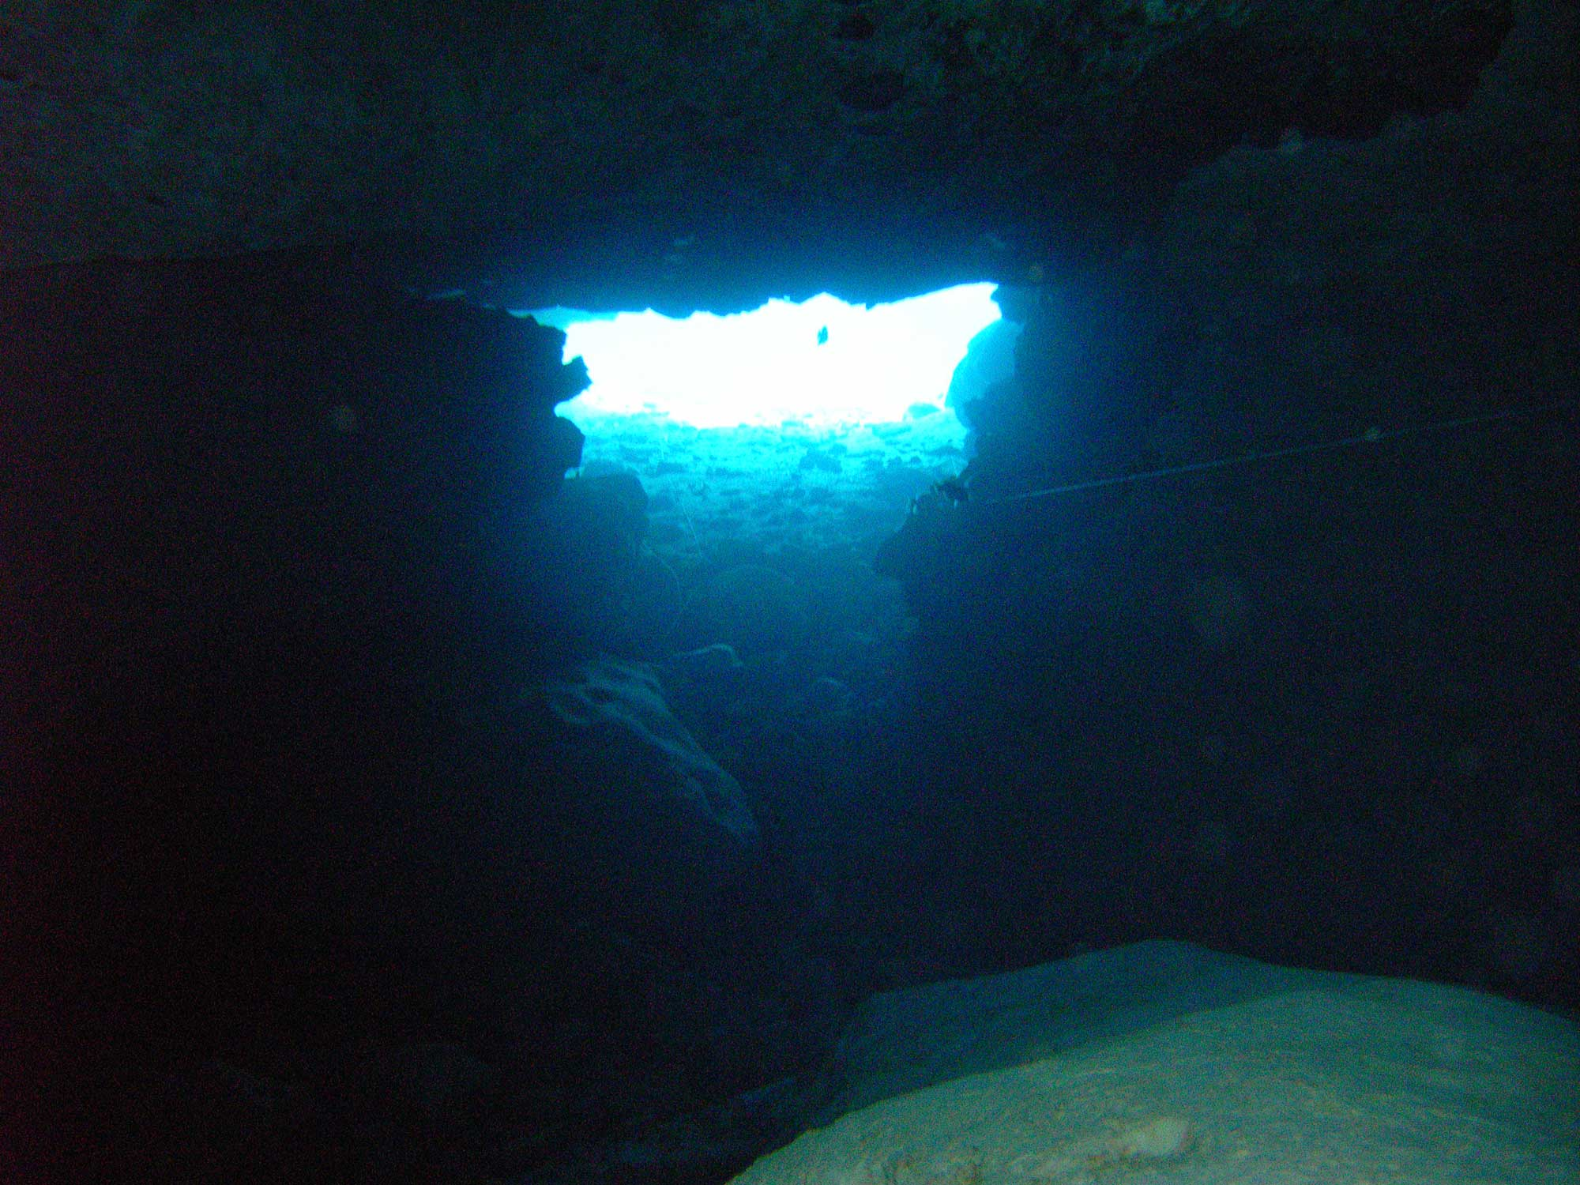
45. High contrast low lighting inside the alcove

Characters/Vehicles
See Area 1 - Characters/Vehicles

Area 2: Titan Sniper Alcove

Level Objectives
- Primary
  - Acquire Sniper Rifle
  - Maximize kills
- Secondary
  - Avoid falling rocks from above shot down by opponents
- Bonus
  - First Blood – First to score a kill in a match
  - Killing Spree – 5 kills without dying
  - Dominating – 10 kills without dying
  - Rampage - 15 kills without dying
  - Unstoppable – 20 kills without dying
  - Godlike – 25 kills without dying
  - Massacre – 30 or more kills without dying
  - Double Kill – 2 nearly simultaneous kills
  - Multi Kill - 3 nearly simultaneous kills
  - Mega Kill - 4 nearly simultaneous kills
  - Ultra Kill - 5 nearly simultaneous kills
  - Monster Kill – 6 or more nearly simultaneous kills
  - Jack Hammer – 15 kills with the Impact Hammer
  - Gun Slinger - 15 kills with the Enforcer
  - Combo King - 15 kills with the Shock Rifle combo
  - Shaft Master - 15 kills with the Link Gun alternate fire
  - Flak Master - 15 kills with the Flak Cannon
  - Rocket Scientist - 15 kills with the Rocket Launcher
  - Head Hunter - 15 Headshots with the Sniper Rifle
- Hidden
  - N/A

Challenge Highlights
Area 2: Titan Sniper Alcove
- Combat
  - Combat in the Sniper Alcove mostly involves picking of players in the mining station with the long-range Sniper Rifle; however, because the alcove is very small, there is opportunity for frantic close-quarters combat when more than one player inhabits the area
- Stealth
  - Players ideally want to inhabit this perch exclusively and pick opponents off far away from immediate danger
- Puzzles
  - N/A
- Conversation
  - N/A
- Boss Battles
  - N/A
Area 2: Titan Sniper Alcove

Water Cooler Moments
- Holding the alcove for as long as possible while racking up kills and defeating all who attempt to claim it; receiving the Headhunter bonus for 15 Headshots with the Sniper Rifle in one game
- Element of surprise when Snipers perched in the alcove die from the falling rocks that opponents shoot down from far across the map in Area 1.

Area 3: Liandri Deep Space Training Station

Text Description
This space station is the training facility in deep space that is executing the Titan virtual reality sequence. Asteroids and nebulae paint the backdrop while the playable area uses the same industrial meshes and layout as in Area 1, the Titan Mining facility. The lighting dramatically changes and gravity reduces to half strength as all ambient noise and weather effects subside for the darkness and silence of space. This transition occurs halfway through matches. Players experience a bright flash post-processing effect as the sky and lighting transition to this deep space station. All gameplay remains the same with the exception of low gravity and absence of loose rock to shoot down onto the Sniper Perch.

Visual References

Terrain/Vegetation
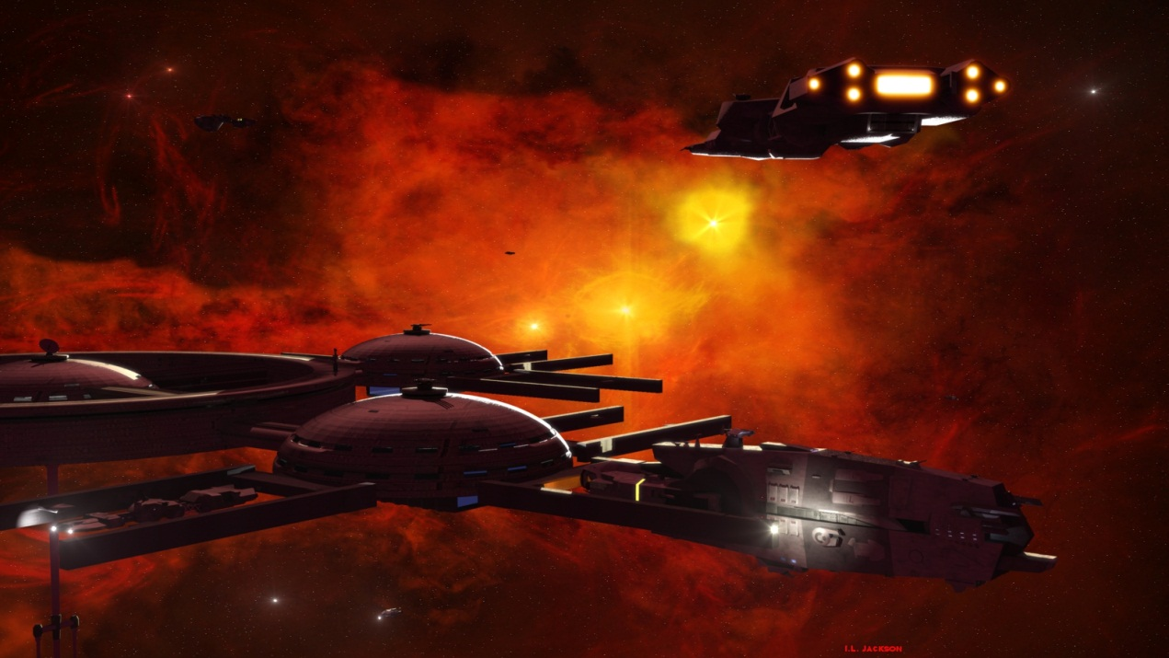
46. Example of space station environment

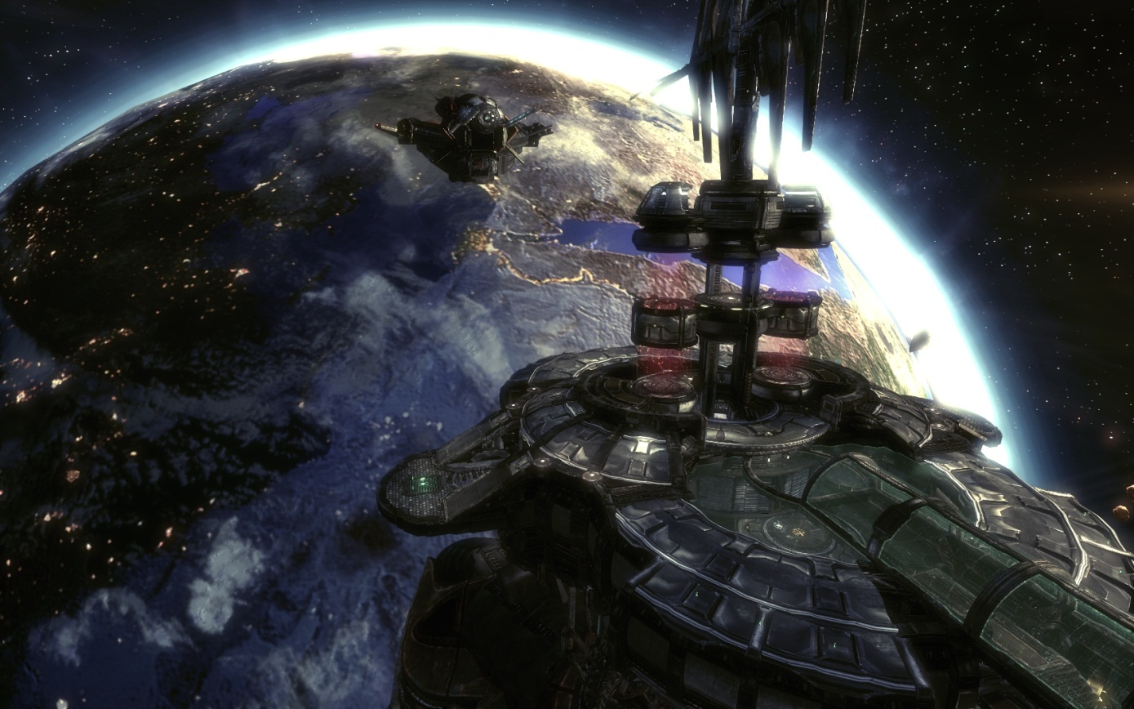
47. Space station environment as seen in Unreal Tournament III

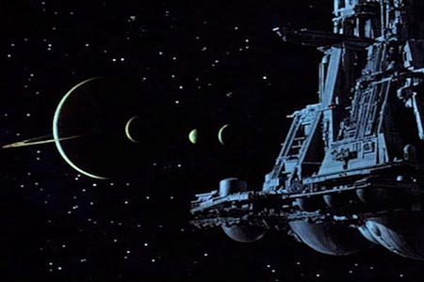
48. Stars and planetary backdrop as seen in Aliens

Models/Architecture
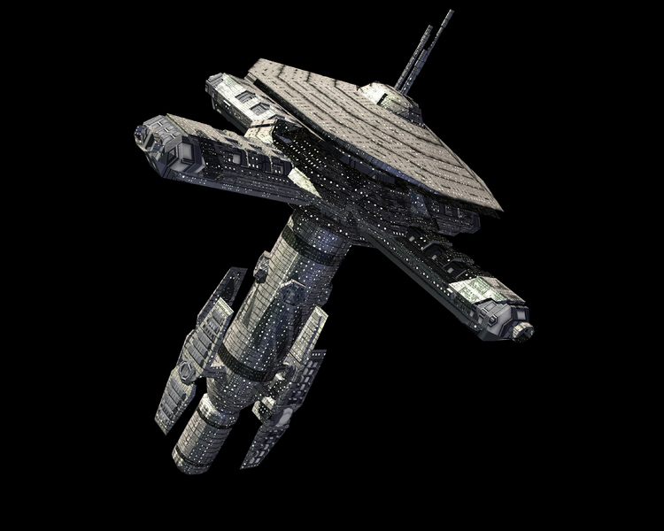
49. Futuristic, yet rough industrial architecture
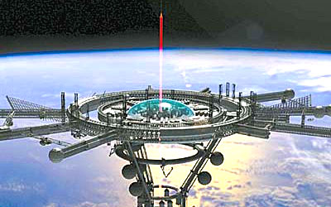
50. More angular space architecture
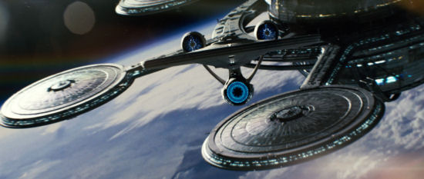
51. Space vessel as seen in Star Trek

Textures/Lighting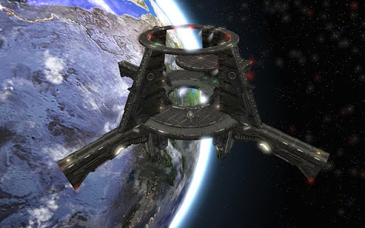
52. Earth-Orbiting vessel, directional light from reflecting planet
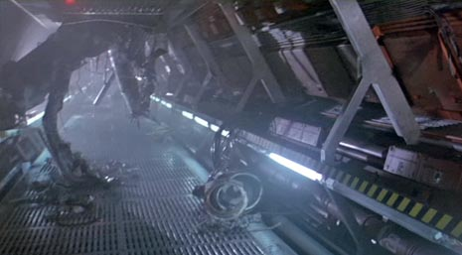
53. Rough, cold materials as seen in Aliens

Characters/Vehicles
See Area 1 - Characters/Vehicles

Area 3: Liandri Deep Space Training Station

Level Objectives
- Primary
  - Maximize kills
  - Minimize deaths
  - Avoid Damage
- Secondary
  - Capitalize on Powerups
  - Collect weapons
  - Capitalize on health and armor pickups
- Bonus
  - First Blood – First to score a kill in a match
  - Killing Spree – 5 kills without dying
  - Dominating – 10 kills without dying
  - Rampage - 15 kills without dying
  - Unstoppable – 20 kills without dying
  - Godlike – 25 kills without dying
  - Massacre – 30 or more kills without dying
  - Double Kill – 2 nearly simultaneous kills
  - Multi Kill - 3 nearly simultaneous kills
  - Mega Kill - 4 nearly simultaneous kills
  - Ultra Kill - 5 nearly simultaneous kills
  - Monster Kill – 6 or more nearly simultaneous kills
  - Jack Hammer – 15 kills with the Impact Hammer
  - Gun Slinger - 15 kills with the Enforcer
  - Combo King - 15 kills with the Shock Rifle combo
  - Shaft Master - 15 kills with the Link Gun alternate fire
  - Flak Master - 15 kills with the Flak Cannon
  - Rocket Scientist - 15 kills with the Rocket Launcher
  - Head Hunter - 15 Headshots with the Sniper Rifle

Challenge Highlights

Area 3: Liandri Deep Space Training Station
- Combat
  - Quick, frantic, danger comes from all dimensions because of the map’s use of verticality
- Stealth
  - Very little stealth gameplay in Unreal Tournament III; the layout of Titan VR leaves few to no viable stealth options
- Puzzles
  - Wise players make strong note of jump pad and portal destinations, players can no longer shot loose rocks down on opponents in the Sniper Alcove from afar
- Conversation
  - N/A
- Boss Battles
  - N/A

Area 3: Liandri Deep Space Training Station

Water Cooler Moments
- Gravity shift creates a huge shift in gameplay and turns the tides of battle; creates unpredictable match results as those who succeed early in normal gravity may pull ahead but fare poorly in low gravity

Actors

All Players
- Model(s): See Area 1 - Characters/Vehicles
- Inventory: Instruction: Impact Hammer, Enforcer
- Start Location: See “S” marks in General Game Flow
- Motives/Objectives:
  - Maximize kills
  - Minimize deaths
  - Avoid Damage
  - Capitalize on Powerups
  - Collect weapons
  - Capitalize on health and armor pickups

User Interface
- Pre-Game Information
  - Briefing
    - Map loading screen: Displays map name, tips and gametype
- In-Game Information
  - Introduction
    - N/A
  - In-Game
    - Health – Bottom-Left, Numeric out of 200
    - Ammunition – Bottom-Right, Numeric, varies
    - Score – Top-Right, Numeric
    - Armor – Bottom-Left, Numeric, Humanoid Icon displays armor location and what player is or is not wearing
    - Place – Top-Right, Rank
  - Objectives
    - Deathmatch gametype displays in the menu
  - Conclusion/Debriefing
    - N/A
- Post-Game Information
  - Debriefing
    - N/A
  - Stats
    - Score screen, displays kills, deaths, numeric
- HUD Elements
  - Normal Elements Used
    - Health
    - Armor
    - Ammunition
    - Score
    - Place
  - Special Elements Required

- None

Gameplay Details

Gameplay Mechanics
- Prerequisite Skills
- run, shoot
- Skills Learned – Jump, Crouch, Secondary Fire, Chat, Jump Pads, Low-Gravity

Level Overview Map and Key
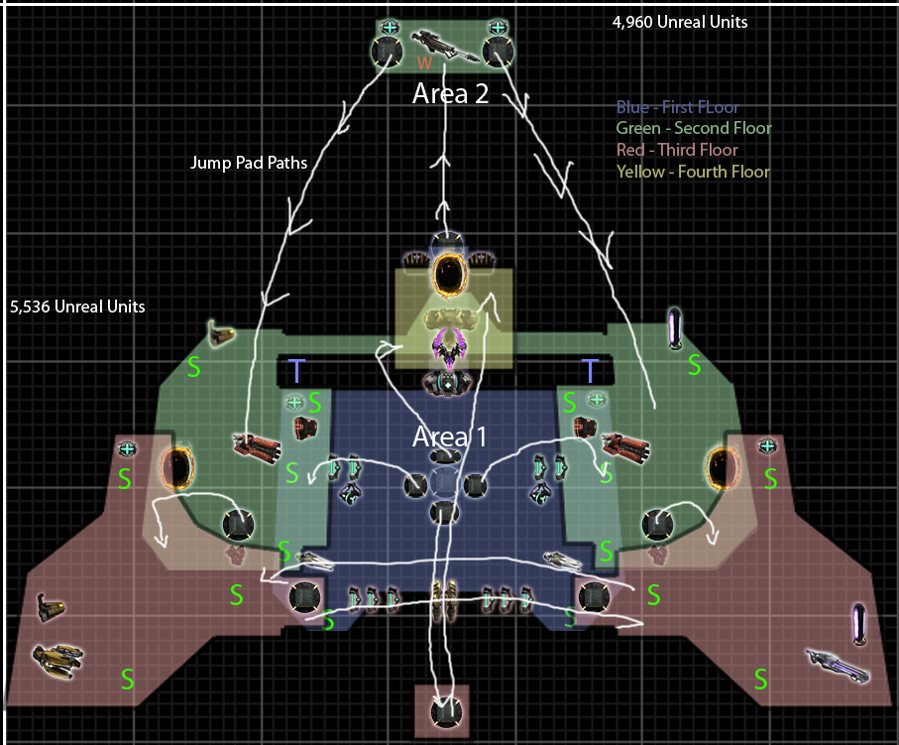
54. Level Overview Map
55. Level Overview Key

Area Walkthroughs/Detailed Map Descriptions

Area 1: First Floor
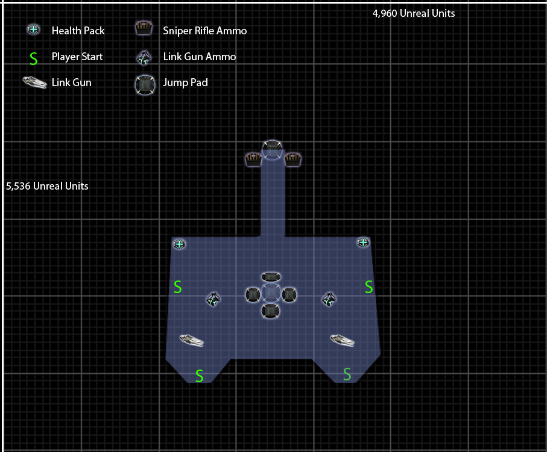
56. Area 1: First Floor - Map and Key

Gameplay
- The bottom floor in Titan VR is one of the least safe environments within the play space. This level does provide players with access to health pickups, a moderately powerful Link Gun, and the central jump pad area that grants direct access to the second and fourth levels of the map. Players can access the jump pad to the Sniper Alcove from the first floor as well. This mobility is what offsets the danger of being so far below hostiles. Players on upper levels have a much easier time targeting opponents below. This is why the first floor grants so much accessibility. The north central jump pad grants access to the second floor armor on the bridge, the east and west central jump pads grant access to the second level portions respective to their sides, and the south central jump pad grants access to the fourth floor, Damage Amp! and teleport to the armor on the second floor bridge. Players cannot reach the vertical central jump pad without jumping from the second floor. This pad grants access to the airborne Keg ‘O Health.

Dialog
- N/A

Visual References
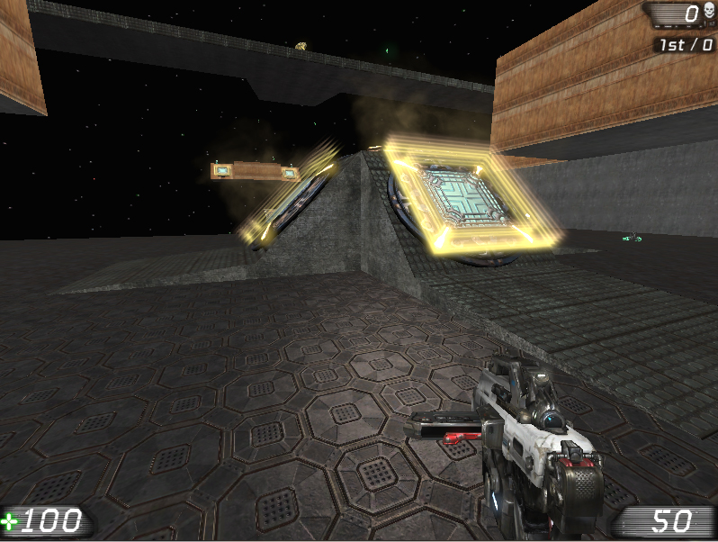
57. Area 1: First Floor - Whitebox example
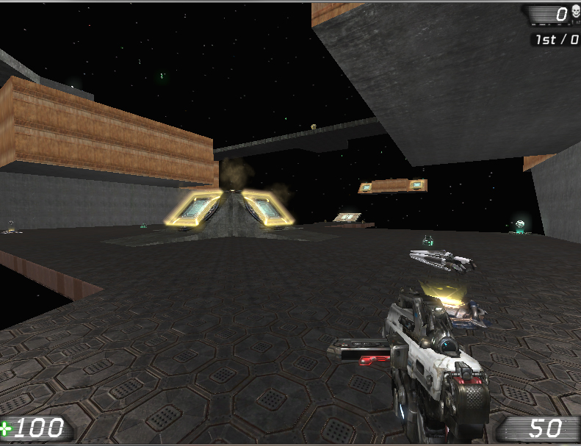
58 . Area 1: First Floor - Whitebox example
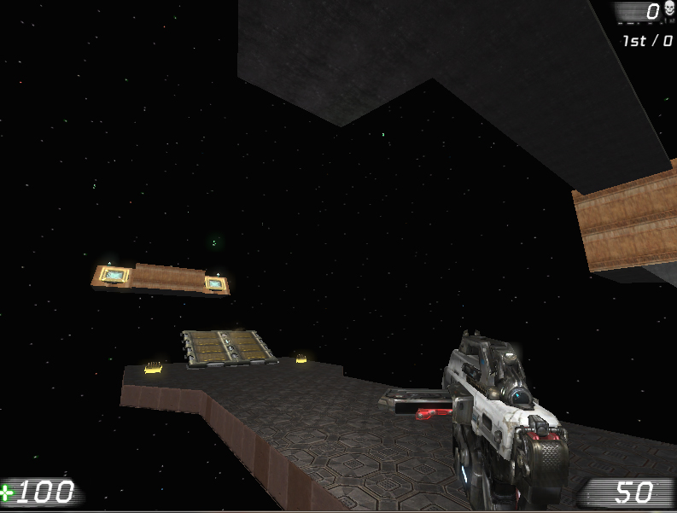
59. Area 1: First Floor - Whitebox example

Area 2: Second Floor
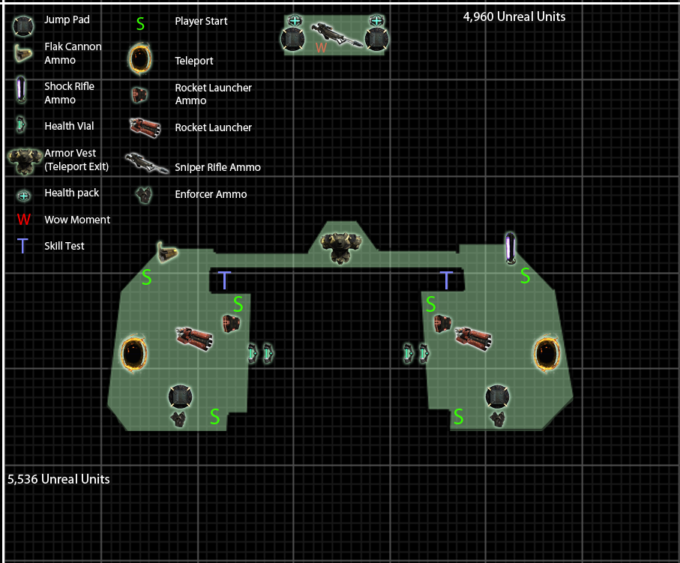
60. Area 2: Second Floor - Map and Key

Gameplay
Main Area (South):
- The second floor is where most of the action concentrates. This is a result of the desirable Armor Vest on the bridge, abundant amount of ammunition, the Rocket Launcher, and the Teleporter access. The second floor is less dangerous because of its elevation. Players can see all parts of the map with the small exception of the fourth floor.
Sniper Perch (North):
- Players can only access the sniper perch through the northern jump pad on the first floor. Single access grants some advantage to players with exceptional aim, however, any small mistake or shortage of ammunition leaves snipers quite vulnerable to close range weapons an opponent may use to confront them. During the normal gravity Titan sequence, players can shoot falling rock down from above the alcove in periodic increments. This hazard crushes and counteracts players who abuse the sniper alcove.

Dialog
- N/A

Visual References
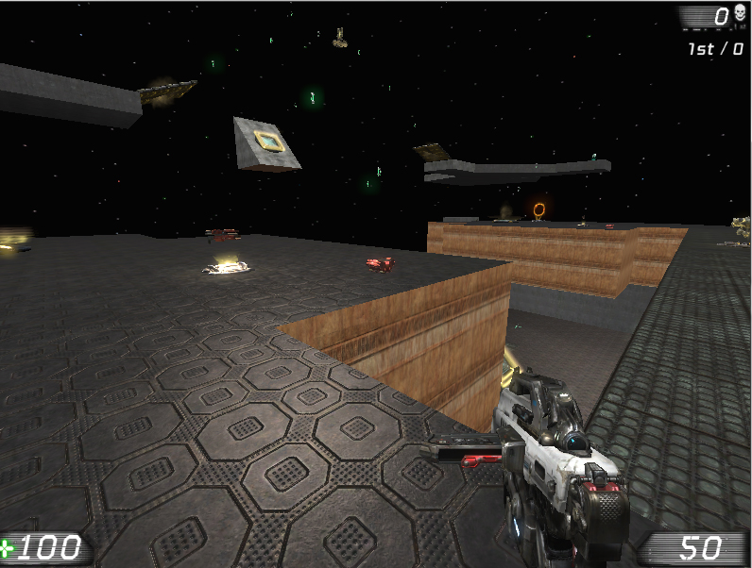
61. Area 2: Second Floor - Whitebox example
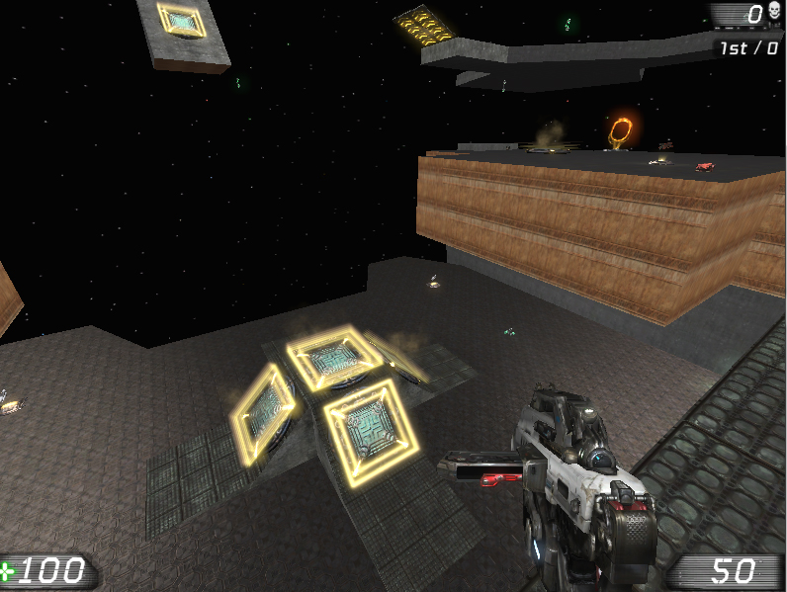
62. Area 2: Second Floor - Whitebox example
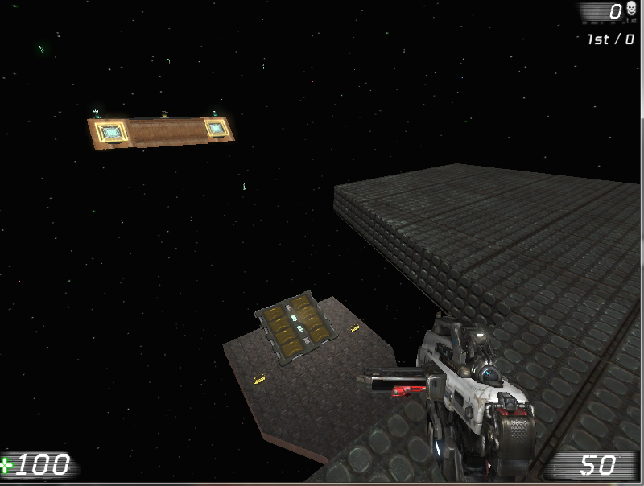
63. Area 2: Second Floor - Whitebox example
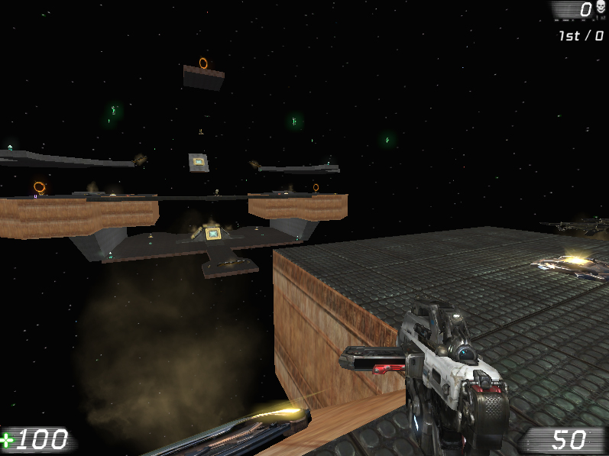
64. Area 2: Second Floor - Whitebox example

Area 3: Third Floor
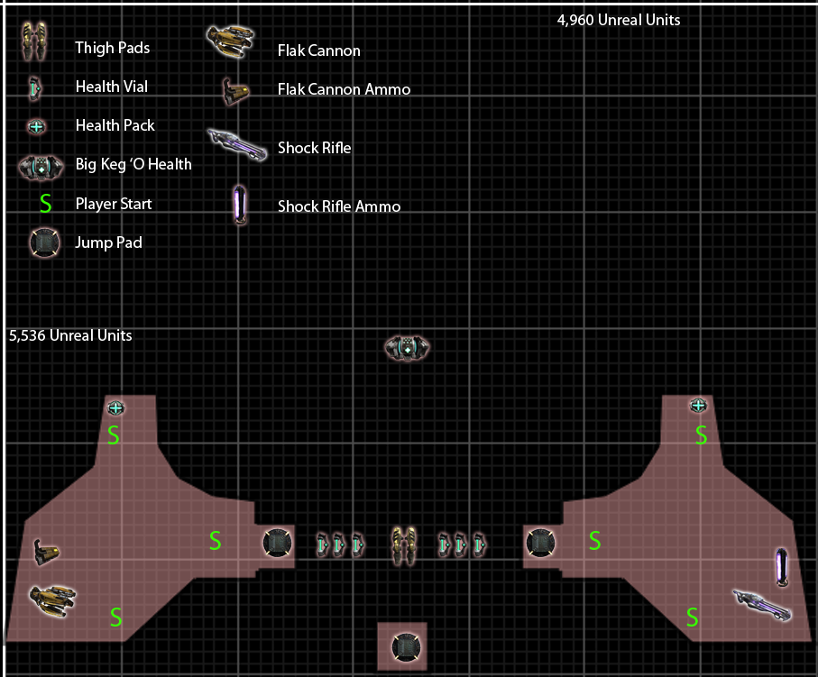
65. Area 3: Third Floor - Map and Key

Gameplay
- The third floor is an advantageous spot because of its elevation and vantage points. Players can look down upon and target most second floor players and most central first floor players. However, the third floor lacks much of the mobility that the second and first floor provide. This results from its smaller size and lack of jump pads with the exception of the horizontal transfer between west and east wings. Exiting the third floor requires manual jumping, as the luxury of safer Jump Pads does not exist. Skillful players who take no issue with descending manually may find that they can exploit the third floor’s height as a useful element of surprise.

Visual References
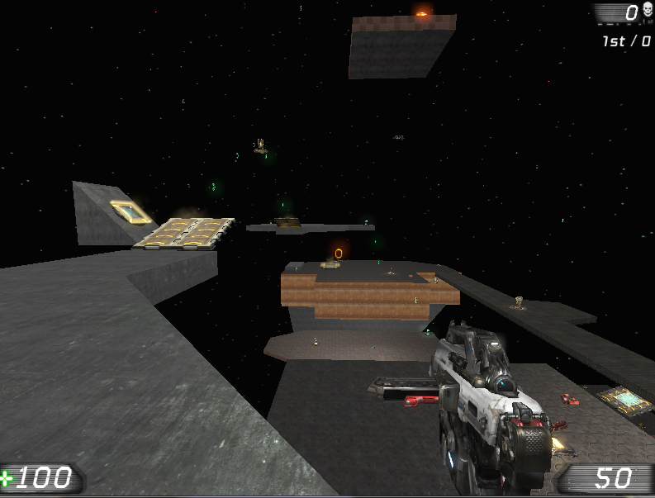
66 Area 3: Third Floor - Whitebox example
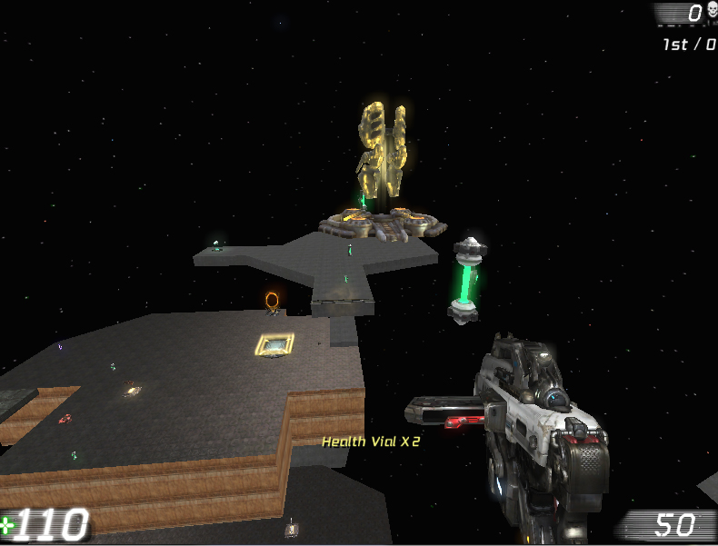
67 Area 3: Third Floor - Whitebox example
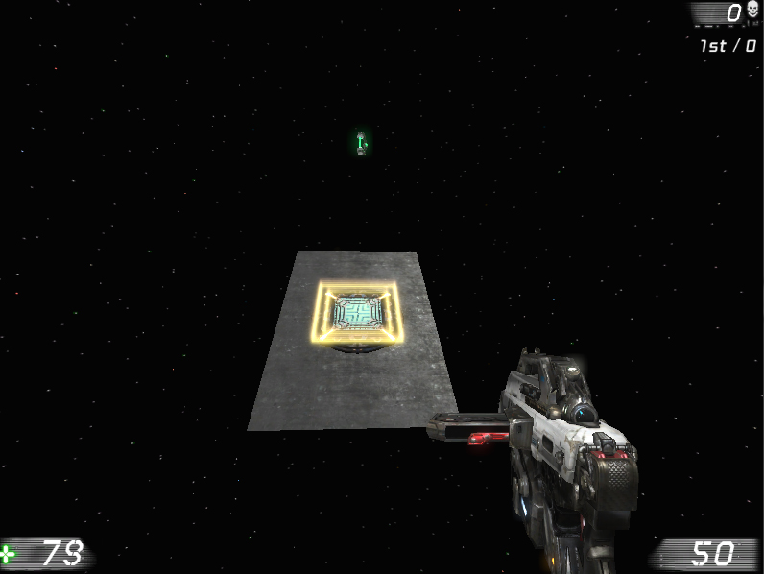
68 Area 3: Third Floor - Whitebox example

Area 4: Fourth Floor
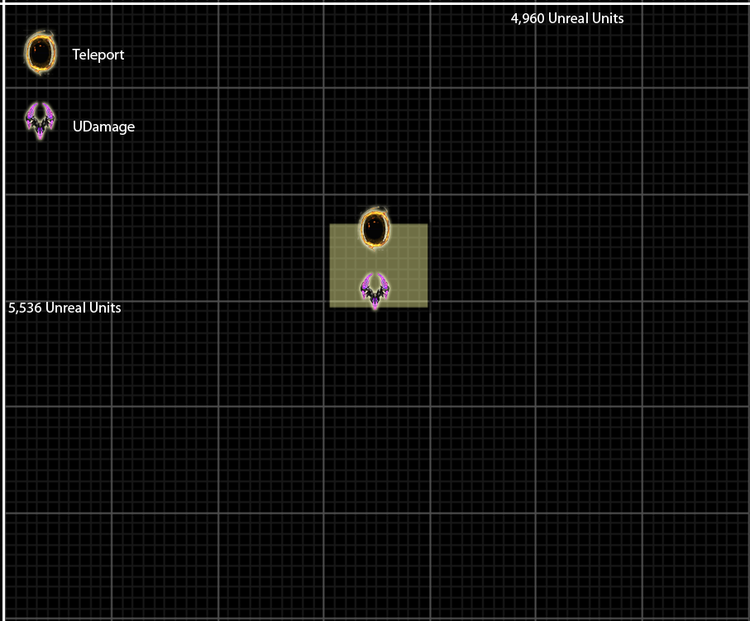
69. Area 4: Fourth Floor - Map and Key

Gameplay
- The fourth floor is nothing more than a small, central platform high above the first three floors. This floor is about 3 x 3 player widths in dimension. Players can only access this floor by using the south central jump pad from the first floor which leads to a third floor jump pad that lands players right on top of the powerful Damage Amp!. The teleporter leads to the Armor Vest on the second floor bridge. The only other exit is to jump down, which usually results in fall damage. The teleporter creates an incredibly short path between this very useful powerup and the Armor Vest, making the fourth floor a desirable place to visit when the Damage Amp! powerup is active.

Visual References
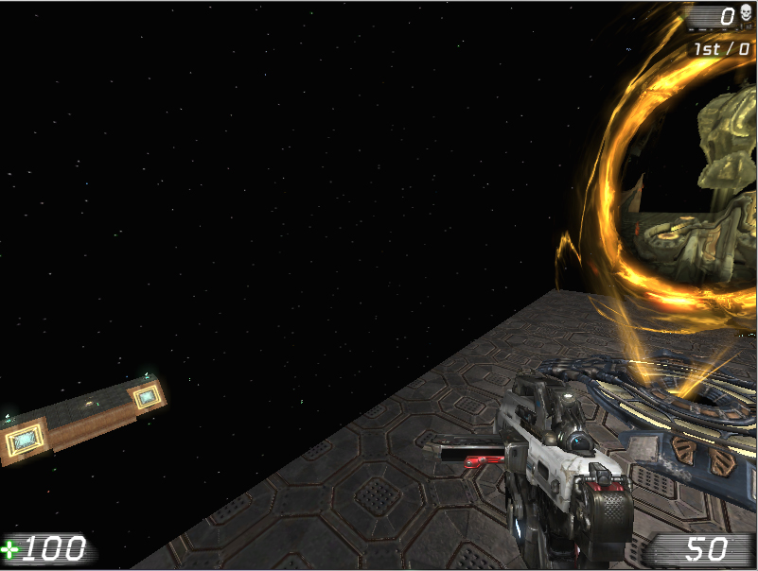
70. Area 4: Fourth Floor - Whitebox example
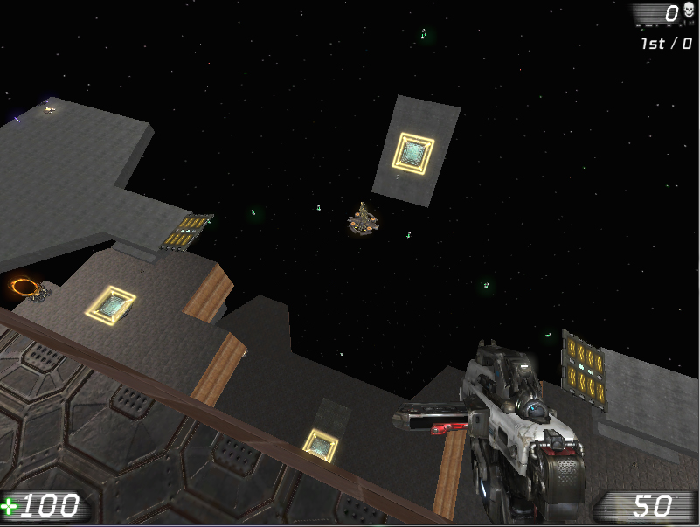
71. Area 4: Fourth Floor - Whitebox example
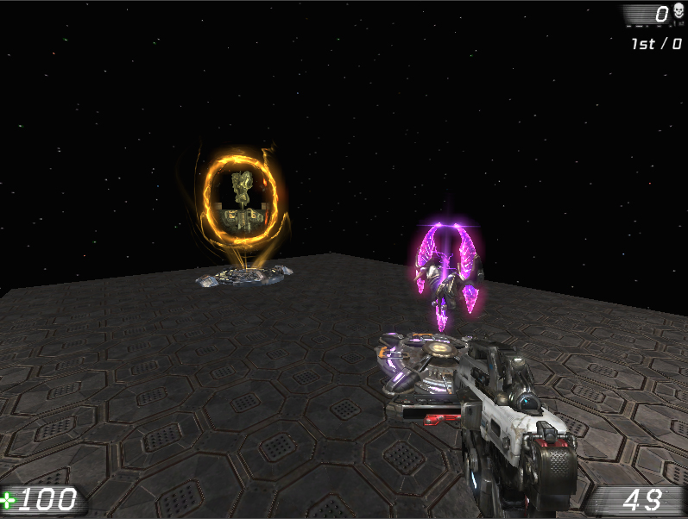
72. Area 4: Fourth Floor - Whitebox example

References
3. http://liandri.beyondunreal.com/w/images/UT3_enforcer.png
4. http://liandri.beyondunreal.com/w/images/UT3_hammer.png
5. http://liandri.beyondunreal.com/File:UT3_link.png
6. http://images.wiki.wegame.com/i/sb9HHFig.png
7. http://liandri.beyondunreal.com/w/images/UT3_flakcannon.png
8. http://liandri.beyondunreal.com/w/images/UT3_rocket.png
9. http://liandri.beyondunreal.com/w/images/UT3_sniper.png
10. Screen shot of from Unreal Editor 3
11. Screen shot of from Unreal Editor 3
12. Screen shot of from Unreal Editor 3
13. Screen shot of from Unreal Editor 3
14. Screen shot of from Unreal Editor 3
15. Screen shot of from Unreal Editor 3
16. Screen shot of from Unreal Editor 3
17. Screen shot of from Unreal Editor 3
18. Screen shot of from Unreal Editor 3
19. Screen shot of from Unreal Editor 3
20. Screen shot of from Unreal Editor 3
21. Screen shot of from Unreal Editor 3
23. http://images.astronet.ru/pubd/2006/08/02/0001215065/titanrain_garlick.jpg
24. http://apod.nasa.gov/apod/image/0601/titan_huygens_big.jpg
25. http://lightsinthedark.files.wordpress.com/2009/04/pia11838.jpg
26. http://www.sciencephoto.com/image/131768/530wm/C0068749-Mining_on_Titan,_artwork-SPL.jpg
27. http://kr.starcraft2.com/features/images/marsara-thumb.gif
28. http://media.giantbomb.com/uploads/1/14434/1088814-liandri_super.jpg
29. http://www.arcadiastreet.com/cgvistas/spacexp/images/se_titan_weather_station_600.jpg
30. http://laurieannismorgan.com/samples/2dgallery246.jpg
31. http://thumbs.dreamstime.com/thumblarge_309/12208528242ABkGp.jpg
32. http://media.giantbomb.com/uploads/1/14434/1088792-iron_guard_super.jpg
33. http://media.giantbomb.com/uploads/1/14434/1088813-necris_super.jpg
34. http://media.giantbomb.com/uploads/1/14434/1088811-ronin_super.jpg
35. http://media.giantbomb.com/uploads/1/14434/1088812-krall_super.jpg
36. http://media.giantbomb.com/uploads/1/14434/1088814-liandri_super.jpg
37. http://www.worldbestspot.com/Spotimage/Inner%20Space%20Caverns.jpg
38. http://www.penick.net/digging/images/2009_05_21%20Inner%20Space%20Cavern/Cave%203.JPG
39. http://4.bp.blogspot.com/_Hgsp-00XxiA/TD9wwo2ok0I/AAAAAAAABpE/vqJJPOy8NFQ/s1600/071505-Kolobcave.jpg
40. http://www.green-planet-solar-energy.com/images/titan-moon-mountains.gif
41. http://sci.esa.int/science-e-media/img/31/Titan-surface-rock-sizes.jpe
42. http://www.jpl.nasa.gov/images/cassini/20100511/cassini20100511-browse.jpg
43. http://static.photaki.com/red-rock-wall-in-utah-square-rock-wall_282500.jpg
44. http://laurieannismorgan.com/samples/2dgallery246.jpg
45. http://southeasttechnicalscuba.com/Images/Cavern.jpg
46. http://fc07.deviantart.net/fs70/f/2011/312/c/1/phoenix_nebula_space_station_by_darklorddc-d2dbwu1.jpg
47. http://pnmedia.gamespy.com/planetunreal.gamespy.com/newsimages/ut3hq/large/dm/deimos2.jpg
48. http://images.wikia.com/avp/images/3/31/Nostromo_LV426.jpg
49. http://www.futuretimeline.net/22ndcentury/images/space_station_22nd_century.jpg
50. http://www.acceleratingfuture.com/michael/blog/images/space_elevator_station.jpg
51. http://www.universetoday.com/wp-content/uploads/2009/05/startrek_spacedock_small-thumb-550x233-17606.jpg
52. http://lh3.ggpht.com/_jFnbk1J6dq0/SpmqBlDT5oI/AAAAAAAAABg/CPL9LGXV3X8/SpaceNoxx1.
53. http://application.denofgeek.com/images/m/corridors/Aliens2.jpg

