Math 105: Music & Mathematics
November 30, 2017
Test #3

For each question, show your work and/or explain your answer as appropriate (unless the instructions for that question indicate otherwise). You will not receive credit for an answer with insufficient supporting work or explanation, even if it is correct. Also, keep in mind that partial credit (for an incorrect answer) can be given only if your supporting work or explanation is shown.
If you need more space for work or explanation than is provided, please use the back of the page rather than a separate sheet of paper.

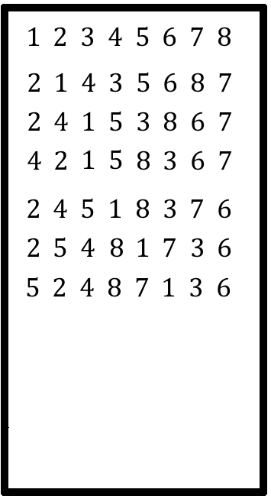
1. A change-ringing group produces changes of eight bells by repeating a sequence of three permutations. The first several changes that they generate using their system are shown to the right.

a) What are the three permutations that are being used to generate these changes? Write your answers using cycle notation.

b) Continue the list shown in the diagram by filling in the next three changes that will be obtained if the same pattern is continued.

c) What permutation would rearrange the list in the first row, 1 2 3 4 5 6 7 8, into the list in the fourth row, 4 2 1 5 8 3 6 7, all in one step? Write your answer using cycle notation.

d) If this same repeating pattern is continued long enough, how many different changes will be generated before repetition occurs? Explain your answer. (Note: do not try to answer this question by actually listing all of the changes; that would take way too long. Find another way to count them!)

2. For each of the following, all notes are selected from the set {A, B, C#, D, D#, E, F#, G, G#}. (There are nine notes in this set). Remember that a melody is an ordered selection of notes.

a) How many ways are there to write a three note melody if no repetition of notes is allowed?

b) How many ways are there to write a four note melody if exactly one note must be a sharp (C#, D#, F#, G#), and no repetition of notes is allowed?

3. How many distinct ways are there to rearrange the letters of each word?
a. CAMDEN

b. LOBLOLLY

4. In the game of “three card poker,” a “hand” consists of three cards that are selected from a standard deck of 52 cards. The order of selection is not considered, and no card can be selected twice. (Reminder: in a standard deck, there are 13 cards of each suit, and 4 cards of each rank.)
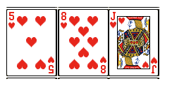
a. In three card poker, how many different ways are there to select a “flush” – that is, a hand where all three cards are of the same suit? (For example, the hand shown below to the right is a “flush,” because all three cards are hearts.)

b. In three card poker, how many different ways are there to select “one pair” – this means two cards have the same rank, and the third card has a different rank. (For example, the hand shown below to the right is “one pair,” since it includes exactly two kings.)
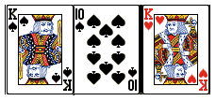

5. For this problem, all notes are to be selected from the set {F, G, G#, A, A#, B, C, C#, D#, E}. (There are ten notes in this set.) Remember that a chord is an unordered selection of notes.

a) How many ways are there to select a four note chord?

b) How many ways are there to select a five note chord that includes exactly two “sharp” notes (G#, A#, C#, or D#) and three “natural” notes (F, G, A, B, C, or E).

6. For this problem, start by writing out the first ten rows of Pascal’s triangle in the space provided. (Remember that the first row consists of two 1’s.) Then, answer the questions that appear below.
a. Write out the first eight rows of Pascal’s triangle (the first two rows are provided for you):
1 1
1 2 1

b. Circle the number in the above triangle that corresponds to $C\left(8, 4\right).$ Briefly explain your choice.

c. Shown below are the first few entries of the 30th row of Pascal’s triangle. Fill in the next two entries in the conveniently provided boxes. (Hint: the correct answers have four digits and five digits, respectively.)

